METEORITES, MINERALS AND MERENSKY - 2023
My Story of the Vredefort Impact Structure
VREDEFORT, BUSHVELD AND GREAT DYKE
THE UNCLOTHED EMPERORS – Observe, Theorise, Prove

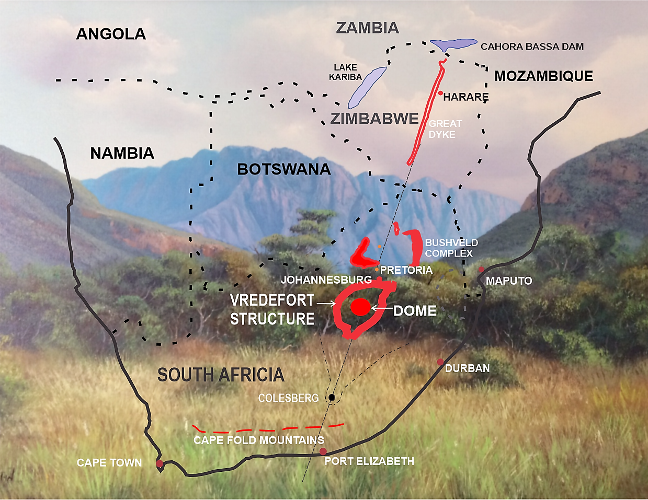
Copyright © David Parkinson Howcroft, Australia 2017, 2020, 2022 & 2023
In a Special Paper for the 29th De Beers Alex L. Du Toit Memorial Lecture, Wolf Uwe Reimold wrote, ‘This has proven, just like the debate about continental drift, and on a smaller scale, about the origin of the Vredefort Dome, that ideas and hypotheses that initially are widely regarded as absurd and consequently are subjected to negative critique, may well have merit’ (Reimold 2007). Reimold was discussing new multidisciplinary research, bringing together scientists from the planetary, earth and life sciences. It would never have been possible for me to write about my hypotheses without them. ‘If I have seen further, it is by standing on the shoulders of giants’ (Isaac Newton 1675)

Contents
Abstract 3
Introduction 4
1.0 Vredefort, the world’s largest meteorite impact structure 6
2.0 Earth impact effects, power and forces involved 12
3.0 Asteroid belt, metallic meteorites and multiple impacts 14
4.0 Simple, complex and ‘penetrative’ craters 18
5.0 Penetration through geological rocks 20
6.0 The ‘scarps’ of upturned strata, magma dykes and caves 21
7.0 Witwatersrand basin, worlds’ largest deposits of gold 24
8.0 Bushveld Complex, world’s largest deposits, Cr, Pt, PGMs, Vanadium, ++ 27
9.0 The Great Dyke of Zimbabwe 33
10.0 The swathe of minerals south-west to north-east 36
11.0 The Triassic-Jurassic mass extinction 40
12.0 Karoo Mantle Plume 42
13.0 Continental drift 204 Ma till now 46
14.0 The diamond ring 49
15.0 Coal in crater and ripple valleys 50
Conclusions. 52
Reference list 55

About the author, David Parkinson Howcroft 65

‘In questions of science the authority of a thousand is not worth the humble reasoning of a single individual’. Galileo Galilei (1564 – 1642)
Abstract
Since the 1990s when Geoscientists investigated the geochronological record of the Vredefort Impact Structure using many new sources of dating based on nuclear decay and zircon crystals, they assumed that the dark, almost black, pseudotachylite breccia (PTB) between the cracked rocks was impact melt. Over the past 30 years they have improved their accuracies of measurement to arrive at a figure of 2023+ 4 Ma (Million years ago) for the impact. However, since 2005, analysis of pseudotachylite breccia, (PTB) has come a full circle after Shand first correctly described it in 1916. It is now accepted that the PTB is powdered rock and worn clasts from adjacent enclosing host rocks and not impact melt! The target rocks were shaken violently by the earthquakes following the impact or compression and decompression shock waves. The age of the PTB and Vredefort Granophyre has been found to be the same as the surrounding rock. I suggest that the existing precise age measurements are for the host rock and not the meteorite impact.
It is also now accepted that the Witwatersrand Basin, the source of the largest deposit of gold in the world, is encompassed by the Vredefort Impact Structure (although it is not conventionally accepted that gold and uranium came from the meteorite). This ~300 x 150 km oval crater, with a subsurface entry south of Welkom identified by numerous faults and the major Colesberg Positive Magnetic Anomaly Trend; the ~800 km long V-shaped trend is also an indication of an oblique impact of less than 7.5º to the horizontal which resulted in a massive underground explosion. Today the inside cavity of this Colesberg Trend is filled with < 300 Ma Karoo sediments whilst immediately outside the Trend line is ~2700 Ma Ventersdorp sequence.
Despite many years of searching by geoscientists from Witwatersrand University and others, no signs of ejecta or true impact melt from Vredefort have been found. Sir Isaac Newton’s approximation for impact depth and modern hydrocode 3D computer simulations indicate that it is possible for these low angle impacts at hypervelocity to travel long distances through rock. I have named these penetrative meteorite craters.
The Bushveld Complex (BC), the world’s greatest continental Large Igneous Province (LIP) starts about 50 km north-east of the northern rim of Vredefort and is presently dated 2060-2054 Ma. This intrusion, the Rustenberg Layered Suite (RLS), contains 7% by weight (approximately 100,000 billion tonnes) of minerals including world leading deposits of chrome, vanadium, and Platinum Group Metals (PGMs) and 93% local metamorphic rock. The age given for the RLS is the same as the Pretoria Group strata from the floor and the roof. I suggest that this age for the horizontal intrusion is based on ~2060 Ma strata of sedimentary rock in the meteorite’s pathway from Vredefort. This had been subject to acoustic fluidization (shattered without melting, flows like liquid) which carried eroded projectile minerals with it into the BC. As there are no signs of shock impact, BC is not regarded as of meteoritic origin. My contention is that all the shatter cones and other shock metamorphic effects are near the Vredefort Dome as this was where the greatest impact forces occurred with the tail end of the penetration not generating sufficient pressures and temperatures.
The Great Dyke (GD) is not a dyke, but, I suggest, an astrobleme. This lopolithic, Y-shaped meteorite scar, starts roughly 250 km north-east of the end of the BC and ploughs horizontally for 550 km across Zimbabwe. The structure has been dated as 2575 Ma, although the target rock is in this age bracket. From overhead it is exactly in line with the centre of the Bushveld Complex and the Vredefort Dome. From the side it is 0º to the ground. The entry points of Vredefort and the GD are 800 km apart. At 111 km per degree, the result is an oblique impact for Vredefort of 7.2º. This is what would be needed to penetrate 25 km deep under the present Dome and continue through the BC to Polokwane in the north-east. The geological connection between the Bushveld Complex and Great Dyke is in the same minerals, especially chrome and PGMs with both deposits the only known with more platinum than palladium.
Up until the late 1980s, before the zircon and radiometric 2023/2060/2575 Ma dates were arrived at, geoscientists of the time believed that the Vredefort Structure’s age was in the order of at least 250 Ma (Dietz 1961) or that it was comparatively young looking for the ages given to it. ‘Unless a crater is unusually large all traces of its presence will be eroded away in less than 600 million years’ (Wetherill 1979). ‘Old craters are less abundant simply because they have been destroyed by erosion, sedimentation, and other geologic processes’ (Grieve 1990). ‘The Bushveld magmatic province is an unusual LIP. In spite of its Palaeoproterozoic age [2055 Ma] it is undeformed’ (Kinnaird 2005). I am inclined to agree with these authors.
To look at 298-200 Ma an alternative time, we need to go to many other branches of science. After spending millions of years under the Antarctic Circle covered in 4 km thick ice, the melting glaciers scraped across Gondwana, leaving the Dwyka layer of round, roughly 20 cm rocks, as markers. If Vredefort, the BC and GD were really formed prior to this glaciation event all the rims, scarps and outcrops surrounding these three structures would have been scraped flat and shock-formed caves north of Witwatersrand collapsed under the weight of ice. The Dwyka layer is buried deep in the dish of the Bushveld Complex and then covered with young Karoo sediments to ground level. Only if BC was formed after the glaciation could this have happened. If much earlier than Dwyka, say 2060 Ma, then the dish would have already silted and the Dwyka layer would be at ground level. The Karoo Elliot Formation dated from 220-201 Ma is stained red with iron oxide and contains abnormal traces of uranium, the same element that shares the lining of Vredefort Impact crater with fine gold. These layers contain large numbers of fossils, over 30,000 so far including about 3000 species indicating a mass extinction during this period.
Introduction
At two hundred and eighty-four kilometers in diameter, the Vredefort Meteorite Structure in South Africa, with its central rebound, the Vredefort Dome, is accepted as the largest known impact site on Earth. After 100 years its formation is still regarded as a mystery.
Radiometric dating granophyre, a molten rock outcrop on the Dome (rebound core) was first used in 1963 to calculate the age at ~ 2030 Ma. The nearby Bushveld Large Igneous Province, world renowned treasure chest of valuable minerals, is dated 2054 Ma. The chrome and platinum-rich Great Dyke in Zimbabwe is dated as 2575 Ma. As a result of the multi-million-year age differences, these three structures are not considered to be connected. But what if they were all the same age? What if the astrophysicists and geologists prior to radiometric dating were correct in their estimation of an age of 300-200 Ma? This paper examines the evidence that Vredefort, Bushveld and the Great Dyke were concurrent and recent, causing Earth-changing events.
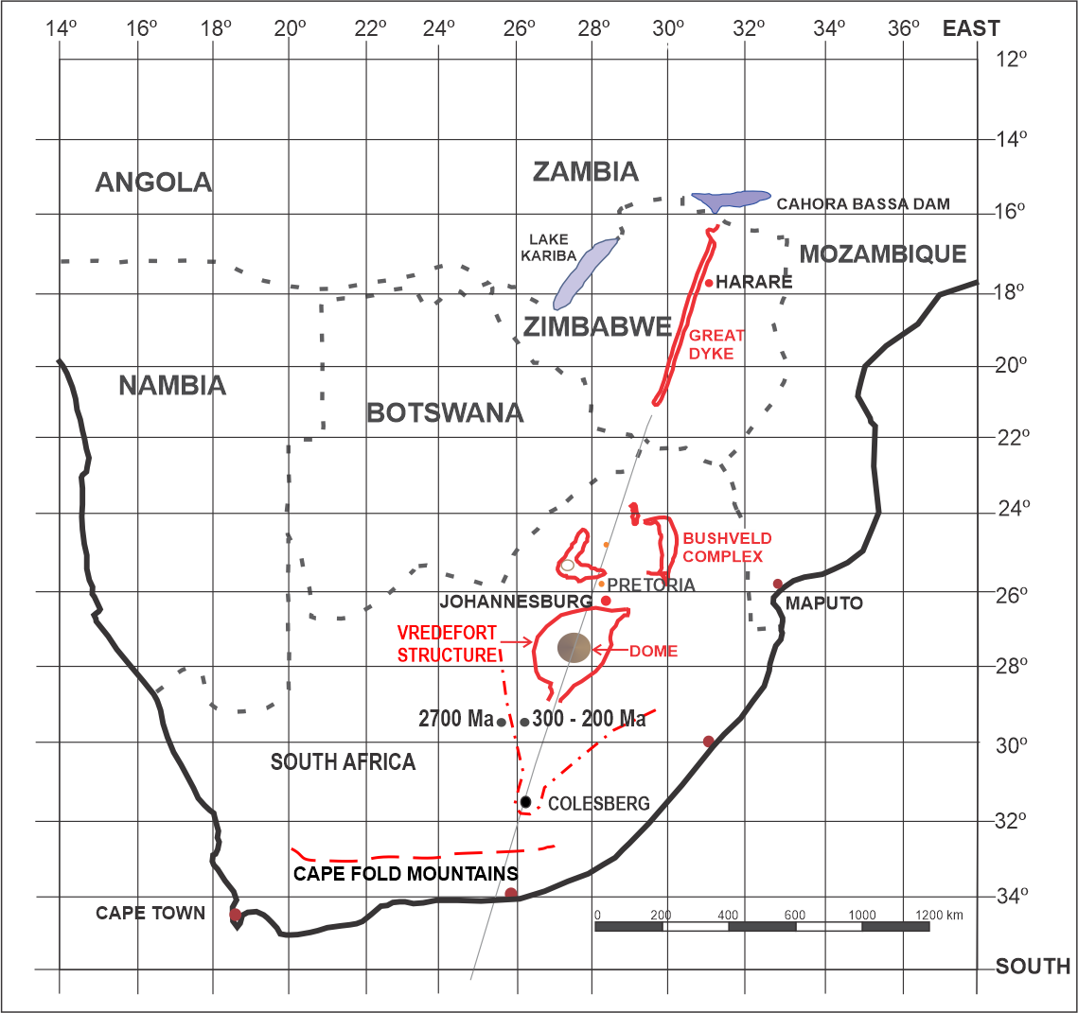
Fig. 1. Alignment of Cape Fold Mountains, Colesberg, Vredefort, Bushveld Complex & the Great Dyke.
Extreme Events from this period include:
- The Norian to Triassic-Jurassic Mass Extinction where 80% of all species on Earth were wiped out over 20 million years and for which the cause is thought to be a giant impact followed by a large igneous province.
- The 204 Ma beginning of the Karoo Mantle Plume in the north of Kruger Park which later capped the Drakensberg Mountain Range in 182 Ma
- The 185 Ma breakup of Gondwana restarting continental drift.
My main hypotheses contend that the Vredefort Meteorite Impacts were part of a cluster that was linked to:
- The gold & uranium lining the Witwatersrand Basin (Vredefort Crater)
- The Bushveld Complex filled with 300-200 Ma Karoo sediments.
- The Great Dyke in perfect alignment with Bushveld Complex & Vredefort
- The same minerals in the Bushveld Complex & Great Dyke
- Colesberg Positive Magnetic Anomaly Trend with Karoo sediments
- The Cape Fold Mountains dated 215 +3 Ma.
- The swathe of minerals across southern Africa
- The 20 million years Norian to Triassic/Jurassic extinction
- The red dust, rich fossils, and uranium of the Karoo Elliot Formation
- The Karoo Mantle Plume
- The Gondwana breakup
- The explosion of Kimberlite diamond pipes of southern Africa
- The Karoo age coalfields of the Free State, Highveld, Witbank, Springbok Flats, Ellisras (Lephalale), Mopane Limpopo and Molteno (Eastern Cape).
Radiometric dating methods are accurate, but I contend that samples came from the Vredefort Structure host rocks and, in the case of the Bushveld Complex and Great Dyke, from the target layer of strata into which the minerals were intruded or impacted horizontally. This would account for the currently accepted three separate 2 Ga ages for the same event and totally overshadow what I believe to be the true age.

1.0 Vredefort, the World’s Largest Meteorite Impact Structure
Up until the early nineteen sixties, most geologists believed that the 45 km diameter dome with a 20-25 km wide surrounding collar of upturned upper-crustal strata surrounding the Free State village of Vredefort was cryptovolcanic, that is, a ‘hidden volcano with no signs of volcanic material or prior volcanic activity’ (Bucher 1963)
There were a few exceptions; a Scottish born mineralogist at Stellenbosch University, Samuel James Shand, had suggested ‘an expulsive force of enormous power at Parijs’. He also predicted that ‘When one is dealing with an extraordinary phenomenon, no possibility is too extraordinary to be worthy of consideration’. He was the first to study and name ‘pseudotachylyte’ (now pseudotachylite) a dark filling between host rocks and suggest that it was formed as a result of shock in host rocks caused by a ’gigantic impulse or series of impulses’ and not impact melt (Shand 1916).
Then in 1936, two American professors from the Southern Methodist University, Drs. John Boon and Claude Albritton proposed that this supposed crypto volcanic structure could be the result of a meteorite impact. However, Vredefort still puzzled them. They said, ‘One hardly knew which was better - a meteoritic hypothesis without meteorites or a volcanic hypothesis without volcanics’ (Boon & Albritton 1938).
Eleven years later the well-respected Reginald Daly, Professor of Geology at Harvard, backed up Boon and Albritton and added that the energy released by the large, high velocity meteorite would have been great enough to volatilise target and meteorite materials. This event would have been explosive, caused by pressure, and percussive, from the impact (Daly 1947).
Geological and geophysical data gradually began to show support for the meteorite theory. In the early 1960’s, well-known American planetary scientist, Robert Dietz, who was the first to suggest that Sudbury was a large complex impact crater, wanted to prove that the Vredefort Dome was a crypto-explosive impact structure (Dietz 1961b). He suggested to a Witwatersrand University researcher Robert Hargraves that he should look for impact shatter cones, sharp pointed rock chards, which were duly found. Hargraves also discovered that all the cones, in their original positions, pointed to the centre of the dome indicating that this was the source of the shockwave (Hargraves 1961). In 1963 Nicolaysen radiometrically dated an outcrop of dark igneous granophyre, a fine-grained rock, at ~2030 Ma. However, according to Robert Dietz, Nicolaysen did not believe that Vredefort was impact related, rather endogenous origin, derived from Earth by geological processes such as volcanic lava.
Later others found signs of shock in quartz (Carter 1965). About this time (Dence 1968) from Canada again suggested that the Vredefort Impact Structure looked like it could be a far larger complex crater with the Dome being only the remnant central ring or rebound. Further proof of the impact structure came when crystals of coesite and stishovite were discovered. These are high pressure and temperature forms of silica that can only be derived from very extreme pressures, too high for volcanic activity (Martini 1978).
Despite all the extraterrestrial meteorite impact validation coming through, most South African geologists still believed that the structure was volcanic in the form of a cryptoexplosion. In July 1987 the International Conference on Catastrophes in the Geological Record and Cryptoexplosion Structures was convened in Parys, a town within the Vredefort Dome. After many papers were presented and arguments put forward, it was voted that, based on the evidence, what was then known as the Vredefort Crater was a large impact structure.
‘The final piece of the puzzle was provided by the giant leaps in computer technology in the 1990’s that allowed more complex numerical modeling of impact cratering’ (Gibson 2019) These models showed that the Vredefort Dome was only part of the much larger Vredefort Impact Structure, a complex meteorite crater (Turtle & Melosh 1996; Ivanov 2005) The term structure in place of crater was proposed by Richard Grieve 1987 and then adopted by Reimold & Gibson 1996.
At the turn of the century Richard Grieve and Ann Therriault proposed a 300 km multi-ring basin (Grieve & Therriault 2000). Over my lifetime, estimates of the original rim diameter have evolved from 40 km to 70-90 km to 250-300 km!
From the 1990’s onwards, teams of geoscientists using various modern radiometric techniques set an age in the order of 2020 Ma for the Vredefort structure. Samples were taken from the granophyre dikes or pseudotachylite which were both presumed to be impact melt. (Walraven, Armstrong & Kruger 1990, Allsop, Fitch, Miller & Reimold 1991, Kamo, Spray, Kelley & Reimold 1995, Kamo, Reimold, Krogh, & Colliston 1996, Hart & Hargraves 1995, Spray 1995, Reimold, Krogh & Colliston 1996, Koeberl et al. 1996, Moser, 1997, Wielicki 2012). ‘The age of the impact structure is generally assumed to be 2.023 + 4 Ga based on U-Pb age of authigenic zircon in a pseudotachylyte’ (Kamo et al. 1996).
I have stood by my proposal for more than 30 years that this age of 2020 Ma is incorrect as the host rock is being dated instead of the impact itself.
The respected late Henry Jay Melosh said that pseudotachylite could not come from friction melt as this would not continue to be generated in the large quantities observed after it formed, lubricating the rock faces (Melosh 2003).
Despite considerable searching no impact ejecta has been found for Vredefort (Grieve & Therriault 2004, Mohr-Westheide & Reimold 2010). Impact melt is required for the correct dating as host rock dating can only set a limit for the maximum age of the impact. Oblique impacts of less than 15º produce oval craters and little impact melt, nor do they reset radiometric measurements as the impact pressures and temperatures are not high enough (Pierazzo & Melosh 2000a)
It is now proposed again, more than 100 years after Shand in 1916, that pseudotachylite was formed by ‘impact-induced seismic shaking’ and that ‘most pseudotachylyte was thus not injected from elsewhere but produced in situ.’ and have ‘not necessarily been molten’ (Garde & Klausen 2016). Wolf Uwe Reimold et al. prefers ‘decompression melting (ie., in situ generation of melt) upon central uplift collapse, or impact melt infiltration hypotheses.’ Regardless of who is correct about the formation, I support Garde & Klausen as there are no signs of impact heating therefore the term melt is incorrect, but Reimold went on to state ‘Importantly, all the past clast population and chemical analyses have supported an origin of these breccias from local lithologies only’ and ‘PTB [PseudoTachylite Breccia] lie within the range [2020 Ma] of their respective host rocks...’ (Reimold, Hauser, Hansen, Thirlwall & Hoffman, 2016).
Based on magnetite and Verwey transitions it is possible that no wholesale heating of the [Vredefort Impact Structure] occurred above 550-600 ºC for 3 min or above 500 ºC for 1 h during or since the time of impact’ (Laurent Carporzen, Stuart Gilder & Rodger Hart 2006). Computer simulations demonstrated that only limited shock heating of the target rocks took place (Turtle, Pierazzo & O’Brien, 2019). It is now generally accepted that ‘Pseudotachylite and shock-generated impact melt are not the same products, and it is important not to conflate them; each provides valuable insight into different stages of the hypervelocity impact process’ (John Spray & Marc Biren 2021)
The Vredefort Granophyre was first dated 2016+24 Ma (Walraven et al 1990). U-Pb geochronology on the granophyre in the core rocks indicates 2020+3 Ma (Moser 1997) which is comparable to the ⁴⁰Ar-³⁹Ar dating of pseudotachylite at 2018+14 (Spray et al 1995). At that time the granophyre was also thought to be impact melt.
An excellent (and timely) systematic literature review has been carried out by Matthew Huber and Elizaveta Kovaleva of 33 peer-reviewed papers on the examination of the Vredefort Granophyre. This survey has shown that ‘some of the detrital zircons were likely derived from rock fragments enclosed within impact melt’ and, ‘based on the Ti-in-zircon thermometer, the zircons were determined to be inherited preimpact’. ‘Both studies attempted to determine the ages of zircons within the granophyre but showed that the grains were likely inherited Archean zircons rather than newly grown’ (Huber & Kovaleva 2020) and the opinion that granophyre is also formed from the assimilation of epidiorite, metamorphosed existing sedimentary rock, which was not necessarily mafic (Therriault, Grieve & Reimold 1997). The Vredefort pseudotachylite and granophyre are remarkably pristine and have not interacted with fluid since formation and the granophyre is especially remarkably fresh (Harris & Fagereng 2013).
Before Wolf Uwe Reimold moved to the Museum fur Naturkunde, Berlin after a long career at Witwatersrand University, he stated in ‘Impact Structures in Africa: A review’ that ‘in the mid-1990s it was recognised that the entire Witwatersrand Basin represents the actual erosional remnant of the Vredefort impact structure;’ (Reimold & Koeberl, 2014). Later he re-examined Vredefort to measure the ages of the host rock from the Transvaal Supergroup, the pseudotachylite and the granophyre to show that they all dated at 2.02 Ga. ‘The PTB plots exactly between the two host rock data points. Granophyre and epidiorite data again form a close data array’ (Reimold et al 2017). They all have dated the same as the host rock that has not been reset by high intensity impact shock. Due to the low intensity seismic shock from an oblique impact and low temperatures (granophyre contains pigeonite which degrades above 900º C) one cannot assume that this is the impact age.
The impact could not be older than 2.02 Ga as that is when the host sediment formed, but it can be less. ‘In many cases the age of the target rock provides the only maximum age constraint for crater formation’ (Martin Schmieder & Elmar Buchner 2008). If one would put some host sedimentary rocks in a polishing tumbler and pulverize them the remaining dust would still have the same chemical makeup and age as the original rocks. It requires extreme temperatures and/or pressures to reset radioactive elements, zircons or paleomagnetic pole positions.
Scientists had measured the present depth of the structure’s floor below present sediment and debris at 15 km using seismic technology (Friese, Charlesworth & McCarthy 1995). From this, others calculated that the highest point the dome reached above the floor before collapsing was 29 km (Henkel & Reimold 1996). This 14 km peak height above ground level would only have occurred above the Vredefort Dome due to the momentum of the central rebound and would begin to collapse seconds later. The forces resulting from the collapse in a few minutes, of raw sedimentary rock, from a height nearly twice as high as Mount Everest would have crushed much of the rock to dust and caused the earthquakes that formed the pseudotachylite. Most of the dust would have been immediately carried away by violent windstorms and the balance of debris by erosion off the Dome into the surrounding crater lake in a short period of time, Even considering that a significant portion of this overburden may have been fallback breccia’ (Reimold Gibson & Henkel 2008). It would not take more than a few million years for the Dome to be eroded to the level it is now.
The pre-existing 15-25 km thick Transvaal Group sedimentary strata had tipped and slid into the crater; shattered rock debris from the crater walls and the collapsed dome filled most of the newly formed ringed crater lake. The remaining balance would be filled in a few million years with Karoo sediments from airborne dust and river sediments.
If the age of the Vredefort impact was really 2020 Ma, the crater lake would have completely silted by ~1900 Ma. The problem with this is that ‘the southern half is partially covered by younger sediments and volcanics of the Karoo Supergroup’. [300-180 Ma] (Therriault 1997) This is topped with rich even seams of coal dated 215-208 Ma (Schmidt 2006) and then a covering of more Karoo sediment.
From shocked rock shatter cones the transient cavity, the initial immediate crater, was estimated at 136-152 km; making use of these values in relation to other exposed Earth and Moon craters, the outer rim was calculated to be about 270-300 km. The latest method involved estimating the diameter of the base of the rebound at floor level as 95 km and then calculating an outer ring diameter of about 284 km. This would make the Vredefort Meteorite Structure the largest known meteorite impact site in the world (Therriault, Grieve & Reimold 1997).
The final crater diameter assumes that the original structure was round. However, if the gold reef lining the impact crater is linked, as I have always proposed, then it is possible to follow a map of the Witwatersrand gold mines (Vorster 2001) or excellent drawing of the Vredefort Structure superimposed on the Witwatersrand (Frimmel, Groves, Kirk, Ruiz, Chesley & Minter, 2005). ‘The preserved structural basin is elongated to the NE and ~350km long, 150 km wide and up to 8 km thick’ (Law & Phillips, 2006) The jelly bowl shaped impact crater is oval, the same length on its current south-west to north-east axis and about half that width across. It is not too difficult to see how perfectly one fits into the other.
My hypothesis here is that the oval shape is due to a group of about two or more large, fractured, metallic, meteor bodies, from a wider group, impacting Earth at a very shallow angle (Burchell & Whitehorn 2003) from the current south-west (Dietz 1961) and north-east trending (Kinnaird 2005). Along the meteors’ entry point, south of Welkom, the outer crater rim is not visible, but the major faults are (Frimmel, et al, 2005 p. 772).
Further SE is the beginning of the Colesberg Positive Magnetic Anomaly Trend, (See Fig 2) a V-shaped layer of magnetite which stretches 400 km to the north and about the same to the east. This cutaway funnel shaped hollow slopes downwards at about 5-7º towards the Vredefort Dome where it rises suddenly to the surface with the rebound of the core. It is suggested by the authors ‘That the Colesberg magnetic anomaly trend and the Vredefort discontinuity (together with its magnetic anomaly) are directly correlatable.’ If the rebound lifted the magnetite this would mean that the rebound occurred after the Colesberg Trend, even by a matter of minutes. As we have a dating for the Karoo sediment in the Colesberg Trend this means that the Vredefort Structure is in the same age.
The authors also describe the steeply dipping to overturned structures in the Welkom area and the sudden change from the 2700 Ma Ventersdorp sequence to the west and Karoo strata to the east of the north- bound anomaly. (Gillian Drennan, Robb, Meyer, Armstrong & de Bruiyn, 1990). This indicates that the magnetite lining of this cavity is filled with Karoo sediments, which are younger than 300 Ma. The Welkom fractured reefs, more than a kilometre below ground, (Lehmann 1959), are covered with Karoo Supergroup sedimentation, 300-180 Ma. If the impact crater was formed 2020 Ma, then it would have had time to be filled with at least 2000-million-year-old sedimentation.
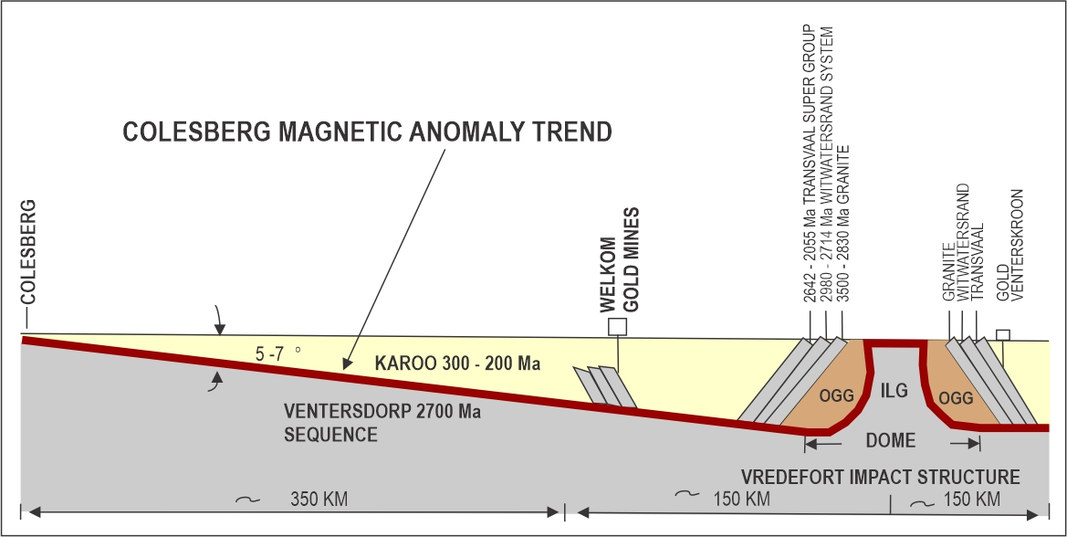
FIG. 2. Colesberg Positive Magnetic Anomaly Trend showing entry direction and slope. Note filling with Karoo ~300-200 Ma era sediments.

In all the areas where gold is mined around the outer crater, the ‘Witwatersrand Basin’, the paleoslope directions all angle down towards the central rebound dome, except for Evander (Frimmel 2005). The Vredefort Dome collar, which also has conglomerates containing gold, slopes outward away from the rebound Dome (Fig. 2). This would not allow the placer theory of gold deposition to be viable.
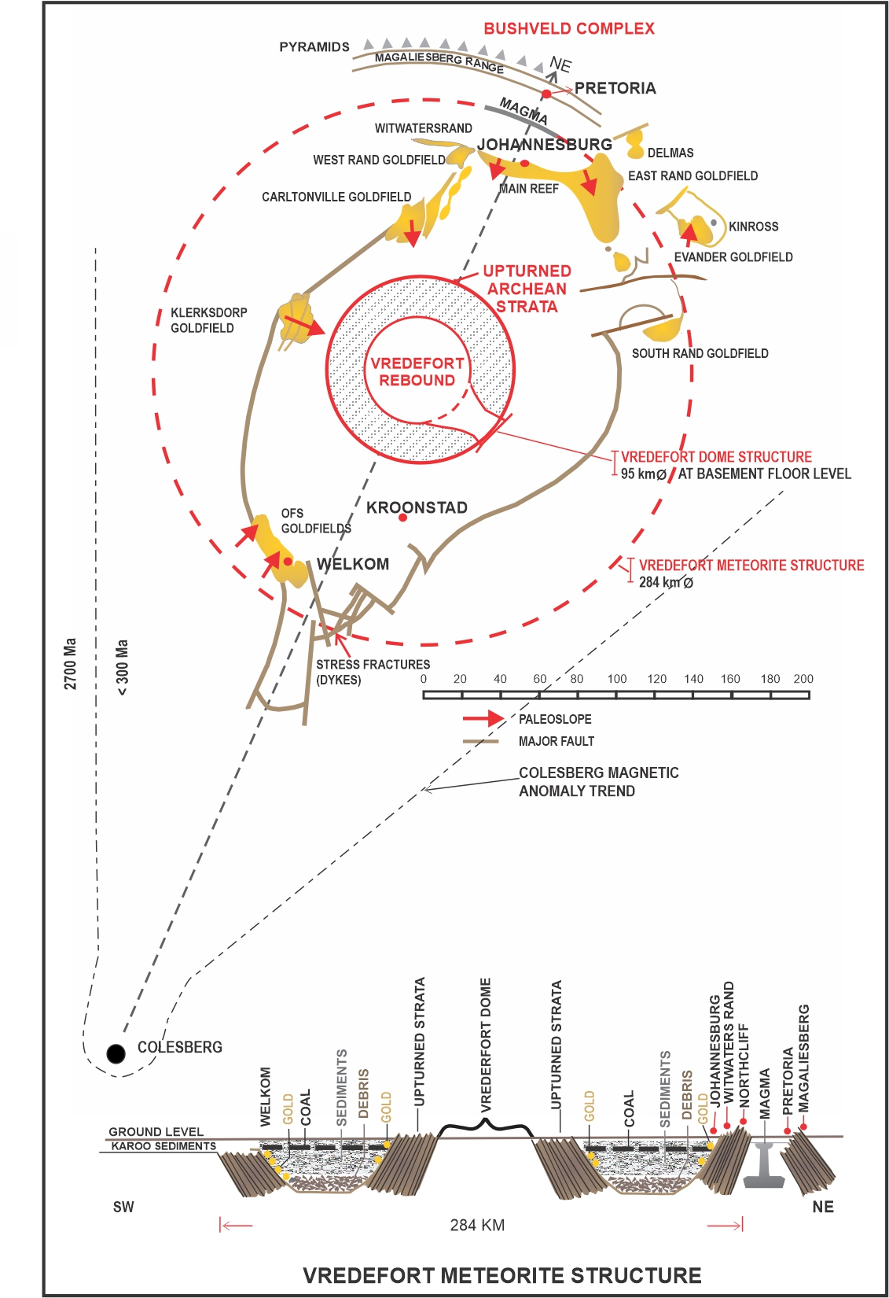
Fig 3. Vredefort Meteorite Structure & Colesberg Magnetic Anomaly Trend location
Further, the richest reef, 41,700 tonnes of gold mined from 1886 to 1987 in the Central Rand Group (Pretorius 1991) through Johannesburg, is robust, exposed, and unbroken. The total gold mined in the Witwatersrand Goldfields by 2016 was 56,000 tonnes (Chamber of Mines 2017) with reserves of about 38,000 tonnes. Besides these 150,000 tonnes of uranium oxide has been mined with the gold (Frimmel 2005).
I suggest that an approach of a string of metallic, mountain sized fragments, equivalent to a 28 km diameter meteor, would have been soundless and barely visible to any lifeforms until the final moments. Their entry speed, about 25 km/s, compressed the atmosphere ahead in a brilliant white light of 5000ºC (Struve 1950) seconds before impacting with Earth, one behind the other, at a very shallow angle of about 7 degrees (Chapter 4). They penetrated the existing 2700 Ma Kaapvaal strata starting near Colesberg, and then continued to ~ 25 km deep below the old 2642-2055 Ma strata of the Transvaal Supergroup.
The impact caused a mighty explosion of superheated vapour from the 2% water in the rock and the acoustic fluidisation of the rock itself. Material below the meteorite was driven downwards and radially outwards (Dence 1968). This blasted out a transient chamber ~136-152 km in diameter (Therriault 1997) with a depth of 52 km (Impact Effects, Melosh et al 2018) and the thick strata roof lifted with this great explosion.
As the transient crater reached maximum depth the floor came to a standstill and then began to rebound. The target floor rock was released from high pressure and, helped by gravity effects from fluid forces below, driving the crater floor upwards through the roof to a height of 29 km (Henkel & Reimold 1996). This over-heightened central peak would suffer a dynamic collapse with material sliding down into the newly formed crater.
As the crater outer wall rock rebounded, it blasted ejecta out and upward at ballistic speed allowing the walls to slump into the crater. The strata left around the crater rim and surrounding the dome tipped on edge and slid down into the crater. This is what remains today to be seen around the Vredefort rim and the central dome where the strata is nearly vertical and, in some places, overturned. (Fig. 4)
The fireball of incandescent gas, containing ejecta, vapourised gold and uranium, was blasted upwards forming a 1000 km diameter superheated mushroom cloud that lasted for over two hours (See Chapter 4, Earth Impact Effects).
Within the main Vredefort Structure chamber, this was followed several tens of seconds later by the centre of the floor rebounding upwards (Melosh 1989) and piercing the roof of remaining central sedimentary layers to form the 45 km diameter Vredefort Dome surrounded by an old upturned, and some overturned, 20-25 km thick collar of Pre-Cambrian rock (Dietz 1961).
The meteorite fragments shot through the crater in a few seconds causing an outward shock wave travelling at about 5 km/second to compress the target rock. As the shock wave passed, the rock rebounded with a residual velocity of about one-fifth, moving the target material at 1 km/second (Melosh 1989). This created the transient crater in about 1 minute blasting hot ejecta out of the crater at ballistic speed.
‘It is further estimated that the whole impact structure evolved and collapsed within about 4 minutes’ (Melosh 1989),
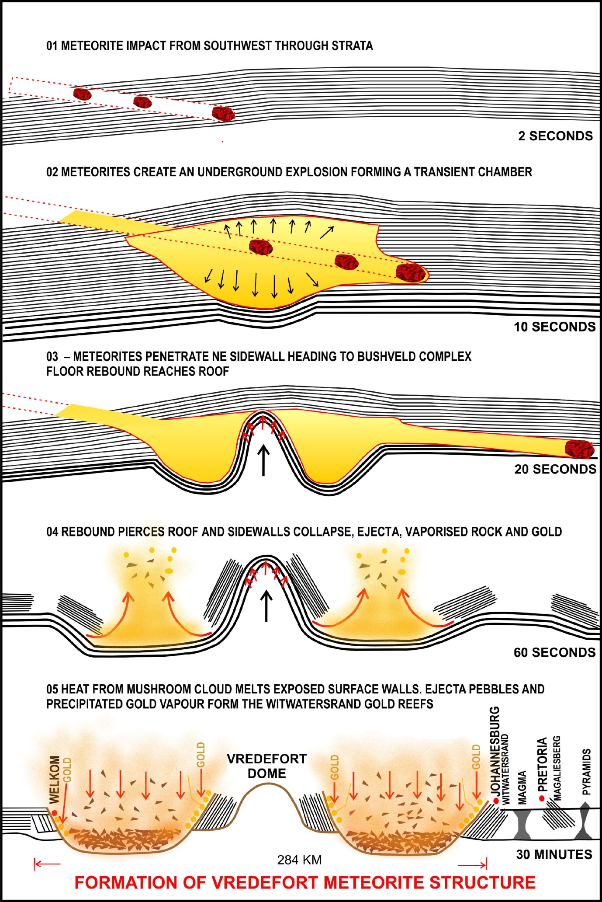
Fig. 4 Formation of the Vredefort Impact Structure.
Where the thick, old Transvaal Supergroup strata had been blasted off in a neat ring around the 146 km diameter transient chamber, the vertical chamber walls below began to decompress, ejecting small, shattered rock, to be rounded by collisions and their ballistic velocity. Slowly the remaining outer strata sheared off from the Magaliesberg in a wider ring and slumped (Turtle 2005) at 60 degrees into the crater (Whiteside, Hiemstra, Glasspool, Pretorius & Antrobus 1976) which doubled the transient diameter. This left the jagged, north-facing scarp of south sloping sedimentary layers forming the 56 km wide Witwatersrand, White Waters Ridge, rising 300 metres above the torn plain.
Today, from the Johannesburg suburb of Northcliff there is a wonderful view from the edge where one can look 30 km northwards to the 100 km wide scarp, the Magaliesberg Range, passing across Pretoria. This is the first of a series of rows of matching, south-facing, upturned concentric scarps. (Chapter 6.0 p. 26).

2.0 Earth Impact Effects, Power and Forces Involved
Purdue University has published an interesting Earth Impact Effects Program (Marcus, Melosh & Collins 2018). This simulator is used to calculate the size, speed, and other effects of a meteorite strike (Table 1).
Table 1 Data calculated using Earth Impact Effects Simulator from Purdue University.
Parameter | Value | Comment
Speed Min 17-Max 40 km/s | 25 km/sec | (Grieve 1990)
Meteor (equivalent) Diameter | 28 km | Adjust to get 284 km Diameter
Structure Rim Diameter | 284 km | (Therriault, Grieve & Reimold 1996)
Meteor density | ~8000 kg/m³ | For Iron meteorite
Target rock sedimentary | ~2000 kg/m³ | Karoo and Transvaal Group
Angle of approach | 5 Degrees | (Burchell & Whitehorn 2003)
Transient Diameter | 146 km | Earth Impact Effects Program
Transient depth | 52 km | Earth Impact Effects Program
Final depth | 2 km | Floor 15 km + debris + Tvl sediment
Volume target vapourised | 44,000 km³ (Only 8% of total in BC) | Earth Impact Effects Program
Fireball diameter | 1068 km | Earth Impact Effects Program
Radiant Energy than Sun | 1440 more | Earth Impact Effects Program
Duration of Radiant Energy | 2.2 hours | Earth Impacts Effect Program
Earthquake Richter scale | 11.2 | Earth Impact Effects Program

We have our accepted diameter of 284 km for the outer rim. Meteorite speed has been selected as 25 km/sec as ‘Asteroids strike the earth at an average speed of about 25 km/second’ (Grieve 1990). (Minimum 10, maximum 40 km/sec).
During impact this meteorite cluster dissipated energy equivalent of 6.86 billion Megatons of TNT (Earth Impact Effects Program). By calculation this is 180 billion times greater than the combined atomic bombs dropped on Hiroshima, 15 kt, and Nagasaki, 21 kt, (Malik 1985) and 137 million times greater than the largest man-made nuclear explosion on Earth, Russia’s Tsar Bomba 50 Megaton (Adamsky & Smirnov 1994).
The impacts could have shattered 44,000 cubic kilometres of the sedimentary rock and created a fireball 1068 km in diameter. If you were standing 1000 km away, where Port Elizabeth, South Africa, is today, the Thermal Radiation, 1440 times more intense than the Sun, would have incinerated you. This was followed three and a half minutes later by a seismic shock wave, with a force of 11.2 reading on the Richter scale with the resultant earthquake damaging or flattening every single structure. The air blast would arrive 50 minutes later at the speed of sound and a pressure of 50 atmospheres which would blast away any structures left standing as well as all trees (Earth Impact Effects Program). The dust and ejecta would be four metres thick one thousand kilometres away from the impact (Marcus, Melosh & Collins 2018) This red dust soaked into the existing old Rooiberg, staining it and forming the 215 Ma Elliot Formation Red Mudstone (Chapter 15).

3.0 Asteroid Belt, Metallic Meteorites and Multiple Impacts
3.1 Asteroid belt
Every day, hundreds of thousands of meteors burn up in the Earth’s atmosphere, most millimetres in size (Parkes 2018). About every 100 years, one that is metres in diameter almost reaches the ground resulting in serious local damage such as that in Russia in 1947 (Struve 1950). Apollo objects, asteroids or comets whose orbits pass through the Asteroid Belt, average 1 km in diameter. They reach Earth about once every 250,000 years leaving a 20 km diameter crater (Wetherill 1979). About every 100 million years a meteorite of more than ten kilometres in size will cause worldwide damage that could cause mass extinction. The Vredefort Meteorite cluster of planetary core material that impacted earth should be a once in Earth’s lifetime event (Marcus, Melosh & Collins 2018) and should theoretically only have occurred during planetary formation 4500-4000 Ma (Elkins-Tanton 2016).
Planetary formation started some four and a half billion years ago. Not, as has long been accepted, with a gentle accumulation of dust and gasses, but a far more violent formation, with planetoids forming and then crashing together. These planetoids have even been shown to generate enough internal heat to melt and form metallic cores as the denser materials sink to the centre. Gradually fewer and larger planetoids form, crash together and reform until one is left large enough to survive and sweep the orbit clear, absorbing the debris. This then becomes the planet (Elkins-Tanton 2016) (Fig. 5.)

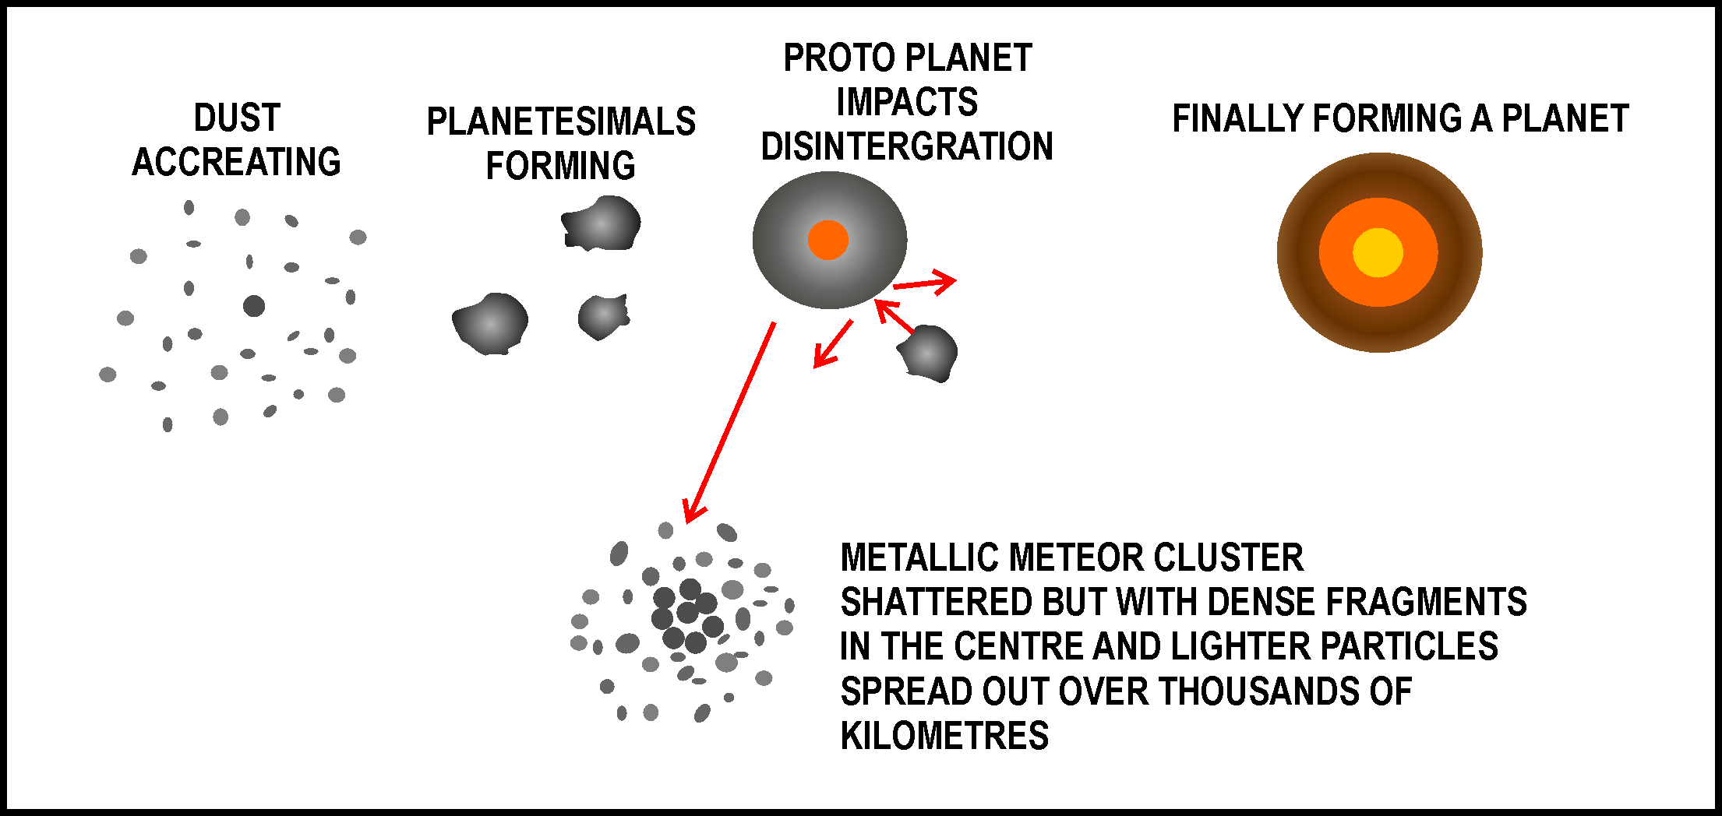
Fig. 5. Planetary formation
However, planetary formation in the solar system was successful except for that unstable area between Mars and Jupiter where today there are more than 400,000 objects greater than one kilometre in diameter (Wetherill 1979). This is the Asteroid Belt which is left with a relatively small amount of material, the remnants of planetesimals or the remains of one or more successful planets that were later smashed to smaller fragments. About 85% of the remains are chondrites, stony objects (Wetherill 1979), but M-types are rich in minerals which would have originated from a core. ‘Most irons… are interpreted as fragments of cores of about 50 large ancient bodies that have been shattered by impacts’ (Bonin 2012). An example of this is the 226 km diameter nickel-iron asteroid known as Psyche which is expected to be visited by a NASA mission in 2021 (Elkins-Tanton 2016, Schroeder 2018).
Planetary scientists now accept that a collision took place in space with an asteroid known as the L-Chondrite Parent Body (LCPB), about 150 km in diameter. Common fossil meteorites (1 to 20 cm large) in roughly 470 Ma sediments confirm the breakup and still now 30% of all meteorites impacting Earth are from the LCPB. This largest documented breakup in the past 3000 million years shattered the asteroid leaving a huge dust cloud that reduced sunlight as dust fragments were drawn towards Earth and the Sun. Some of this dust settled on Earth leaving traces of chromite, nickel, and iron in layers of strata from Siberia to Gondwana giving them the dating. It also showed that this dust cloud had a cooling effect for more than 2 million years causing a prolonged ice age, lower sea levels, and fauna diversification. Fine dust appeared first in the record, followed by larger grains due to the Poynting-Robertson drag effect. (Schmitz, Farley, Goderis, et al, 2019). For the metallic core, this drag would have minimal effect or the impact could have slowed it down to take a few hundred million years to reduce its orbit. It is interesting to note that if we compare the ratio of core diameter to outer diameter of Earth to the core of the 150 km original LCPB it works out to 29.9 km! As the Vredefort meteorite was calculated at 28 km diameter using ‘Earth Impact Effects’ this is quite a coincidence. This means that the remaining, shattered metallic core of the LCPB could be the smoking gun for the Vredefort Meteorite Group at 215 Ma, but not at 2020+ Ma.

3.2 Metallic meteorites
The relationship between meteorites and minerals is well established. For example, it is always possible to find out which rocks come from meteorites by the abnormal amounts of metal in them, such as iron and nickel. These high-density metals would not be on the surface of the newly formed, still molten Earth. Rather they would sink through the melt and travel downwards to the centre of the planet. Once there they would not return to the surface as a dropped stone would not return to the surface of a pond. After the Earth cooled and a crust formed, metals found on or near the surface have come from space as the crust prevents them from sinking to the core. Deep volcanoes or mantle plumes only have trace amounts of minerals and are mainly made up of lava, molten rock from the Earth’s mantle.
These high-density metals are called siderophiles (iron lovers), as they would like to join the high-density iron at the core of a planet. For this reason, an elevated concentration of siderophilic metals in impact melt rock is a good indication of meteorite activity (Alvarez & Asaro 1990). Most of the metallic elements in and around the Vredefort Structure, Bushveld Complex and the Great Dyke, include gold, chrome, platinum, PGMs, cobalt, manganese, vanadium, nickel, and iron, are siderophilic. ‘25% of known terrestrial impact structures are associated with economic mineral deposits’ (Grieve & Masaitis 1994, Grieve, 2005)

The following impacts bear this out:
- Sudbury, Ontario, Canada, 250 km diameter, 1849 Ma, where they mine large quantities of nickel and copper as well as cobalt, silver, gold, platinum and palladium as by-products plus other non-economic minerals (Osinski, Grieve et al 2018)
- Rochechouart, France, 20 km diameter, 207 Ma, Nuclear analysis indicated Ir, Os, Re, Au, Pd, Ni, and Ge. These siderophile elements prove that impactor was an asteroid. (Janssens, M-J., Hertogen J., Takahashi H., Anders E., Lambert P. 1977)
I propose that the Vredefort, Bushveld Complex and Great Dyke cluster of metal-rich meteorites which left a legacy of the world’s greatest deposits of minerals have come from remnant core material of some shattered planetoid, ‘the remains of which are now likely to form the Asteroid Belt’. (Struve 1950). (Refer back to Chapter 3.1 Asteroid Belt, L-Chondrite Parent Body (LCPB), 466 Ma).
It is also stated that ‘most irons are related to M-Type, metal-rich, asteroids and interpreted as fragments of the cores of about fifty larger ancient bodies that have been shattered by impacts’ (Bonin, 2012). Note that the LCPB which broke up in about 466 Ma would have had an iron-rich core. If this core or fragments thereof impacted Earth, they would be classified as M-Type meteorites.
3.3 Multiple impacts
It now appears that many of these asteroids are not alone on their long journeys through space. Besides the multiple Shoemaker-Levy-9 Comet impacts with Jupiter in 1994, it does appear that meteors often fragment into separate pieces when in near-Earth space before entry. In Russia, 70.3 Ma, the Kara astrobleme left a 65 km crater and its sister Ust- Kara left a 25 km diameter crater. These two impacts resulted from the same meteor that broke into two bodies shortly before contact with Earth (Shumilov 2020).
An asteroid, P/2013 R3 was seen to break up into 13 discrete pieces between October 2013 and February 2014. Pictures were captured on the 2.4 m Hubble Space Telescope, the 10 m Keck, 6.5 m Magellan and the 8 m Very Large Telescope (Hapgood & Rothwell 1981).
I hypothesise that the Vredefort Structure + Bushveld Complex and the Great Dyke are also the same age, created within minutes, of each other.
Between 280 Ma and 200 Ma, southern Africa was lying on its side, rotated clockwise relative to now (Hurley 1968, Veevers 2004, Moorbath 1977 & a series of graphics from the Senckenberg Museum). This positioning, combined with up to 23 degrees of obliquity (angle at which the celestial equator intercepts the ecliptic), would allow meteorites from other parts of the solar system to impact southern Africa from west to east. It is also unlikely that southern Africa would have been in a location and rotation on Earth to create three separate, once in a solar lifetime, events, adjacent and perfectly aligned west to east as they were in 215 Ma with each other and the planetary plane. (Fig. 6)
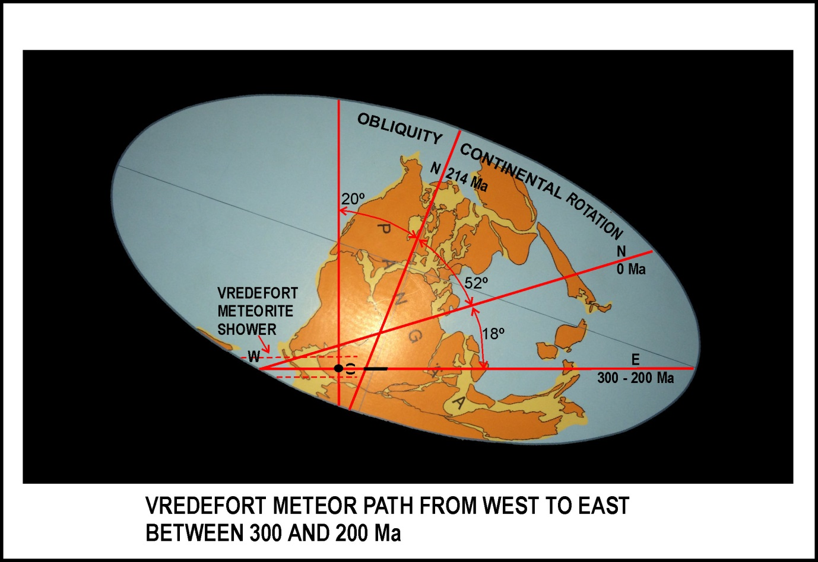
Fig. 6. Vredefort/ Great Dyke Meteorites impacting West to East between ~300-200 Ma
In the previous version of Meteorites, Minerals & Merensky published in 2018 I included the Manicouagan Cluster of impacts as an example of multiple impacts (Spray, Kelly & Rowley 1998). Detailed examination of their ages has since shown that these five impacts were not connected. I have also withdrawn a connection between Manicouagan and Vredefort taking place as Vredefort is distinctly oval indicating a very oblique impact, whereas Manicouagan is round. Sorry.
To get back to the unlikely proposition that three individual meteorite events, separated by millions of years, had resulted in impacts at Vredefort 2020 Ma, Bushveld Complex 2055 Ma and the Great Dyke 2575 Ma, there would have been a 70% chance for each of them to have landed in the ocean, the remains never to be seen again, and very little chance that they would be metallic, as 85% of meteorites are stony (Wetherill 1979). This means that of all meteorites that collide with Earth only 3.75% are terrestrial metallic impacts. Oblique impacts, <15 Degrees, are also very rare, leaving non-circular craters that are only seen in about 5% of all large Solar system bodies (Burchell & Whitehorn, 2003). This would give the metal rich Vredefort and the Great Dyke a minute chance of being separate impacts in location and time.

4.0 Simple, Complex and ‘Penetrative’ Craters
4.1 Simple meteorite crater
If the meteorite is less than about one hundred metres across, it forms a simple crater (Fig. 7a) when it collides with Earth. This impact makes a crater in the form of a bowl. The shock waves compress the target rock then the release wave melts, vaporises, and blasts out ejecta; molten rock as well as debris from the meteorite itself. On Earth these craters can reach a maximum diameter of about 5 km and depth of about 1 km (Grieve 1990). The immediate or transient diameter of the crater is smaller than the final size as the steep walls slide into the cavity, but the transient depth is greater as the final cavity is partially filled with debris and melt.
A well-known example of a large simple crater is the Meteor Crater (formally Barringer) in the Arizona desert in the USA. The iron meteorite was estimated to be about 60 metres in diameter, weighing a million tons and leaving a crater 1.2 km in diameter and 170 metres deep. The age of Meteor Crater is 60 ka (Schmieder & Kring 2019) and the meteorite dissipated energy of about 5 mega tonnes of TNT.
4.2 Complex meteorite crater
When meteorites are larger than about a kilometer in diameter and travelling in excess of 20 km/sec the impact compression followed by reflected rarefaction of the shock wave excavates a transient cavity, deep enough for reflection waves and gravity to help rebound the centre like a stone dropped in water (Grieve 1990) (Fig 7a). With large complex craters the transient depth is deep enough to penetrate the Earth’s brittle crust to an area in which plastic deformation takes place. The reflected rarefaction wave with shock and gravitational effects can raise the central rebound core to great heights in seconds before it partially collapses (Fig 7b). Such a cratering process is possible only because of a temporary reduction in friction in the fractured rocks surrounding the growing crater’ (Ivanov 2005), and ‘The reduction in friction can be described in terms of the acoustic fluidization model’ (Melosh & Ivanov, 1999)
After ejecta is blasted out of the transient cavity the walls and rebound core collapse and debris slumps down into the newly formed jelly-bowl shaped crater. The final crater floor is not as deep, relative to width, as simple craters and usually contains one or more concentric floor rings which Richard Grieve called ‘ripples’ (Grieve 1990), as opposed to the additional inward facing ‘scarps’ beyond the outer rim.
Examples of complex craters on Earth are Sudbury, Ontario, Canada, 200 km diameter, 1849 Ma, Chicxulub, Mexico, 180 km diameter, 66 Ma and Manicouagan, Quebec, 100 km diameter, 215 Ma (Schmieder & Kring 2019).
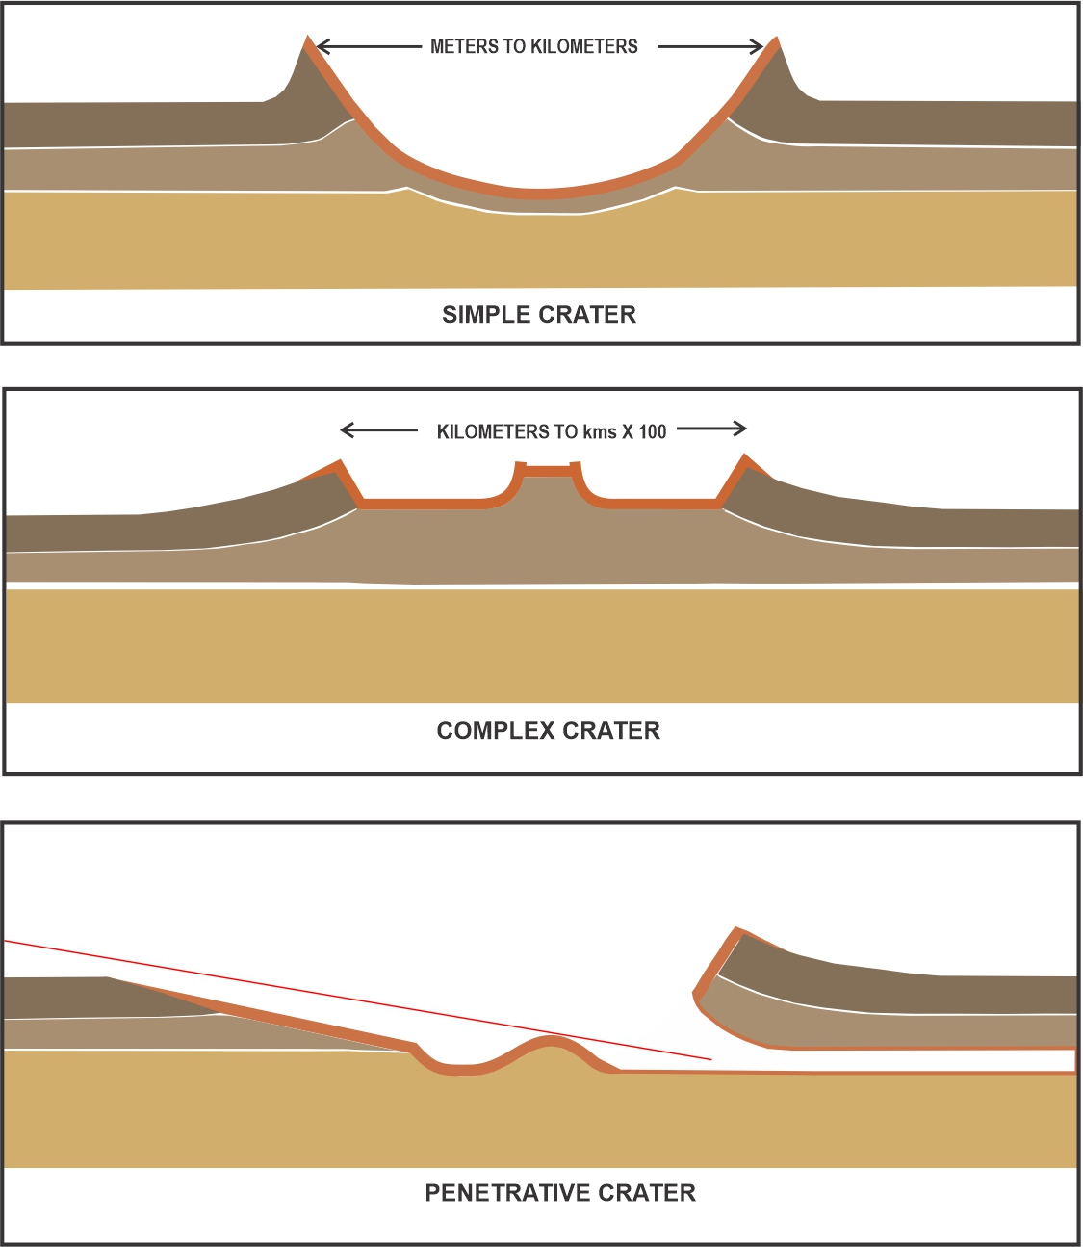
Figs. 7 a, b, c Crater formats
4.3 Penetrative Meteorite Crater
My hypothesis is that there is a third category that should be considered. This type of structure would result from a meteor impacting Earth at a shallow angle of < 15º (Fig. 7c). In the cross-section of Meteor Crater, it is seen that the meteorite impacted at an angle estimated to be about 30 degrees. One side has a higher rim and from borings made here this is found to have a deep pocket of shattered rock (Beals 1958). This profile is mild compared to that which we have from the Vredefort Structure where an asteroid penetrated from the current south-west (Dietz 1961); this was hundreds of kilometers before Welkom as indicated by the Colesberg Positive Magnetic Anomaly Trend (Drennan, et al 1990) (See Figs. 2 & 3)
I suggest that this penetration resulted in the side entry of mafic-ultramafic material into the Bushveld Complex (Kinnaird 2005, Mungall, et al., 2016). I also propose that The Great Dyke across Zimbabwe is a grazing penetrative impact from a separate, smaller fragment.
Vredefort is also non-circular to such an extent that the ellipticity (length/width) is about 2.0 when you follow the gold and stress fractures (Frimmel 2005). This figure could only occur if the oblique incidence is less than 15 degrees to the ground and these only occur in about 3-5% of craters on Venus, Mars, and the Moon (Burchell & Whitehorn 2003). There is also ‘a low amount of projectile contamination in lithologies [that] may reflect an oblique impact’ (Tagle, Erzinger, Hecht Schmitt, Stoffler & Claeys 2004) referring to Chicxulub Crater. It is interesting that Vredefort is oblique and has no signs of true impact melt or ejecta. However, I believe that the gold and uranium lining the crater came from vapourised, then precipitated, fragments of the projectile with the balance of minerals penetrating through to the Bushveld Complex and Platreef at temperatures that did not exceed 900⁰ C.
My examples of penetrative meteorite craters are the Vredefort Impact Structure, 284 km diameter which is complex and penetrates a total distance of ~1040 km, and the Great Dyke in Zimbabwe, 550 km long, which is purely penetrative.

5.0 Penetration through Geological Rocks
How it is possible for a meteorite, or fragments thereof, to penetrate horizontally below ground level? The signs are that the Vredefort Meteorite travelled underground for 1040 km through the sedimentary target strata from Colesberg, south of Welkom to beyond Polokwane and another large particle formed the Great Dyke 550 km long not far below the surface across Zimbabwe.
Firstly, they need to be metallic. Chondrites, stony meteorites, would disintegrate close to the impact zone. As the Bushveld Complex contains over 100,000 billion tonnes of metals including 6 billion tons of chrome, as well as all the iron, manganese, vanadium, platinum and other minerals (Vorster 2001), this would make an excellent projectile. It also makes no difference that the penetrating minerals would become fluid at some point in its journey as it has been shown that most projectiles become fluid above the speed of the shock wave through themselves but continue to penetrate in a hydrodynamic manner (Charters 1960).
Hydrocode modeling of oblique impacts indicates that a metallic core is stretched out between 10 and 100 times, increasing with decreasing angle of entry (Kendall and Melosh 2016 p38). Hydrocode simulations with a 100 km diameter iron core at 45º and 11.5 km/sec resulted in a metallic core penetration on the Moon of about 1600 km (Kendall & Melosh 2016).
Our 28 km fragmented metallic core at 25 km/sec should penetrate ~1000 kilometers.
Even a simple, basic calculation of penetration by Newton, which works for hypersonic velocities, meets these criteria for an oblique <10⁰ impact such as Vredefort.
Depth of penetration = Length of projectile x (Density projectile/Density target)
Length of projectile at 28 km (diameter) and elongated to 10-100 times when penetrating.
Density of projectile estimated at 8 t/m³ and sedimentary rock 2 t/m³
Depth of horizontal Vredefort penetration = 28 x10 x (8/2) = 1120 km.
And for the Great Dyke = 14 x 10 x 8/2 = 560 km
This is the low end of the elongation estimate and ties in with the Vredefort meteorite impact beginning at Colesberg and coming to a wobbly stop at the top of the Platreef, north of Polokwane, distance of ~1040 km and the Great Dyke smaller meteorite fragment entering near West Nicholson in Zimbabwe and coming to a stop near Casembi on the border with Mozambique, about 550 km and ending in a ‘snakes head’.
Secondly, there needs to be sufficient energy to drive this projectile for hundreds of kilometres through old, sedimentary rock. This would require mass and speed. Einstein came up with Energy = Mass times Speed squared. Think about an anti-tank kinetic projectile, roughly 700 mm x 25 mm, weighing about 6 kg. This is travelling at about 1500 m/second which can penetrate 700 mm hardened steel armour (M829A3 2016).
With the hypervelocity kinetic weapon and hypersonic cruise missiles research projects being carried out, the damage mechanism for high velocity/hypervelocity projectile impact on semi-infinite targets has become the research keystone in impact dynamics’ (Sun, Shi, Lui and Wen 2015) and impact at Mach 15, about 5 km/second (Xu et al 2021) can penetrate any current warship, submarine, or concrete structure without explosive charges.
Our Vredefort projectile cluster has a mass ~160 billion times more and a speed 5 times higher. This makes the energy 4,000 billion times greater! The impact had the kinetic energy to dissipate about 25 Megatons TNT per meter travelled and an impact pressure of 60-100 G Pa (600,000- 1 million Atmospheres) at post-shock temperatures of 1500-2500 ºC (Stoffler & Grieve 2007). This is certainly sufficient to drive the Vredefort projectiles through the sedimentary strata for 1040 kilometres and the Great Dyke for 550 km.
In laboratory experiments, the small projectiles lose mass shortly after entry bringing the penetration to a halt. Despite this Newton is still valid for hypervelocity penetration calculating 86.5 mm penetration for a measured 70.32 mm penetration (Lu, Zhang, Xue, Guo, Shang, Liu, Ren & Long 2021). ‘It can be concluded that with increasing the diameter, the projectiles will suffer less relative mass loss than smaller projectiles at the same velocity, which indicates that the mass loss may less influences [sic] the penetration efficiency of large, scaled projectiles. (Yang, Jin, Zhang, Wang & Wang, 2017). In the hydrodynamic state ‘the projectile as a whole enters the plastic flow state and can be regarded as a steady state fluid. The projectile mass is entirely lost at the end of penetration’ (Xu, Qui, Li, Cheng & Chen 2021).
With large projectiles such as the Vredefort meteorite there is sufficient material to have mass loss due to friction and still make the full distance. Vredefort meteorite minerals, such as large amounts of iron, manganese, chrome, vanadium, and PGEs are spread out across the Bushveld Complex to the end of the Platreef. The same goes for the Great Dyke with minerals spread out from about 50% from the start of the Dyke as far as the ending at its ‘Snakes Head’.
In the Vredefort/ BC and Great Dyke, with multi-billion tonne metallic meteorites at hypervelocity, the now fluid or fragmented projectiles could separate into various elements ‘As a result of fractionation processes resulting from the depositional environment or as a product of ballistic fractionation’ (Tagle et al, 2004 referring to PGE at Chicxulub Crater). The radiating shock waves from the penetrator pass through the surrounding rock resulting in a process of acoustic fluidization, ‘...making coherent rocks behave like a liquid without melting’ (Melosh 1979, 1996 and Spray 2016

6.0 The Scarps of Upturned Strata, Magma Dykes and Caves
6.1 The scarps of upturned strata
The chrome and other minerals in the meteorite fragments did not disintegrate on impact or in the explosion under the Vredefort structure. Because of their size, metallic content, and the shallow angle, they penetrated almost parallel to the Earth’s surface and travelled hundreds of kilometres underground towards the north-east in less than a minute. These hypervelocity penetrations would have converted some of their immense kinetic energy into heat, melting the projectiles in seconds as pressure was converted to heat. The large amounts of metallic penetrator residue, shattered host rock from acoustic fluidisation and magma from shock heat then ploughed on through the sub-surface creating 100 km wide waves of uplifted concentric scarps, hundreds of metres high, alternating with west-east dykes of newly erupted hot magma (molten rock) as they went (Fig. 8).
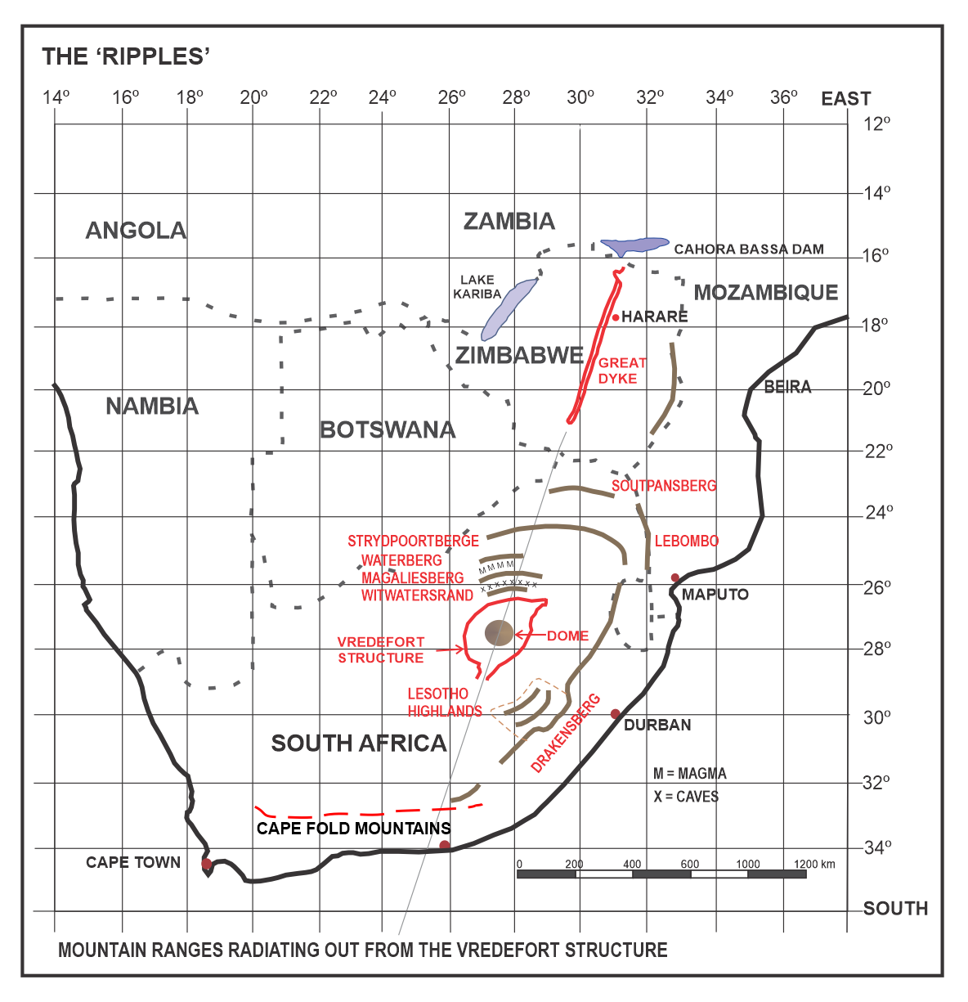
Fig. 8 Cape Fold Mountains then scarps radiating out from Vredefort like ripples
Eventually the tail end of the molten projectiles lost energy, slowing down to hydraulically intrude horizontally between layers of sedimentary rock to form the basis of the Bushveld Large Igneous Province. (Chap. 10) Some of the leading, metal rich, molten mineral fragments continued past the Bushveld Complex to come to a squiggly stop north-west of Polokwane. However, the scarps did not stop there as the seismic shock waves below the sedimentary crust radiated outwards to the north thrusting up more mountain ranges as they went.
The north-eastern outer rim of the meteorite crater is the 300-meter-high Witwatersrand, stretching 56 km from Krugersdorp in the west through Johannesburg (Northcliff) to Bedfordview in the east with sedimentary slabs, jagged on edge, facing north and sloping steeply back where they had slumped into the crater. The 100 km wide scarps that spread outwards through the crust to the north left us with the south facing Magaliesberg, Waterberg, Strydpoortberge, Soutpansberg and Lebombo mountain ranges. The distance from Vredefort Dome to the outward facing scarp of the Witwatersrand, which slumped into the crater, is roughly 120 km. The next four scarps have cliffs facing the Dome. From the Witwatersrand it is 65km to Magaliesberg, 105 km to Waterberg, 120 km to Strydpoortberg, 175 km to Soutpansberg and 350 km to Lebombo Mountains in the east which head south along the coast to join the Drakensberg Range.
To see an example of this we need to look at Orientale, a large multi-ring basin on the Moon’s western limb. ‘Orientale possesses at least five circular rings that form inward-facing scarps up to 6 km high’ and ‘up to basins with an internal mountainous ring and, on some bodies, exterior scarps that encircle the impact site’ (Melosh & Ivanov 1999)
6.2 Magma dykes
Midway from Johannesburg to Pretoria, between the Witwatersrand and Magaliesberg ranges is a twenty-kilometre wide west-east seam of hard, blue, igneous, dolerite rock which is mined in huge quarries at Diepsloot and Midrand for crusher stone.
Beyond Pretoria, on the N1 you can turn west on the N4 route along the valley floor north of the Magaliesberg Range. Here you will follow a 100 km long string of pyramid shaped hills stretching all the way past Rustenburg. These pointed hills contain the sought-after Pyramid Gabbronorite; a dark-coloured inverted pigeonite bearing gabbronorite. This is commonly known as Impala black marble. The Reserve Bank building in Pretoria is clad with this product. In the village of Pyramid on the R101 route you can see a hundred-metre-high cross-section in a rock quarry showing slabs of sedimentary rock that were lifted by the magma without melting them. Pigeonite breaks down at 900º C which indicates the temperature limit for this magma in the Bushveld Complex.
6.3 Caves
The shock wave from the meteorite impact radiated outward, compressing the underground sedimentary strata. This was followed by a rebound that can tear rock apart to form massive cave systems. Signs of these remain in long valleys alongside the Witwatersrand, most of them now flooded. This aquifer stretches from the town of Springs, east of Johannesburg to Botswana in the west. The water stored is about the same as contained in Lake Kariba (Turton 2012), an amount of 181 cubic kilometres (World Bank 2018).
Until 1938 when the Vaal Dam was built, Rand Water pumped its utility supply for Johannesburg out of this aquifer at Zuurbekom, near Lenasia. Mines to the west of Johannesburg could only sink shafts after the development of cementation in 1925 to get through these flooded caves and others have had to pump hundreds of thousands of tons of a cement-minedump-sand mix into the caves to control flooding.
To the west, sinkholes are a huge problem, even swallowing an entire mine reduction plant in 1962 at West Driefontein with the loss of 29 lives and a house with the entire Oosthuizen family at Blyvooruitzig in 1964.
A team from the University of Johannesburg has now examined the recently discovered Armageddon Cave. This is 4 km long, 50 m wide and 260 m deep in the West Rand area that has not flooded. Researcher, Pedro Boshoff from the University of Johannesburg, says that the shock waves would have compressed the strata along the Witwatersrand and then suddenly released causing low angle slip faults with rock layers shearing past each other. He has made the connection with the Vredefort impact and therefore concludes that this giant cave is 2023 million years old which would make it the oldest cave on Earth by far (Tucker 2015). The previous oldest is the Jenolan Cave in the Blue Mountains to the west of Sydney, Australia, which is dated at 340 Ma (Armstrong and Osborne 2007).
The problem with Armageddon being dated 2023 Ma is that the area where all these caves occur was below 4 km of ice during the period 302-288 Ma (Bangert 1999) when Gondwana was over the South Pole. If this did not collapse the caves, the following glaciers that scraped off the surface and left the Dwyka debris would have. This would mean that the caves must be younger than 288 Ma. If the Vredefort Meteorite struck the ground after the glaciers and the Ecca strata had been formed, then the age of ~288-200 Ma makes more sense.

7.0 Witwatersrand Basin, World’s Largest Deposits of Gold
The almost 300 km diameter Vredefort Structure rim is surrounded except the buried south-east by the world’s largest accumulation of gold mines. This can be seen on the Geoscience Gold map (Vorster 2001). One hundred and thirty years of mining from the Witwatersrand goldfields has produced more than half of the worlds’ gold, over 56,000 tons (Chamber of Mines 2017). They still have the largest reserves in the world although current levels of newly mined gold accounts for only 5% of worldwide production. Now that the deepest mines are below 4 kilometres, the costs of mining and safety of workers limit the depth of gold extraction.
Although the Vredefort Structure fits perfectly into the Witwatersrand Basin with its sloping sides, where sedimentary layers slumped into the crater (Turtle & Melosh 1996) then coated with fine gold in pebble conglomerate. This was aged at 2040 Ma (Rundle & Snelling 1997). However, this age is contested on the grounds that it was only dating the host rock grains between the pebbles (Law & Phillips 2006). Richard Grieve & Ann Therriault said, ‘The deposits are at least partly syngenetic with respect to the impact event’ (Grieve 2000), meaning that the gold appeared at the same time as the meteorite impact, although no suggestion is made as to its source. Richard Grieve and Wolf Uwe Reimold pointed out that the Vredefort Impact Structure ‘encompasses the entire Witwatersrand Basin and the associated world-class goldfields’ (Grieve, Reimold, Morgan, Riller & Pilkington 2008)
Within the Vredefort Impact Structure, gold, mainly as fine fragments less than 0.5 mm diameter is found embedded with a variety of ~25 mm round pebbles in a conglomerate of quartz (Whiteside, et al. 1976). This is associated with the entire structure cavity excluding the interior of the rebound at the Vredefort Dome. The gold reef lies on top of old Transvaal Group sediments which slumped into the Vredefort Structure cavity, sloping at about 60 degrees to the south at the surface of the Main Reef in the vicinity of Johannesburg, decreasing to about 15 degrees at a depth of three kilometres (Whiteside, et al. 1976). The walls of the entire original ‘jelly bowl’ from Welkom to Klerksdorp to Johannesburg and Springs are lined with fine gold It is probable that the original floor at 8-15 km deep is also lined with gold as this metal occurs on some of the outside steeply sloping strata walls of the remnant rebound core (Vorster 2001). This would preclude the Placer Theory of deposition. (Visit Venterskroon to see the old gold mining sites with conglomerates).
I suggest that when the meteor cluster penetrated the Earth’s atmosphere at a shallow angle from the current south-west, the fragments of gold were already heated from friction. After penetrating the Earth with other larger, higher melting point minerals they melted first and were vapourised with moisture in the underlying strata forming a huge underground chamber. When the roof of this chamber collapsed in a ring at the edge of the transient cavity, the vapourised gold was blasted out with other shattered rock and ejecta. The rebound lifted the supracrustal strata forming an upturned collar around the dome and, as the transient wall collapsed, the outer ring of strata slumped into the newly formed Vredefort Impact Structure.
Seconds after the crater formation, the ring of fire, with its mushroom cloud and radiant energy, 1400 times greater than received from the sun (See Earth Impact Effects), melted the upper surfaces of the exposed, steeply angled strata surfaces lining the crater, turning silica rock into molten quartz. A shower of hot, round ejecta pebbles rolled into this melt combined with fine grains of precipitated gold and uranium to become imbedded, forming the conglomerates of Witwatersrand Gold Reef, the richest in the world (Fig 9). Jonathan Law suggests precipitation as a possibility ‘to generate round mineral shapes’ and that ‘Irrespective of the origin of the gold, the compositions and compositional ranges of all grains are similar, requiring either a remarkably homogeneous source terrane of detrital or post depositional control on gold compositions. He also points out that ‘None of the existing arguments for the Witwatersrand mineralization unambiguously support a placer or modified placer model for the mineralization’ (Jonathan Law and Neil Phillips 2006). Meteor Crater in Arizona was believed to contain a metal core, but the only iron found was in minute spherules that precipitated down onto the surrounding countryside.
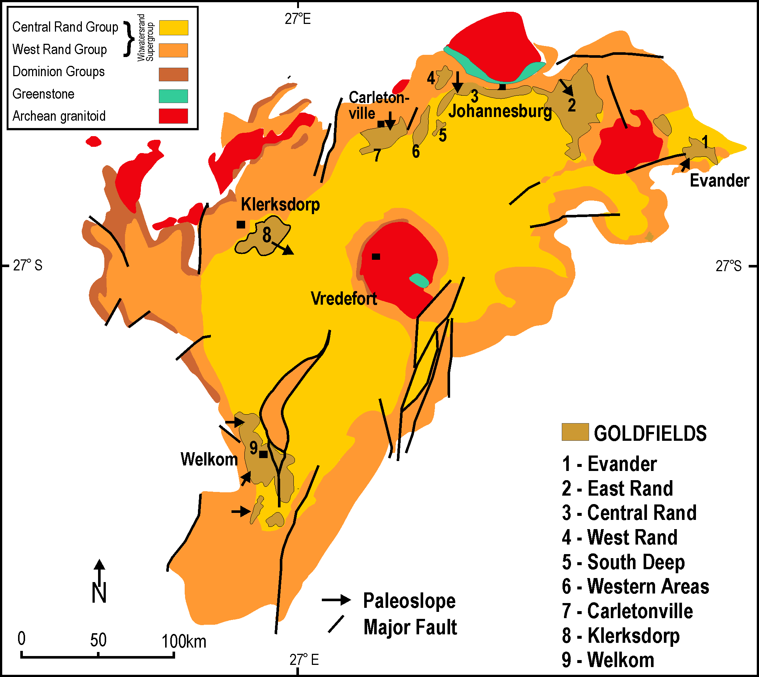
Fig. 9. Locations of the Witwatersrand Goldfields surrounding the Vredefort Impact Crater

In South Africa some of the vapourised gold was deflected to the north and north-east by the remains of the surge wave from the initial explosion causing fine fragments to rain down in the Mpumalanga and Limpopo provinces, and to this day, you can still find Zimbabweans panning for those small specks of gold in the streams in the vicinity of the Great Dyke. It is well known historically that this area was a great source of surface and alluvial gold that was exported via the Mozambique coast by Arab and then Portuguese traders. Hans Merensky’s missionary/mapmaker father, Alexander, located the area of the lost city, Great Zimbabwe, by reading logs recorded early by Portuguese Captains (Lehmann 1959). This great stone complex was known as a gold trading centre from 700 to 1100 AD (Gayre of Gayre 1972).
Geologists still write about gold that was placed in reefs on the walls of the Witwatersrand Basin lake by age old river deltas as paleoplacer deposits or welled up out of the crust as hydrothermal deposits (Therriault, Grieve & Reimold 1996).
In the 1990s, geologists said that the long-held belief that the placer source of gold and uranium from the very old greenstone granite was not possible as the mineral composition was not the same and there was just not enough to be a source of the rich Witwatersrand Gold Reef (Pretorius, 1991). A recent paper states, ‘If the placer model is correct, which granite-greenstone source rocks provided what amounts to ten times the total gold ever mined from all comparable terrains globally?’ and ’One of the arguments the “placerists” use against the hydrothermal model is: why are only the conglomerates significantly mineralized if hydrothermal fluids bearing gold in solution percolated through the entire stratigraphic sequence?’ (Bruce Cairncross 2021).
I suggest that the reason for overlooking a meteoritic source of gold was that until about 1980 the Vredefort Dome was considered to be the full size of the impact crater. Such a simple crater did not match up with the Witwatersrand Gold Reef and therefore could not be considered. No one has returned to the enlarged complex crater to examine why the gold coats the inner walls of the rim as well as the outer walls of the rebound in such a rich, uniform manner. I propose that the gold and uranium came from mineral rich core fragments of the Vredefort Meteor cluster which had penetrated many kilometers under Vredefort exploded through the sedimentary roof as vapour then precipitated and rained down with ejecta on to the exposed hot roof.
A few million years of sedimentation, followed by coal formation and then more sedimentation topped up the remnant crater (Chapter 17) and sealed the gold reef, protecting it.

8.0 The Bushveld Complex, World’s Largest Deposits of Chrome, Platinum, PGMs, Vanadium, Vermiculite and Andalusite
The Bushveld Large Igneous Province is believed, since the 1990s, to be about 2055 million years old (Scoates & Friedman 2008). Using U-Pb and Zircon dating for the age and thermal modelling for the emplacement period it is said to have accreted in a short time, within less than 70,000 years (Cawthorn & Walraven 1998). I believe that this was a much shorter time period.
This Bushveld Complex begins at the north-east edge of the Vredefort Structure and is the largest known layered igneous intrusion in the Earth’s continental crust. It comprises massive emplacements of intrusive rock with high levels of base metals and the world’s largest deposits of platinum-group elements, chrome, and vanadium resources (Reimold & Koeberl 2014) which solidified without erupting through the Earth’s surface. It covers 65,000 square kilometers (Eales & Cawthorn 1996) and is estimated to contain up to one million cubic kilometers of intruded magma. No one knows where this huge amount of magma comes from but, ‘A 300-km-radius crater in 75-km-thick lithosphere can create 10⁶ km³ of magma from instantaneous in situ decompression of mantle material with a potential temperature of 1300⁰C’ however, the authors say that ‘Chicxulub, Sudbury, and Vredefort – are not large enough to create flood basalts according to our model. (Elkins-Tanton & Hager 2005). I suggest that an oblique impact and hypervelocity penetration was not considered.
There are two crescent-shaped ‘brackets’ of dark, mineral-rich mafic rock, exposed at their outer edges and sloping down towards the centre at 10-20 degrees. The middle of the Bushveld Complex (Fig. 10) lies exactly on the line from the Vredefort Dome to The Great Dyke across Zimbabwe.

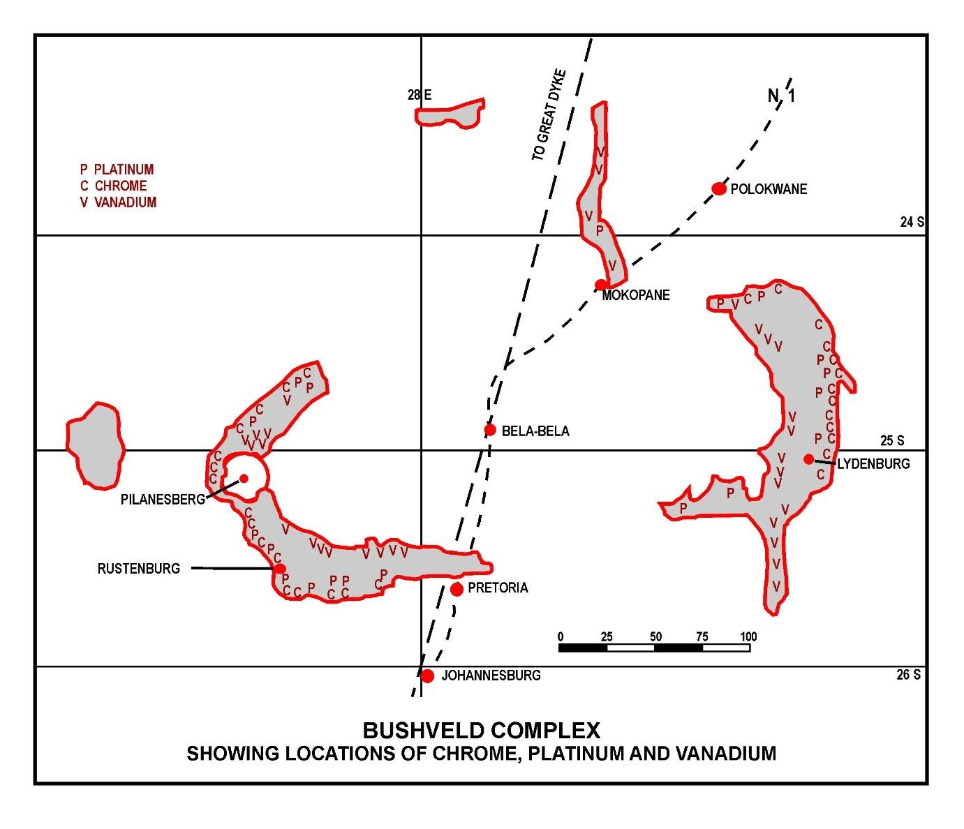
Fig. 10. Bushveld Complex showing locations of chrome, platinum & vanadium
To this day no one has come up with an accepted proposal of how this Large Igneous Province came into existence. ‘The origin of magmas that formed the Bushveld Complex remains highly debated in spite of many decades of intense research’ (Zeh, et al. 2020). ‘The general consensus is that each model has its own particular strengths and weaknesses, but none of them appears to successfully explain all the features of the PGE deposits’ (Latypov, Christakova, Page & Hornsey 2015) ‘Another hypothesis that has been repeatedly proposed is an origin by multiple impacts, sometimes involving a combination of Vredefort and Bushveld impacts (Hamilton 1970, Rhodes 1975, Elston 1995 & 2008). The arguments given in support of this hypothesis have involved structural, stratigraphic, and mineralogical considerations.’ They also stated that geochemistry indicates subcontinental lithospheric mantle and mixing of lower and upper crust and contamination of sedimentary rocks of the Transvaal Supergroup. (Reimold & Koeberl 2014 p 43)
I suggest that the intrusion(s) for the Bushveld Complex travelled subsurface from the Vredefort Impact. This hypervelocity metallic meteorite(s) would be the source of all the minerals and cause a tsunami-like surge of following acoustically fluidized host rock. This would have carried eroded minerals from the metallic meteorite with them through the same conduit. ‘The material engulfed by the shock wave is not only compressed and heated on an extremely short time scale but also caused to flow behind the shock wave with supersonic velocity’. (Stoffler, Ryder, Ivanov, Artemieva, Cintala & Grieve p527 2006)
The ages of the local rock in the 8 km thick Rustenburg Layered Suite (RLS) which contains most of the Bushveld Complex minerals, is the same age as the immediate surrounding quartzite, clay rocks and granitic melt of the floor and roof strata. As the RLS contains a mixture of 7% intruded minerals and 93% intruded local rock it is not possible to separately date these constituents. What is accepted is that this intruded local rock is precisely the same age as the floor rock and roof rock. ‘The Bushveld Complex is overlain unconformably by the Waterberg sediments that are indistinguishable from it on the basis of Shrimp ages; (Dorland et al 2006) dated the lava at the base of the Waterberg at 2.054 Ga’.
The geochemistry from zircon-hafnium isotopic composition ‘reveal that magmatic zircon grains in mafic cumulate rocks from floor to the roof of the c. 9 km thick Rustenburg Layered Suite (RLS) show essentially the same variations in Hf… as those of metamorphic grains and overgrowths in the immediate surrounding quartzite and metapelitic rocks as well as granitic melt batches, granophyre and the upper Rooiberg volcanics… the same values are also obtained for the …surrounding Magaliesberg… at temperatures between 550 and 900ºC… and homogenized during fluid transport in the contact aureole’ (Zeh et al 2020
The separate ages assigned to the Vredefort Structure, the Bushveld Complex and the Great Dyke are approximately 2020 Ma, 2055 Ma and 2500 Ma, a variation of 480 million years, even though these three are physically very close to each other. There is ~ 50 km gap between the outer rim of Vredefort and the start of the Bushveld Complex and ~ 200 km gap between the BC and the Great Dyke and all three are on the exact same alignment from above and the side See Figs 14 a, b & c). ‘The Vredefort Structure and Bushveld Complex are probably related, being unique, contemporary and close.’ (Elston & Twist 1986)
The author of this paper offers radically new hypotheses regarding the age of these structures and their formation. The Bushveld Complex is not accepted by geoscientists (or myself) as the result of a direct meteorite strike from above as no signs of shock-metamorphic effects associated with this type of event have been found. No shatter cones, no planer deformation features (PDFs) in quartz or zircon, no impact melt, and no melt-rich fragmented breccia. There is also no deformation of the floor strata below the Rooiberg Group that would be associated with a direct impact (French 1990).
However, I suggest that horizontal sub-surface penetration of minerals from the Vredefort oblique impact would have the residual force required to intrude the magma and minerals without signs of impact shock. This is confirmed by thermobarometric calculations that yield pressures between 2.1 and 3.2 kb and temperatures between 646 & 760ºC (Engelbrecht 1990). These lower pressures and temperatures would also not have sufficient energy to reset any dating markers.
It has been suggested that the source of minerals in the Bushveld Complex could be plume related following a large meteorite impact (Rhodes 1975). This is unlikely as mantle materials do not contain large, concentrated amounts of siderophilic minerals (Alvarez & Asaro, 1990).
The ultramafic-mafic magma is calculated to contain 7% minerals and 93% host rock. This 7% totals about 100,000 billion tonnes and includes world leading deposits such as six billion tonnes of chromite, plus vanadium, PGEs and other minerals including iron and manganese. These siderophilic, high density, materials, if in the mantle, would have sunk down to the core of the Earth and remained there. Instead, we have these metallic rich reefs, up to a kilometer thick, layer upon layer that could only have come from space after the Earth’s crust had formed. ‘The relevance of PGEs for the quantification and identification of extraterrestrial components was claimed by various authors’ (Tagle et al 2004).
‘Especially in the early days of impact cratering studies, only those impact craters that yielded meteorite debris could be classified unambiguously’, and ‘There is, firstly, the case where melt rock carries enrichment of siderophile elements relatively to the indigenous abundances of these elements to the precursor rocks’ (Reimold, 2007). ‘It is widely accepted that the unambiguous evidence for an impact origin…is... shock metamorphic features... or extraterrestrial chemical and/or isotropic signatures of the projectile’ (French & Koeberl, 2010). ‘Besides shock metamorphic effects, any remnant of the extraterrestrial projectile would represent bona fide evidence for impact’ (Koeberl 2002). Laurite in the UG-2 layer of the BC, ‘contained substantial amounts of Ir and Os’ (McLaren and de Villiers 1982) both signatures of a meteoritic origin. ‘Projectile fragments are restricted to the smaller young structures, but larger structures may contain meteoritic material in the form of enriched siderophile abundances in melt rocks’ (Grieve 1987).

My theory of penetrations via Vredefort to the Bushveld Complex by an extraterrestrial mineral-rich projectile would meet the above requirements for the BC being classified as penetrative meteor crater.
How these layers came to be intruded so evenly across the 450 km wide Bushveld Complex is also unsolved. ‘These include the Middle Group (chromitite), the Upper Group (chromitite), the Merensky Reef (PGEs) and the Pyroxenite Marker. ‘Their remarkable similarity, in both the eastern and western limbs, strongly suggest that they formed simultaneously within a single magma chamber’ (Cawthorn & Walraven 1998).
I, however, disagree with this traditional concept of a single long-lived, repeatedly replenished magma chamber containing minerals settling with gravity. It is obvious from the various photographs of layers of host rock separated by layers of chromite, that ultramafic (mineral rich) magma intruded between the existing strata layers. This is confirmed by a recent paper which shows that the ‘individual chromitite layers of the Rustenburg Layered Suite formed within a stack of discrete sheet-like intrusions emplaced and solidified as separate bodies beneath older layers’ [of host rock]….’Large igneous provinces are the products of massive, short-lived magma generation’ and ..‘Interpretation [of magma chambers] has been challenged by [our] controversial suggestion that ore-hosting ultramafic layers formed by out-of-sequence injection of thin sills into older mafic layers’ (Mungall, Kamo & McQuade 2016).
Other authors mention that the emplacement of 2 km of granitic rocks immediately postdates the mafic phase of the Bushveld Complex and the ages of these two events ‘are not distinguishable’ by conventional means (Walraven, Armstrong & Kruger 1990).
I suggest that the floor rocks, the strata layers, and the Waterberg granite (2058-1927 Ma) above the roof were all in place long before the mafic and ultra-mafic intrusions took place. These sedimentary strata would have been emplaced layer upon layer over millions of years and then split apart by the fast intrusion of hot mafic and ultramafic magma. The Rooiberg Volcanics appear below and above the Rustenberg Layered Suite, with Waterberg surface rocks from 1927 Ma originally cream-coloured but were later stained by the iron oxide from the impact. I have taken photos of these rocks in the Bushveld Complex broken open to reveal cream-coloured interiors.
Another indication that the accepted age of the Bushveld Complex is based on the age of the target rock is the work done on zircons in the Merensky Reef ‘which was difficult due to the very low abundance of U-bearing minerals in the ultramafic-mafic cumulate body’ which resulted in an age of 2054 + 2.5 Ma. However, the authors go on to state that ‘this age is within error of the published ages for the overlying, and locally cross-cutting, Bushveld or Lebowa granite suite’ (Scoates & Friedman, 2006). ‘The overlying Rooiberg Volcanics at 2061+ 2 Ma is indistinguishable from U-Pb zircon ages of 2055-2060 obtained from various parts of the Rustenburg Layered Suite’ (Scoates & Friedman 2008). ‘Further complications in spatial relations are presented by evidence for a catastrophic event between the end of Transvaal sedimentation and the outset of Rooiberg volcanism’ (Lenhart & Eriksson 2012). This word, catastrophic, involving or causing sudden violent change, is so important due to its connection with meteorite impacts! Between the end of Transvaal sedimentation and the outset of Rooiberg volcanics is only correct for a physical location between the two and not an age as the ultramafic-mafic magma was intruded horizontally (Kinnaird 2005, Mungall et al, 2016) into and with layers of the existing Bushveld host strata. This could only have taken place after the strata had been emplaced which means that the impact minerals of Bushveld Complex will be younger than the intruded magma and host rock.
I suggest that a side entry of the minerals from the Vredefort impact fragments mixed with ultramafic magma from local rocks would intrude into existing sills between the lower Rooiberg layers of strata and under the kilometre thick granite above. A tsunami of magma that had mixed with the eroded metallic particles of the initial hypervelocity penetrator poured through the shattered tunnel to the middle of the Bushveld Complex. At this point the remains of the penetrator had continued at hypervelocity to the north of the Platreef where it came to a squiggly stop near Polokwane. The balance of the following flow, rich in minerals (Cawthorn & Walraven 1998) had slowed enough to find a flaw or dyke ‘which led to the formation of an extensive contact aureole (>20 km width) in the underlying rocks of the Transvaal Supergroup (Walraven 1987; Van Tongeran & Mathez, 2015). … ‘the Hf isotopic composition became homogenized during fluid transport in the contact aureole’. (Zeh et al 2020)
The first molten fragments that slowed and filled the contact aureole in the centre of the Bushveld Complex, close to Bela-Bela, spread out between the lowermost strata layers. As this new column of metallic magma was of a higher density than the sedimentary rock it would intrude at high pressure and lift the lowest layer hydraulically without breaking it. After spreading radially outwards for about 200 km, it progressively lost temperature in contact with a large surface area of floor and roof rock. As its viscosity increased, it slowed down and then stopped the flow with magma fusing to the lower and upper slabs of contact rock.
The following ingress of hot, dense, low viscosity magma started to penetrate the next layer of strata above separating that layer and lifting the roof higher. Each succeeding layer spread out further as the rock below it became hotter and allowed the magma to cool slower and penetrate further outwards than the layer below. It can probably be assumed that the uppermost components are the youngest (Scoon & Mitchell 2012). Other authors believe a similar sequence of events took place but in reverse order, ‘once the sill begins to propagate it will continue to expand laterally along the [horizontal] plane, which is exactly parallel to the sill previously emplaced. Provided that a sufficient supply of magma exists, this second sill can propagate to follow the entire extent of the previous sill, at a constant spatial separation below it’ (Mungall et al 2016).
The formation of pigeonite, Impala Black Marble, at about 900 degrees Celsius confirms that the magma had not exceeded this temperature during the side intrusion process. Evidence of successive intrusions exists as each was emplaced before the previous one had a chance to solidify or separate significantly and the magma intrusion stopped very abruptly (Cawthorn & Walraven 1998). This abrupt ending of the intrusion would be an indication of a short lived, but immensely powerful source, such as that expected from a wave of magma following the penetrators and acoustic fluidization of their path from the Vredefort Impact Structure.
From the amount of chrome in the Bushveld Complex reefs, many being one metre thick with 30% chrome content, it would not be possible for known magma to contain that much to separate out unless it was 15 km thick. The conventional thinking is that about 40% of the one million cubic kilometers of mafic magma leaked out as the chrome settled and was then eroded away in a short period of time (Cawthorn & Walraven 1998). As the magma was intruded horizontally and no evidence of excess magma leakage exists, I propose that the abnormally high concentrations of chrome, vanadium, PGEs, and other minerals (Fig. 8) were intruded from the Vredefort meteorite fragments after frictional mass loss due to hypersonic penetration sub-surface from the south-west.
As to where all these six hundred thousand cubic kilometres of mafic magma came from, I turn to a paper suggesting that ‘A giant impactor 300 km radius crater in a 75 km thick lithosphere can create 10⁶ km³ of magma from instantaneous in situ decompression of mantle material with a temperature of 1300 ºC’. (Elkins-Tanton & Hager, 2005). Vredefort Structure is ~300 km diameter and the mafic magma in the Bushveld Complex is about 600 cubic kilometres.
Another point to consider is that the calculated weight of the minerals in the Bushveld Complex is of the same magnitude as the calculated weight in the Vredefort meteorite, about 100 thousand billion tonnes.
It has been proposed that the Bushveld Complex sank in the centre after intrusion and cooling, bending the Earth’s crust due to its immense weight. The dense mafic magma, 3050 kg per cubic metre, 9 km thick and covering 65,000 square km can be calculated to depress the Earth’s crust under it by up to 6 km. Only if the Bushveld Complex is connected at depth would there be sufficient weight to cause it to reach isostatic equilibrium in the middle. Confirmation of this comes from the observed gravity profile from west to east. This left a structure that started with almost identical minerals and layers 300-450 km apart before it sagged. (Cawthorn & Webb 2001, Webb et al. 2004). Later this was supported by ‘the occurrence of xenoliths of RLS material in the Cretaceous [145–66 Ma] Palmietgat kimberlite pipe that is located midway between these two limbs (Webb & Ashwal 2011).
If the Bushveld Complex had formed about 2060 Ma (Walraven 1997): The depression 6 km deep with its 2 km layer of granite would have taken place almost immediately after the intrusion. In less than 100 million years sedimentation would have filled the depression. When the Dwyka glacial rocks were deposited in about 298 Ma they would have been level above the much older filled surface. From then on, the Dwyka could not have sunk into the depression as that would have already been filled up about 1900 million years before!
If the Bushveld Complex had formed between 288 & 184 Ma (This author): The depression would have settled shortly after the formation of the BC. This would take the existing Waterberg Supergroup 2058-1927 Ma, Dwyka glacial layer 288 Ma above that, and Karoo Supergroup Ecca Sediments 274-237 Ma with some younger Stormberg sediments 237-184 Ma onward, down into the depression. Today this Dwyka layer of round glacial rocks is deep underground on top of the 1927 Ma basement of Waterberg. Above the Dwyka the Karoo Ecca layers are covered with Stormberg layers of sediment, coal, and Drakensberg basaltic lavas from 184-179 Ma. (Mtimkulu 2009, Cawthorn & Webb 2001). (Fig.10) R. Grant Cawthorn also says, ‘The layers probably continue under the entire area shown, but near the middle are deeply buried (greater than 5 km depth) by younger granitic and sedimentary rocks (called the Karoo Group) (Cawthorn 2010). The maximum age of this Karoo Group is from 288-184 Ma. This proves that the Bushveld Complex is much younger than the age currently given to it (See Fig 11).
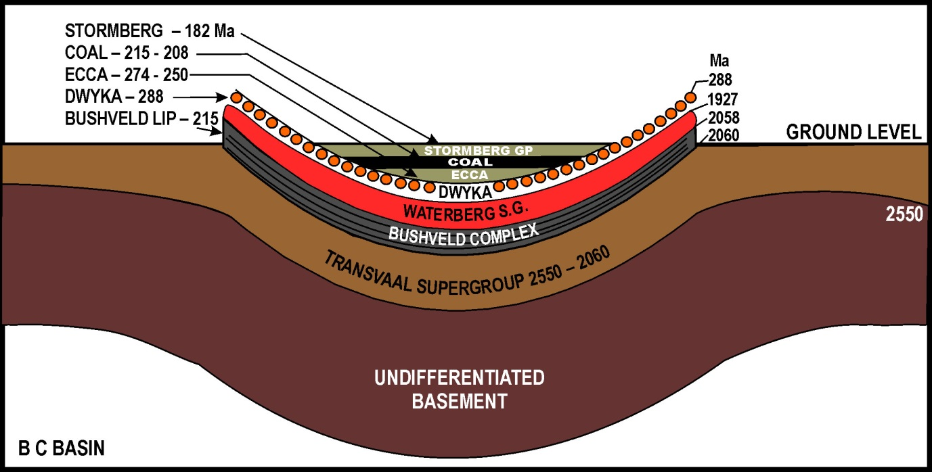

Fig. 11. Bushveld Complex cross section today showing depression
When the geophysicists wanted to get the date of the formation of the Bushveld Complex, they determined the age of rocks in layers of strata, ‘pre and post-dating’ the intrusions of the Bushveld Complex (Table 2).
Table 2 Bushveld complex sedimentary strata (Walraven & Martini 1994)
Age of existing strata | Name of strata
2058-1927 Ma | Waterberg Group
2055-2000 Ma | Pretoria Group
2055 Ma: < < < < < < < < < < < | 215 Ma Bushveld side intrusion
2260-2055 Ma | Pretoria Group
2550-2060 Ma: | Transvaal Supergroup
2700-2500 Ma | Kaapvaal Craton
3000-2700 Ma: | Swazian
Minerals cannot be dated so they dated the host rocks below and above and mixed with the Merensky and other reefs at 2055 Ma. Further they stated, ‘This age is within error of published ages for the overlying, and locally cross-cutting, Bushveld or Lebowa granite suite’ (Scoates & Friedman, 2006, 2008). This implies that the horizontally intruded mafic-ultra-mafic magma (7% minerals mixed with 93% local magmas) of the Rustenberg Layered Suite (RLS) were the same age as the strata of sedimentary rocks above and cross-cutting the reef. The strata between Vredefort and the BC, e.g., Schurwedraai, Roodekraal, Lindequesdrift and Losberg, is also aged at roughly 2060 Ma (Reimold & Gibson 1996). This makes it likely that local horizontal host material that was affected by acoustic fluidisation and transported to become part of the magma would also be this age.
Traditionally scientists do not date fossils themselves, but they can accurately date the strata layers above and below to get precise dates of when the fossils were laid down. In 1980, Luis and Walter Alvarez, Frank Asaro and Helen Michels could date a mass extinction by measuring the age of strata above and below iridium that precipitated into a world-wide layer. This took place shortly after the great Chicxulub Meteorite impact causing the Cretaceous-Paleogene (K-Pg) mass extinction which wiped out the dinosaurs 65.5 Ma. Fern spores below but not above the iridium layer confirmed this mass extinction marker.
These examples of dating are possible because the fossils or iridium were laid down on top of a layer of strata of measurable age and then covered by another layer of measurable age. One can then assume that the fossil or iridium layer is of an age between the two.
However, if you have many kilometres of sediment laid down between 3000 and 1927 Ma and can measure how old every layer is from bottom to top, you cannot know the age of minerals that were intruded later from the side. Imagine shooting a bullet today into the side of a cliff where the strata layers are 2055 Ma. This does not make the bullet 2055 million years old.
In our case, the meteorite’s minerals mixed with magma, formed from acoustic fluidised local rock that had not been shocked or heated to reset the time markers, were intruded horizontally. This forced the floor down and the roof up, between layers of strata in the Transvaal Supergroup that are same age as claimed for the intrusion of the Bushveld Complex. If 2055 Ma is the age of the host rock between Vredefort Dome and the BC there is nothing to prevent the age of the horizontal intrusion of minerals into the Bushveld Large Igneous Complex from being very much younger.
There is another point to make in the measurement of age for the Bushveld Complex. By dating the layers of strata to infer the age of the intrusion, various dates have been calculated depending on the site locality. Hence, we see in two articles on the Bushveld Complex (Walraven & Martini 1994 and Kinnaird 2005) a spread of ages listed of up to +48 million years. This is not possible for an event that took place in ‘a short period of geological time’ (Harmer & Armstrong, 2000) and ‘a time span of a few million years’ (Kinnaird 2005) or ‘less than 75,000 years’ (Cawthorn & Walraven 1998)
I suggest that sometime during the period of the Karoo System, between ~300-200 Ma, large semi-continuous pulses of mineral-rich core material from Vredefort meteorite fragments, travelling hundreds of kilometres some kilometres below the surface, before intruding into the Pretoria Group of the Transvaal Supergroup at a depth that corresponded to an age of ~2055 Ma. Incorrectly, the existing layers of strata and magma from old strata carried in are being dated and not the mineral-rich projectile that penetrated them from the side.

9.0 The Great Dyke of Zimbabwe
The Great Dyke is the incorrect description for this straight, ~550 km long, mineral-rich, 4-11 km wide furrow. I suggest that it is an astrobleme, a word coined by Robert Dietz for an ancient scar left in the Earth’s crust by a huge meteorite (Dietz 1961a) and that it was caused by an independent mineral fragment of the Vredefort Meteor Shower. (See Fig. 12.)

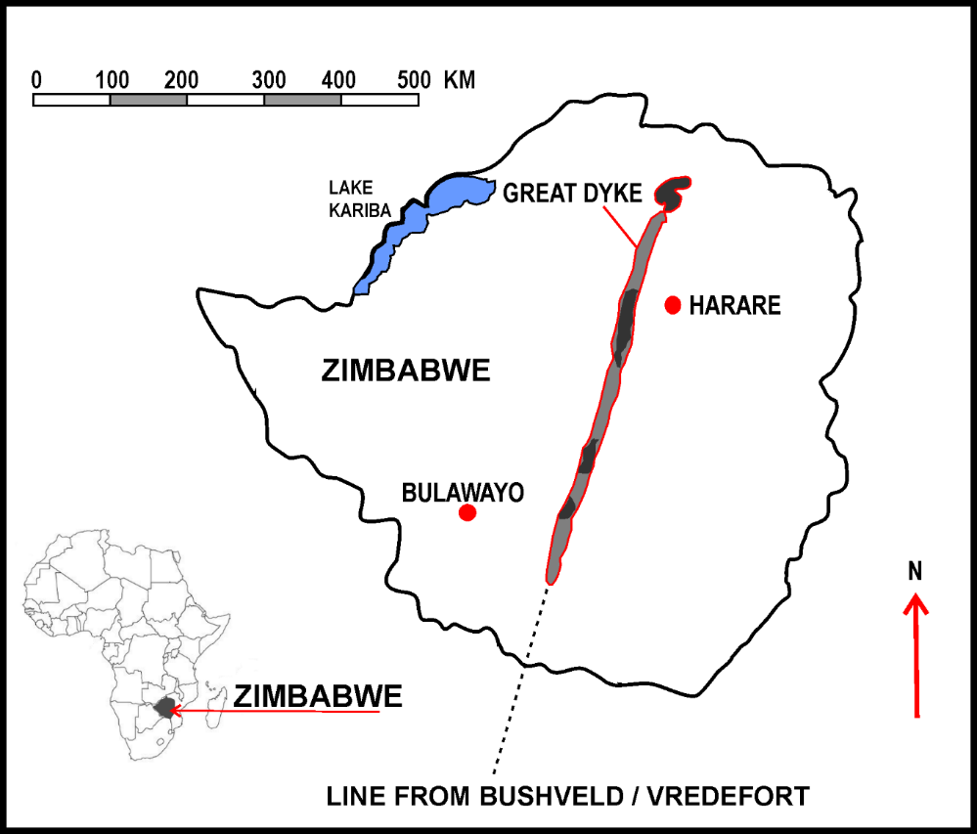
Fig. 12 The Great Dyke astrobleme, the 550 km scar across Zimbabwe

Its lopolithic, Y-shaped cross section gouge, scars the top of the old Zimbabwe Craton. Satellite pictures and terrain maps of the Great Dyke show that the direction started in a straight line from the current southwest and stopped in a swirly ‘Snakes Head’ at the north-eastern end as it ran out of directional speed (Fig.12). Imagine a single large underground nuclear explosion that could make a cavity that looks like the Kimberley Big Hole. Then imagine a multi-million tonne high iron-chrome projectile with the energy of millions of nuclear-sized explosions ploughing through the layered crust a few kilometers below the surface at an entry speed of 25 km/second. The Y-shaped cross-section is from the hypervelocity, horizontal, subterranean explosion that ‘zipped’ through the existing rock strata horizontally, the whole process being over in less than a minute.
How could the meteorite travel 550 km and maintain the same level below ground? The large meteorite fragment entering almost parallel to the ground near Tod’s Guesthouse on the Beit Bridge-Bulawayo Road, would hydrodynamically follow the weaker joints between the layers of strata, blasting off the roof explosively. The curvature of the Earth over 550 km would be compensated by the gravity induced curvature of the penetrator’s path. This would result in the continuous Y-profile, and shedding off its own mineral layers, staying at that approximate level before eventually coming to a stop. The un-deformed structure of the Great Dyke shows that the thick, old Zimbabwe Craton was stable when the intrusion occurred.
The Great Dyke is a gouge of approximately the same depth parallel to the Earth for 550 km whilst the main core from the Vredefort Meteorite penetrated much deeper, about 20-25 km, causing an underground explosion, then continuing to the Bushveld Complex. Before impact, many shattered meteor fragments were spread out across many thousands of kilometres even though they all came from the same direction. Some of the metallic fragments located lower in the meteor group relative to the target would impact south of Welkom whilst others, higher up, would be ‘over the horizon’ and only just skim the ground. The difference in inclination is ~ 7º based on where the Vredefort Meteorites first penetrated and roughly 111 km per degree across about 800 km.
This Great Dyke gouge has near horizontal sills of igneous ultramafic layers. The ferromagnesian rock includes large amounts of chrome and platinum as well as economic amounts of nickel, copper, gold, and platinum group metals. In fact, the mineral composition and grades match the Merensky Reef in the Bushveld Complex closely.
The similarity of the Great Dyke with the Bushveld Igneous Complex is striking.
- The horizontal intrusive layering of sills is indicative of a formation that was not volcanic. ’The evidence presented here is believed to strongly support a primary magmatic [melting & transport] origin for the PGE mineralisation in the Great Dyke’ and ‘accumulated, with minor redistribution, within the partly consolidated silicate crystal mush’. (Wilson & Prendergast 2001)
- The minerals contained in the magma are like those of the Merensky Reef which means it is likely that they were derived from similar chrome and platinum-rich metallic fragments of the same extra-terrestrial source
- The distance that the platinum-rich chrome fragments travelled below ground level. The Great Dyke is 550 km long across Zimbabwe and the Vredefort/Bushveld fragments penetrated from Colesberg, south of Welkom to north-west of Polokwane, about 1040 km. Both trails end with a mineral-rich ‘snakes head’ in the northeast which one would expect from a projectile slowing down out of hypervelocity and losing forward momentum.
- By taking the start of the horizontal Great Dyke scar as 0º inclination and the distance to the start of the Vredefort it is possible to use trigonometry to work out that the inclination of the Vredefort impact was at ~ 7º. This corresponds to the depth of explosion at ~20-25 km under the Transvaal Supergroup resulting in the exposure of the 20-25 km upturned collar around the Dome. This oblique impact also results in an oval crater and lack of impact melt. (Stoffler, Ryder, Artemieva, Cintala & Grieve 2006) ‘The shock wave generated by the impact weakens with decreasing impact angle’ (Pierazzo & Melosh 2000a) and ‘For crystalline granite targets…craters appear significantly elongated along the trajectory path at 15º and ‘Fe-Ni objects could survive a glancing event’ (Gault & Wedekind 1978 as quoted in Pierazzo & Melosh 2000)
- The interesting geographic observation that connects the three events is that the straight–line scar of the Great Dyke is in the same direction and path as the current southwest–northeast trending impact of the Vredefort Meteorite. In fact, on a map you can draw a straight line from the meteorite entry scar south of Welkom near Colesberg, through the centre of the Vredefort Dome, through the highest point of the Witwatersrand at Northcliff, through the middle of the Bushveld Complex near Bela-Bela, pass over the South African border at Pontdrif, and line up precisely with the Great Dyke! Maps for Southern Africa and the latest for Zimbabwe, which shows background terrain, are useful for seeing the Great Dyke and above alignment (Map Studio 2015).
On maps of today’s era, we see this line from the Vredefort Dome via the Bushveld Complex to the Great Dyke in a southwest to northeast direction. If the Vredefort Meteor shower was the core remains of a shattered planet or forming planetoid, probably from the asteroid belt, we would expect it to approach on the planetary plane, from west to east. As shown in Fig. 6 the direction of this line in ~ 300-200 Ma could have been west to east due to the rotational position of Gondwana and the obliquity of our planet Earth.
The age given for The Great Dyke, the scar that lies within the Zimbabwe Craton, has been dated at 2575 million years old (Oberthuer, Davis, Blenkinsop & Hoehndorf 2002). However, the host rock of Zimbabwe Craton is aged from 2800 to 2500 Ma (Dirks & Jesma 2002). It is highly unlikely for the formation of the Great Dyke to be the currently given age, as no signs of an impact structure are normally left after 600 million years (Wetherill 1979), especially as this part of Gondwana was affected by the Dwyka glaciation event which would have scraped the terrain flat in less than 100 million years (Grieve 1984). Robert Gilmour Le Tourneau, creator of giant electric-wheeled earthmovers would have loved that. He always said that ‘No job was too big, only the machines were too small’
If the core material of a metallic meteorite consists of elements that cannot be aged, the age measurement will come from the mixed material derived from the target rock. It is presumed that the age measurement will be reset to zero during the melting or solidifying process. This does not always happen because of meteorite strikes (Taylor 2018) nor is much, if any, impact melt formed after an oblique hypervelocity impact (Tagle 2004) and from impacts into sedimentary rocks (Osinski, Grieve, Collins, Marion & Sylvester 2008). The relatively shallow trench would not have allowed sufficient shock or heat to develop to melt or reset dating markers.
Therefore, for the same reason that the intrusion of the Bushveld Complex was dated by the strata layer in which projectile materials are imbedded or carried in, so it is with the Great Dyke. As the meteorite fragment entered from the side into a strata layer of 2575 Ma its age could be anything from then till now. Take into consideration that the valley and hills on either side would have been bulldozed by glaciers if they had been there before ~300 Ma. I suggest that it was created in the Karoo period between 300 to 200Ma.

10.0 The Swathe of Minerals South-West to North-East
I would like to point out that, not only do we have Vredefort Impact Structure with its gold lining, the Bushveld Complex and Great Dyke in an exact line with chrome, platinum, PGMs, gold, nickel, vanadium, and asbestos, but there are large mineral deposits from 1000 km to the south-west and 1600 km to the north-east of the Vredefort Structure. This 800 km wide swathe of world class economically viable minerals stretches from O’Okiep Copper District in the Northern Cape past the Copperbelt in Zambia to the largest deposits of cobalt mined in Democratic Republic of Congo. The Council for Geoscience has produced downloadable maps of all the minerals of South Africa showing where they are mined. The 25 minerals (precious, metallic, and industrial) that fall into the swathe above are, in alphabetical order: Andalusite, Antimony, Asbestos, Barytes, Chromite, Cobalt, Copper, Fluorspar, Gold, Iron, Lead, Manganese, Molybdenum, Nickel, Phosphate, Platinum, PGMs, Rare Earth Elements (REE), Silver, Tin, Titanium, Uranium, Vanadium, Vermiculite, Zinc and Zirconium (Vorster 2001) (Table 3).

Table 3 The Swathe of Minerals of Southern Africa
Symbol | Name (Comment) | SG | Melt Deg C | Latest pa | Resource | World
Ag | Silver | 10.5 | 960 Deg C | 145 t | 10 kt | 15
Au | Gold | 19.3 | 1062 Deg C | 428 t | 40 kt | 1
Co | Cobalt Inc DRC | 8.6 | 1490 Deg C | 64kt | N/A | 1
Cr | Chromite (Exc Zim) | 6.5 | 1510 Deg C | 6.6 Mt | 5 500 Mt | 1
Cu | Copper Inc Zam/DRC | 8.9 | 1083 Deg C | ~2Mt | SA13 Mt | 1
Fe | Iron (Steel) | 7.86 | 1525 Deg C | 73 Mt | 1 500 Mt | 6
CaF2 | Fluorspar | 3.1 | N/A | 213 kt | 41 Mt | 1
Mn | Manganese | 7.4 | 1220 Deg C | 3.6 Mt | 4 000 Mt | 1
Ni | Nickel | 8.9 | 1452 Deg C | 37 kt | 12 Mt | 3
Pb | Lead | 11.4 | 327 Deg C
Pt | Pt+PGM (Exc Zim) | 21.5 | 1755 Deg C | 255 t | 30 kt | 1
Sb | Antimony | 6.62 | 629 Deg C | 3.7 kt | 250 kt | 4
Sn | Tin | 7.3 | 232 Deg C | nil | 20 kt
Ti | Titanium | 4.54 | 1850 Deg C | 1 Mt | 146 Mt | 2
U | Uranium | 18.7 | 1132 Deg C | 861 t | 284 kt | 4
V | Vanadium | 5.5 | 1710 Deg C | 18 kt | 1.2 Mt | 1
Zn | Zinc | 7.12 | 418 Deg C | 63 kt | 15 Mt | 5
Zr | Zirconium | 4.15 | 2130 Deg C | 253 kt | 14 Mt | 2
 | Andalusite -refractory |  |  | 23 kt | 51 Mt | 1
 | Asbestos |  | Ex Insulation | 28 kt | N/A | N/A
 | Coal (Power/Fuel) |  | Local/Export | 224 Mt | 5.5 Gt | 5
 | Diamond (Kimberlite plus Alluvial) |  | Not Botswana, Namib, Lesotho | 10.8k carats | N/A | 5
 | Phosphate |  | Fertilisor | 2.8 kt | 2.5 Mt | 3
 | Vermiculite |  | Insulation | 209 kt | 80 Mt | 1
This vast array of minerals, many of which form the largest deposits in the world, could not have seeped up through the Earth’s crust from the mantle as they have a higher density. Most of them are siderophiles that would have sunk to the Earth’s core if they had been there during the formation of this planet. After the crust was formed, they could only have come from meteorites.
These were all minerals that would typically have been separated out with a density and temperature in the molten core of some long past planetary formation. After cooling down over hundreds of millions of years and solidifying, with different materials in neat layers, like the segments of an onion, a serious smashup occurred throwing off the mantle and leaving the shattered core to be held together by its own reduced gravity. It is likely that this fragmented core had mostly separated into the various minerals of similar densities before colliding with Earth as most of the minerals are accumulated in individual deposits with the highest densities in the centre of the swathe.
I suggest that as the shattered core approached Gondwana from the west ~215 Ma, at a very shallow angle, the dense individual fragments of gold, platinum, and PGMs as well as a large amount of chrome and vanadium gathered in the core surrounded by iron and manganese, then copper and lastly rocky remnants of the mantle spread out over thousands of kilometres (Fig. 13.a).
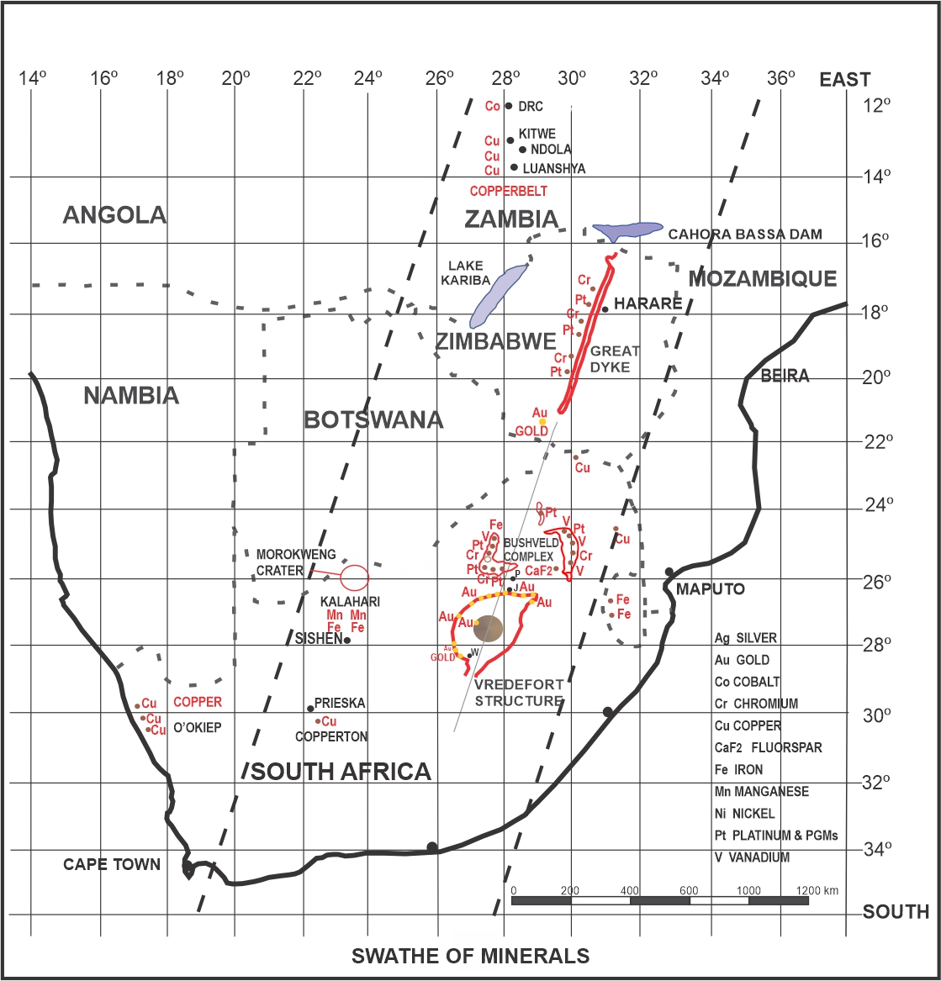
Fig. 13 Swathe of minerals
Looking at the swathe of mineral deposits from above (Fig.14.c), the bottom of the outer core, rich in copper, collided with Earth first in the O’Okiep Copper Region of the Western Cape, followed by mountain sized chunks of iron and manganese in the 160 km long ore body that includes Sishen and Hotazel (Boardman 1977). The centre of the core containing the dense minerals, chrome, vanadium, gold, and platinum, then impacted into the ground from south of Welkom, below Vredefort and under Johannesburg/Pretoria to the Bushveld Complex. Most of the high-density, low melting point, gold, vapourised, remained behind in the cavity before being ejected and then precipitating to cover the strata that slumped into the crater.
Past the Vredefort Structure, the order of impact was reversed with iron and manganese impacting in a semi-circle from Thabazimbi to Swaziland. Copper was deposited to the east at Phalaborwa and north from Musina on the Zimbabwe border to the Copperbelt in Zambia. The largest deposits of copper occur here, exporting about one million tonnes per year. Close by over the border in the Democratic Republic of Congo (DRC) 70%, 64,000 t/a of the world’s cobalt is mined and exported.
The approaching, shattered, planetary core was not a single compact object but would have been spread out whilst travelling through space. The fragments would collide with one another; bounce off for thousands of kilometres, then, the gravity from the heaviest, most densely packed core fragments would draw them back again. This spreading out would be exacerbated by gravity when approaching a large object, like Planet Earth (Fig. 14.a).

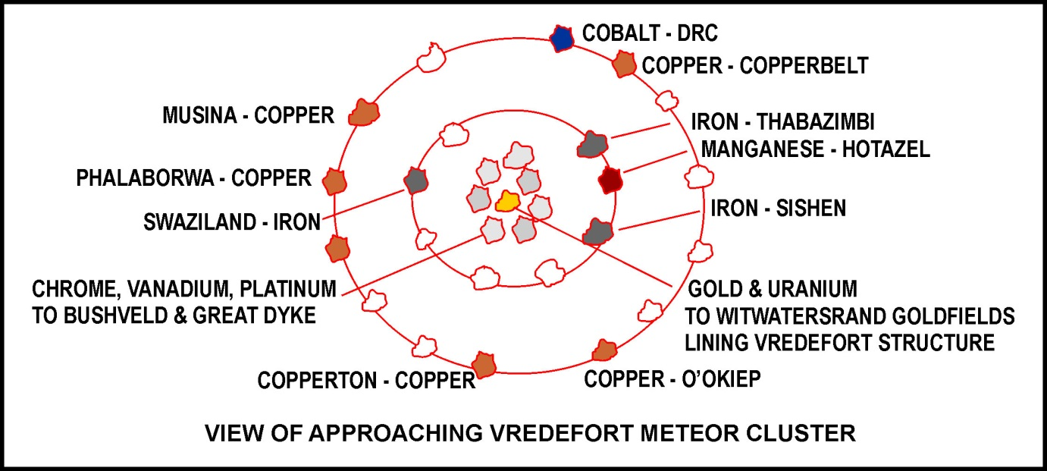
Fig.14.a
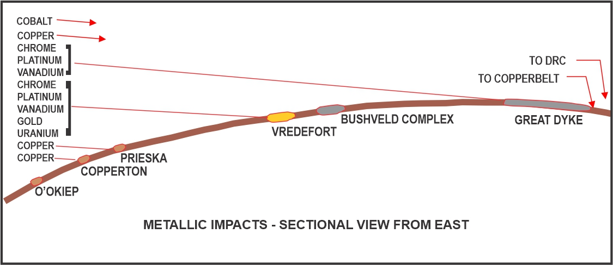
Fig.14.b
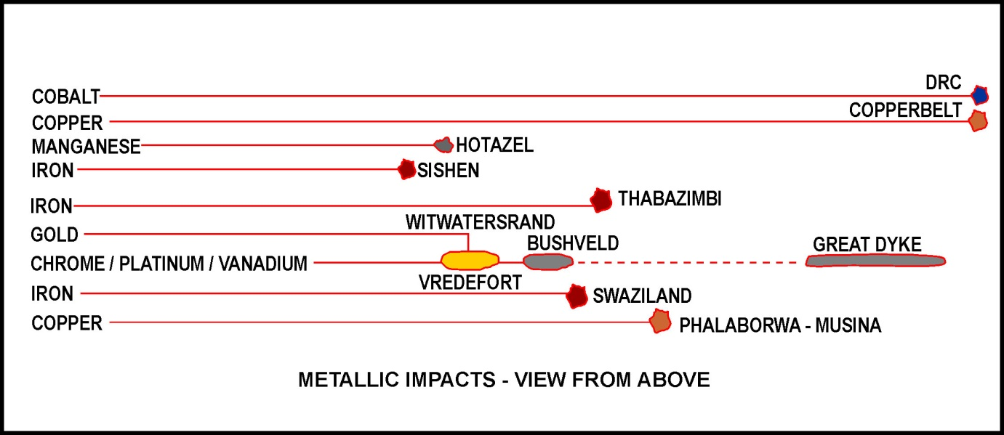
Fig 14.c

13.0 The Late Triassic to Jurassic Mass Extinction
It is said that large impact events occur roughly every one-hundred million years and other extinction events are also likely to have been caused by large impacts (Grieve 1990).
The combined impacts of the Vredefort and The Great Dyke taking place within minutes, would have caused worldwide long-term effects with immediate local devastation from the blast wave, base surge, earthquakes, tsunamis and vaporization of water and rock. The dust and ejecta would be four metres thick one thousand kilometres away from the impact (Marcus, Melosh & Collins 2018) and as the dust encircled the world in a few months, visibility would be limited (Alvarez & Asaro 1990) making the air unbreathable for most animals. Only those that lived underground like our modern-day moles or laid eggs that were buried and hatched later like dinosaurs, reptiles, and birds, survived. Longer term effects would have included global distribution of ejecta, wildfires and darkness, acid rain and greenhouse effects.
The last 20 million years to the end of the Triassic period saw the extinction of 80% of species for which no clear reason has yet been found (Taylor 2018). What has recently been proposed is that the worldwide, long term Carbon Isotope Excursion ‘may have been triggered either by gas emissions from an eruption of a large igneous province pre-dating the Norian/Rhaetian boundary [205.7 Ma], by a bolide impact of significant size or by some alternative source of greenhouse emissions’ (Rigo, Onoue, Tanner, Lucas, Godfrey, Katz, Zaffani, Grice, Cesar, Yamashita, Maron, Tackett, Campbell, Tateo, Concheri, Agnini, Chiari & Bertinelli, 2020).

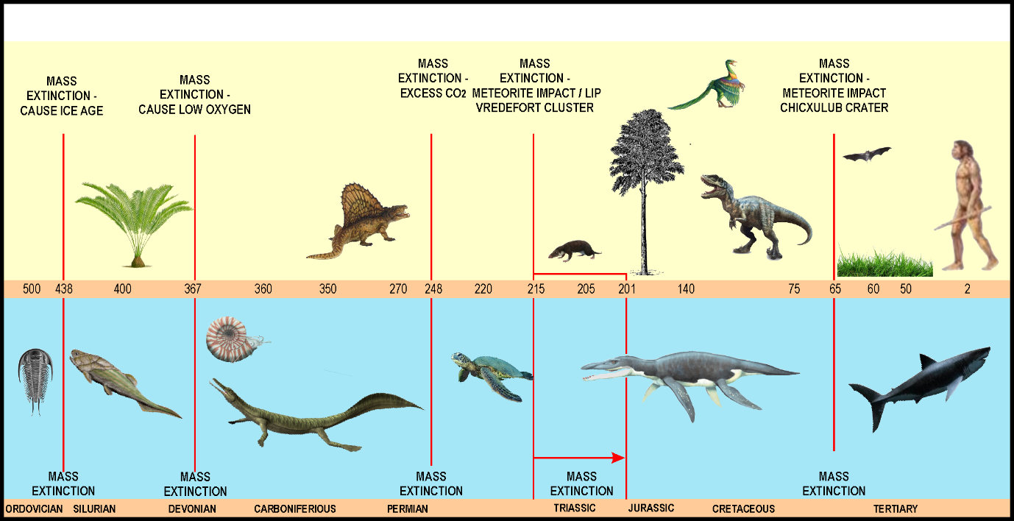

Fig. 15 MASS EXTINCTIONS
An international team of sixteen led by Professor Emese Bordy of University of Cape Town wrote, ‘The upper Stormberg Group (Elliot and Clarens formations) of the main Karoo Basin is well known for its fossil vertebrate fauna, comprising…. Mammals, dinosaurs, and turtles…. Our results confirm that the Elliot Formation contains the Triassic-Jurassic boundary, making it one of the few fossiliferous continental units that records the effects of the end–Triassic Mass Extinction event’. They also examined the Earth’s magnetic reversals which occurred about nine times during the 19-million-year layering of the Lower Elliot Formation. ‘The basal magnetostratigraphic tie is the single age of 215+3 Ma … which has been tentatively linked to a deformation event in the Cape Fold Belt…’ (Bordy, et al, 2020). This date of 215 Ma supports the date that I had developed mainly because of the age of coal deposits and the mid Elliot Formation age when the colouring changed to red due to iron oxide. The Cape Fold Mountains, which are located southwest of Colesberg would be a logical reaction to the surface strata being pulled a few kilometres towards the meteorite entry point and then released.
Looking at the Lower Elliot Formation, 220-201 Ma in the Karoo Supergroup, when this extinction took place, we find that the fine air borne sandstone layer, 500 metres thick, is stained red from iron oxide which forms red mudstone on top. ‘The maroon colouration of the Elliot Formation was not direct evidence of deposition in a desert environment but was rather the result of in situ diagenetic alteration of iron bearing minerals. Iron was released during the breakdown of unstable ferromanganese or iron oxide minerals in the sandstone under surface temperature and pressure’ (Erikkson 1983). I suggest that the fine red cement-like dust that forms the mudstone and stained the sandstone below it came from the 4-meter layer of iron-rich dust that was expelled from the Vredefort impact.

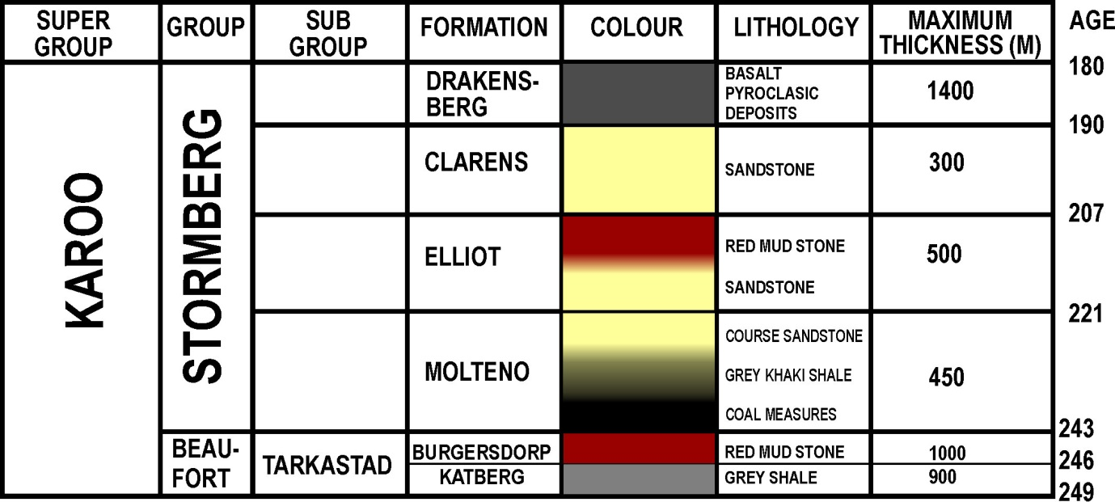
Fig. 16. Elliot layer with iron and uranium dust which began ~ 215 Ma

The Elliot formation clays are also uranium enriched. The Clarens and Molteno above and below are the normal cream sandstone colour. In the past, Iridium or Platinum Group Elements have provided the indication of a meteorite impact. As Uranium has also been recovered as a by-product of gold mining in the Witwatersrand Gold Reef, there is no reason for this uranium not to be the indicator. If correct, then this would give a period when it was deposited between 221-207 Ma. Because the date of the Vredefort Structure is believed to be 2020 Ma, this event was not ever considered as a candidate. I propose that the Late Triassic to Jurassic Mass Extinction was a direct culmination of the Vredefort/Great Dyke Impacts in about 215 Ma.

12.0 Karoo Mantle Plume
The Karoo Mantle Plume is an upwelling of hot mantle material, with a stem, hundreds of kilometres across, and a radiating top under or through the Earth’s crust (Fig. 14). These plumes are up to 3000 kilometres in diameter (Segev 2002), originating from the core-mantle boundary 2900 km below the surface. There are only about twenty of these plumes around the world, mostly welling up as wide mid-ocean ridges (Wyllie 1975). The giant Karoo Mantle Plume first erupted on the northern extremity of South Africa along the Limpopo River 205-204 Ma (Allsop & Roddick 1984; Kent, Storey & Saunders 1992) (Fig. 17).
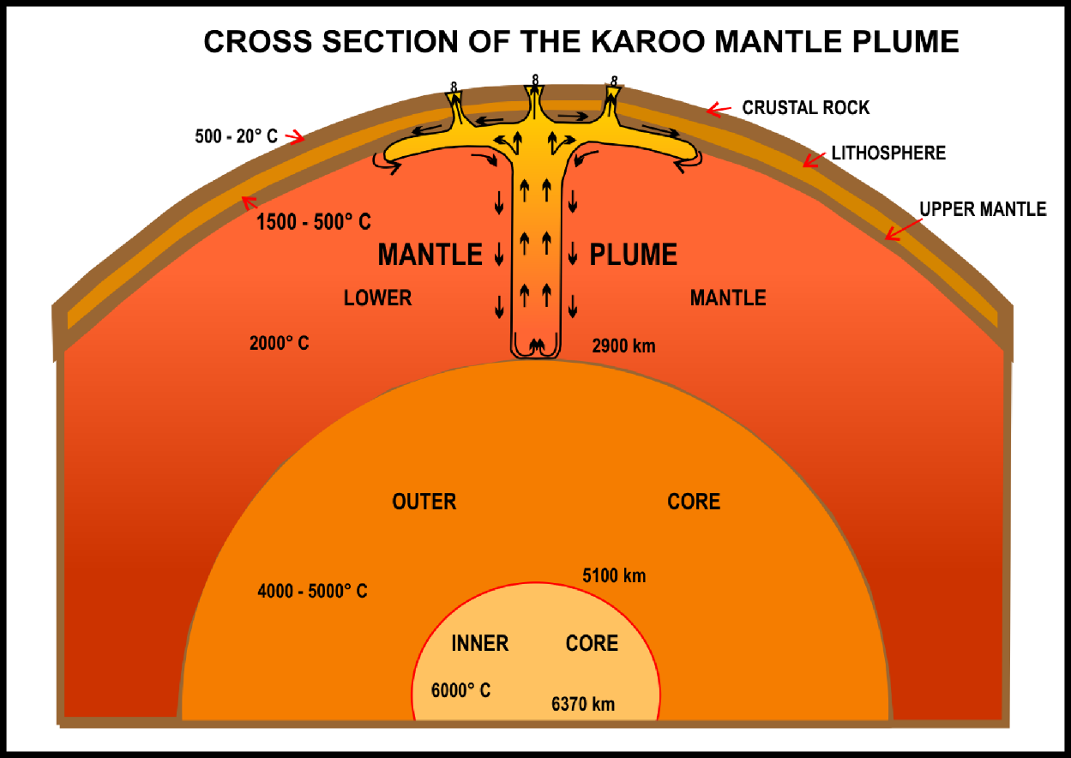
Fig. 17. Karoo Mantle Plume below Vredefort Impact Structure.

There was no known reason for this plume to rise under Gondwana, which had been part of a stable Pangaea for the previous 100 million years. I propose that the Vredefort meteorite impact of about 215 Ma supplied shock and heat energy to upset the equilibrium in the mantle below, giving the impetus for the plume to begin moving. Once started it became self-sustaining as the hotter mantle material that had been trapped below began to rise with convection currents. It would take an impact of such a magnitude as Vredefort to supply the energy to seed the growth of a mantle plume. Prof ‘Wolf’ Elston proposed that the stages were, ‘Impact, mantle upwelling (or plume) with melting in mantle and crust (Elston 2008). This would begin the slow but sure upward current and be the plate-driving mechanism resulting in volcanic eruptions, earthquakes, and continental drift (Wyllie 1975), and the extrusion related to the breakup of Gondwana (Cox 1992).
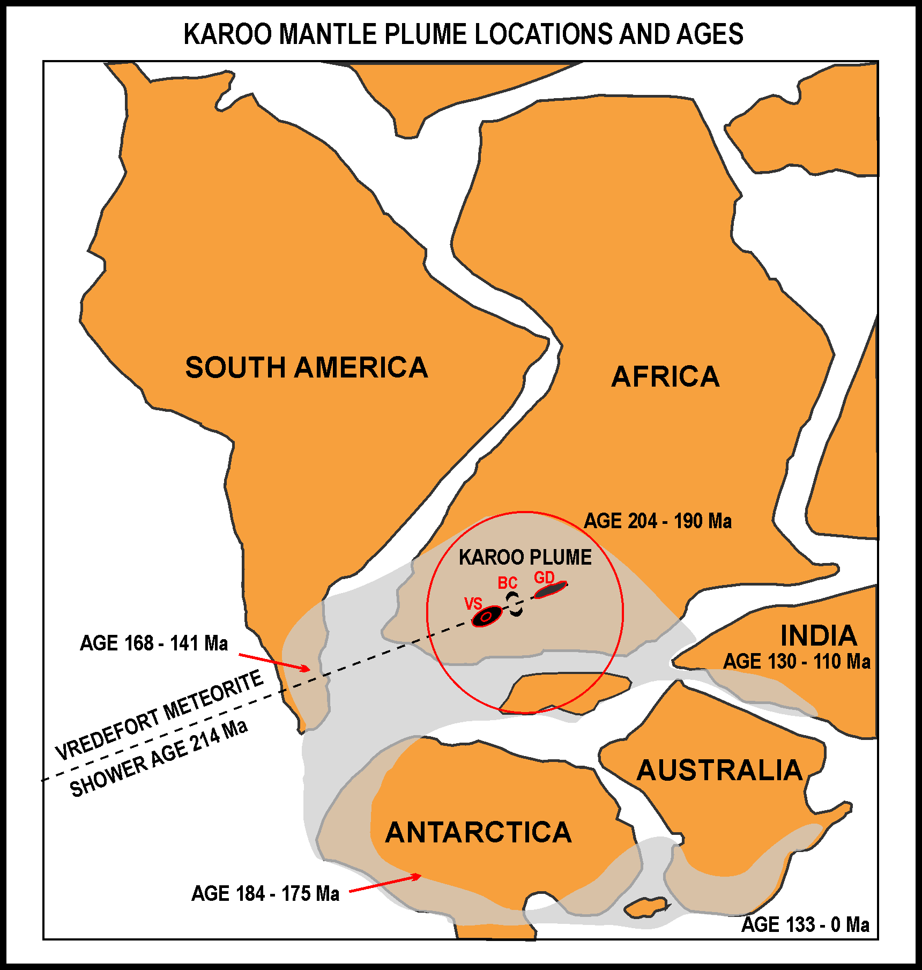.
Fig. 18. Start of Karoo Mantle Plume 204 Ma & then Continental Drift 185 Ma.
The Karoo Large Igneous Province of southern Africa is closely associated with a huge mantle plume which also spread out below the Ferrar Province, under Antarctica, Australia, Tasmania, and New Zealand, as well as the Chon Aike Province under Patagonia (Storey 2004). These igneous provinces formed shortly before the continental breakup of Gondwana and the Karoo Province which has been clearly linked to a mantle plume (Storey, Leat & Ferris 2001) (Fig 18).
The Vredefort Impact shock wave travelled downwards at about 3-4 km/sec until it reached the core-mantle boundary, about halfway to the centre of the Earth, 2900 km in 10 minutes (Marcus, Melosh & Collins 2018). It then rebounded off the denser metallic core, like a billiard ball off the cushion, the turbulence leaving a disrupted path through the normally stable mantle
The second effect of the meteorite impact would be to dissipate energy into the mantle in the form of radiated heat directly below the shattered floor of the 50 km deep transient crater. This additional heat would cause the thick, molten magma in the mantle to become lighter than its surroundings resulting in the beginning of a slow upward movement. Once moving, the plume would continue to rise due to its hotter base. This ultimately caused the breakup of Gondwana. Mantle plumes, because of their sheer size and weight are very slow moving, a mere five centimetres per year (Wyllie 1975). This would account for the time delay of about 10 million years between the Vredefort impact of about 215 Ma and the start of a two-kilometre uplifting of southern Africa. The mantle plume would have created the flood basalt of the Karoo system roughly 200 Ma (Storey, Leat & Ferris 2001). This was followed by the Drakensberg (185-180 Ma) capped by some 1.4 km of basaltic lavas (Veevers 1994; Johnson, van Vuuren, Hegenberger, Key & Shoko 1996).
One hundred and thirty-five million years after the Karoo Plume first erupted it left a ‘breadcrumb’ trail of small volcano remnants from South Africa to Madagascar and then close to Reunion. This was the region where the south-west coast of India was situated about 65 Ma. It is therefore possible that the Deccan Traps were formed by the same mantle plume or an offshoot. As the crust then carried India northwards over the mantle the undersea mantle plume left its trail to the south, now at a small, related hotspot under Marion Island (Courtillot 1990). Another outlier of this mantle plume finally stopped in Queensland, Australia with the Glass Mountains, north of Brisbane.
From 650 Ma to 500 Ma separate old continents on the Earth’s crust, floating over the heavier mantle, were moving together to eventually amalgamate by 320 Ma (Veevers 2004). This supercontinent, Pangaea, with northern America, Europe, and Asia to the north and Gondwana (southern Pangaea) comprising southern Africa, South America, India, Australia, and Antarctica in the south. The whole supercontinent of Pangaea floated southwards positioning Gondwana within the Antarctic Circle for fourteen million years from about 302 Ma to 288 Ma (Bangert, Stollhofen, Lorenz & Armstrong 1999) and during this time ice built up to 4 km thick (Horton, Poulsen & Pollard 2010; Montanez & Poulsen 2013). Then, as Pangaea drifted north the huge expanse of ice began melting from below causing glaciers to gouge out huge areas in present day South Africa (Karoo Supergroup), South America (Parana, Argentina), Antarctica (Beacon) and eastern Australia (South Australia to Queensland) (Dineen, Fraiser & Isbell 2013). This formed a huge inland lake covering Gondwana, about six thousand kilometres in diameter. The bed of this lake was filled with glacial debris; now known in South Africa as the Dwyka Group (Hancox & Goetz 2014).

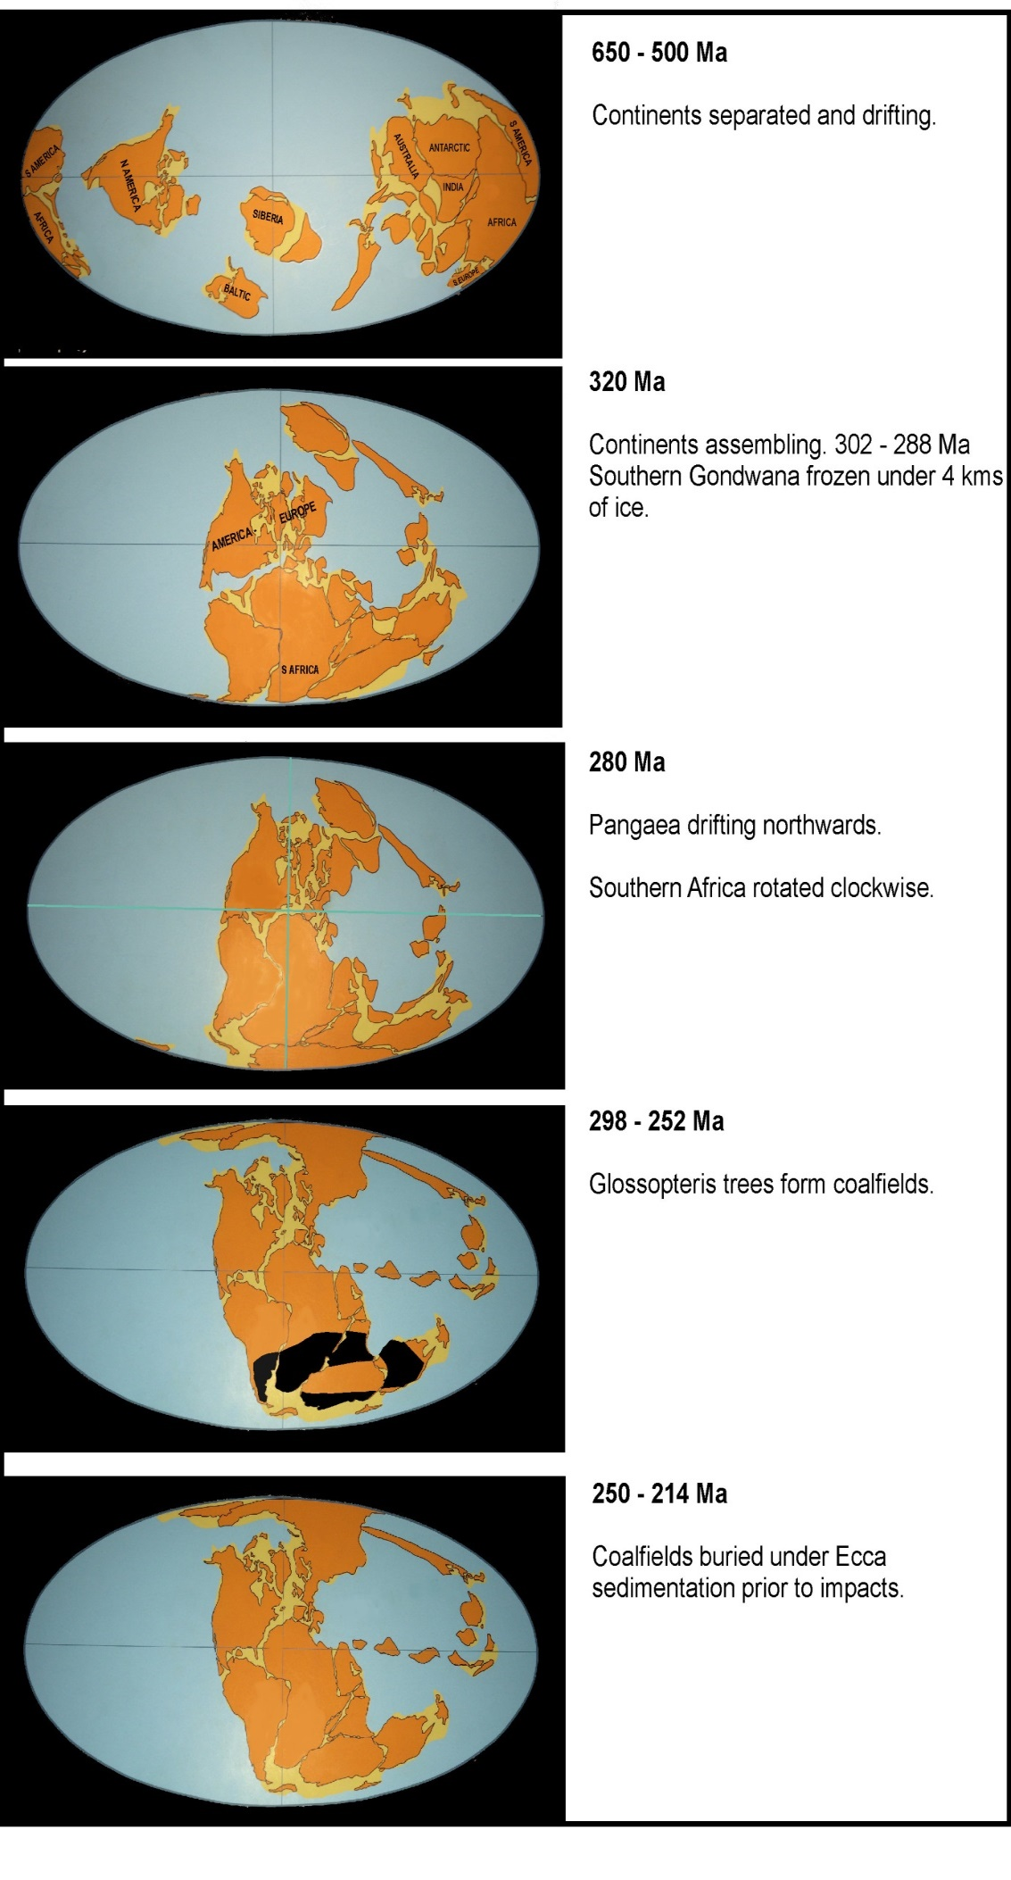
FIG.19. Continental Drift causing assembly before Vredefort Impact
As the lake silted from rivers, fluvial, and windswept dust, aeolian, it eventually became a huge fertile swamp with dense forests of the famous Glossopteris ferns. These proliferated from 298 Ma to 252 Ma (Prevec 2011). This was a water loving fern with tongue shaped leaves that grew to thirty metres high. For roughly fifty million years these swampy jungles laid down the organic debris that became the future Natal Vryheid coalfields in South Africa as well as those in India, South America, and Eastern Australia. The protected Antarctic fields are buried under thick ice once again. In South Africa these deposits became the Pietermaritzburg shale, and Vryheid Formations coal (Fig. 19).
By 252 Ma the giant lake with its swampy jungle had silted and become dryer as Gondwana drifted northwards towards hotter climates and all the vast forests of Glossopteris died out. Intermittent floods and windborne dust buried the Natal coal under kilometres of sediments, the Ecca Group. This situation had stabilized by about 215 Ma (Table 4).

Table 4 From 650 Ma until now - Continental drift, glaciation, coal & sedimentation
Age | Event | Description
650 Ma | Continental drift | Continents separate groups
500 Ma | Continental drift | Continents separate, approaching
320 Ma | Continental drift | Pangaea Supercontinent forms
302 Ma | Continental drift | Gondwana in Antarctic Circle, 4 km ice
288 Ma | Continental drift & Glaciers | Moving north, glaciers, Dwyka debris
298 Ma | Gondwana Natal coal | Glossopteris forests in giant lake/swamp
252 Ma | Glossopteris extinction | Natal coal ends, Ecca sediments cover
215 Ma + | Vredefort-Bushveld-Great Dyke Cape Fold Mountains | Catastrophic damage, mass extinctions Formation of the Cape Fold Mountains
215/208Ma | Crater & scarp valley coal | Dicroidium forests 247-205 Ma
204 Ma | Karoo Mantle Plume | Rising 5cm/year, spreading 3000 km
200 Ma | Continental drift | Breakup following Karoo Mantle Plume
180 Ma | Drakensberg Mountains | Karoo area 1.5 km uplift, magma cap
145 Ma | Karoo Mantle Plume | Continents drifting apart
100 Ma | Kimberlite diamonds | ~80 pipes surround Vredefort Structure
0 Ma | Karoo Mantle Plume | Remnants Marion Island & Queensland
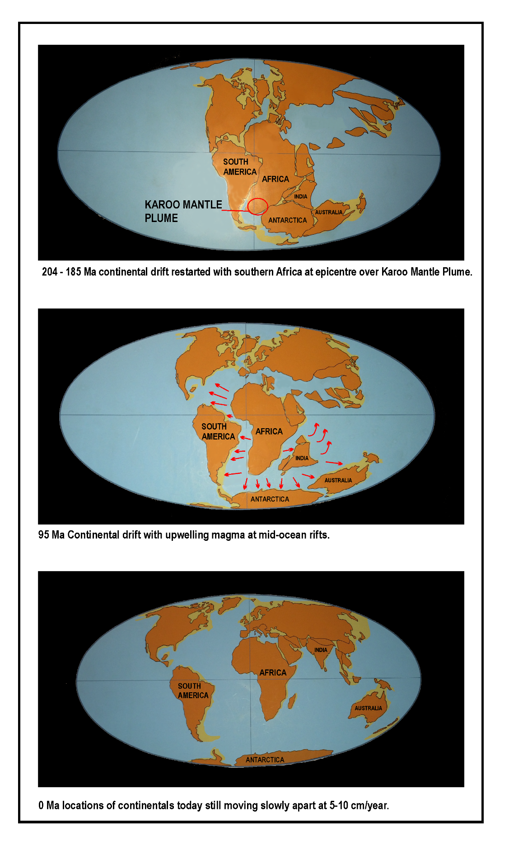

Fig.20. Continental Drift post Karoo Mantle Plume.

Before 1912, when Alfred Wegener, a German meteorologist, polar explorer, and geophysicist, put forward his Continental Drift theory to the Geological Society in the Senckenberg Museum, few had ever thought that landmasses could move, and most did not believe him (Wegner, 2012). One who did and helped with the proof was a South African geologist, Alex du Toit, who mapped the Gondwana Succession of glacial rubble, coal deposits and fossil plants to show that all the southern continents were joined about 200 Ma. Wegener died heroically on an expedition in Greenland in 1950. His theories only became accepted in the early 1960s when other proof, mainly based on ocean ridges and magnetic fragments in rock, was presented (Hurley 1968) (Fig. 20).

14.0 The Diamond Ring
It cannot be a coincidence that about 80 comparatively young, 100 Ma, kimberlite diamond pipes encircle the Vredefort crater. The largest of these are located from Letseng in Lesotho, Jagersfontein in the south-east, to Kimberley in the south, Finsch in the south-west, Jwaneng and Orapa in the west, Cullinan in the north and Venetia in the far north. Most of these are 200-300 km from the Vredefort Dome except Orapa and Venetia which are about 600 km (Vorster 2001) (Fig. 21).
In 2014 the South African diamond production was over eight million carats. That excludes Letseng with eleven diamonds over 100 carats in the first quarter of 2018, Botswana’s Orapa and Jwaneng, and the diamonds washed into the Atlantic and mined in Namibia and Angola. The first diamond found in 1867 was the Eureka in Hopetown weighing 21 carats and the largest from Cullinan that weighed 3106 carats uncut (Chamber of Mines 2017).
The requirements for the rich quantity, quality and size of diamonds to be formed in this specific area are as follows: A source of carbon is required to be converted into diamonds, this being from carbohydrates in gas, oil or coal. Enough carbon is needed to be 160 km deep underground and subjected to pressures of about 6 Gigapascal, about 60,000 Bar. It also needs to be raised in temperature to over about 1300 degrees Celsius (Hart 1992) and it needs to be brought up to the surface from about 160 km deep in a relatively short period of time.
I suggest that the Vredefort meteorite impacts drove large amounts of carbon down under the Earth’s crust from the Glossopteris based Vryheid Coalfields. These coal seams were laid down below the Ecca formation from 298 to 252 Ma. This source of carbon is then mixed with the mantle material. Over the next 116 million years, as the mantle plume rose at 5 cm per year, the carbon-rich magma sank down the sides of the plume until they reached the core only to be circulated 5800 km up again. When they reached 160 km below the surface, where the pressures and temperatures are ideal, the carbon-enriched magma formed diamonds.
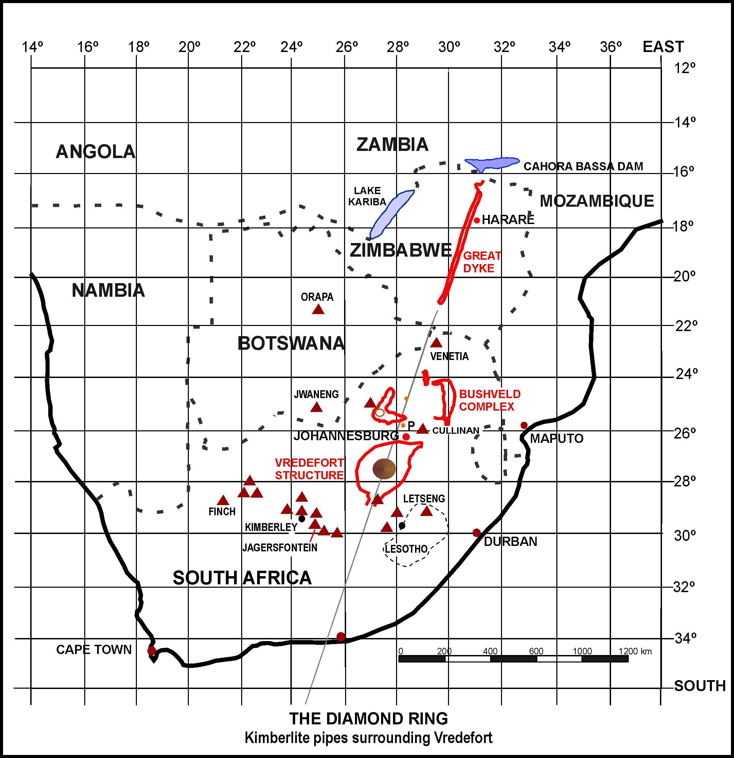

Fig. 21.
Increased heat in this area created the conditions 100 Ma for the diamond-rich Kimberlite to expand and explode upwards through a ring of weakened crust surrounding the Vredefort Structure. This proposal is supported by the time/distance between the Vredefort impacts and explosions of kimberlite out of the mantle plume and the composition of minerals in mantle peridotite which confirm the depth and temperature for the source of the kimberlite diamonds. ‘Available data support the hypothesis that kimberlite intrusions are formed by mantle hotspots’ and ‘In our opinion, the deciding factor in favor of the hotspot concept is that it predicts the ages of the kimberlites so well’ (Crough, Morgan, and Hargraves 1980). Although small diamonds have been found as a direct result of meteorite impacts (Anders 1965), these diamonds were not created directly by the Vredefort impact as no coesite is found in the South African kimberlite (Wyllie 1975).

15.0 Coal in Crater and Scarp Valleys

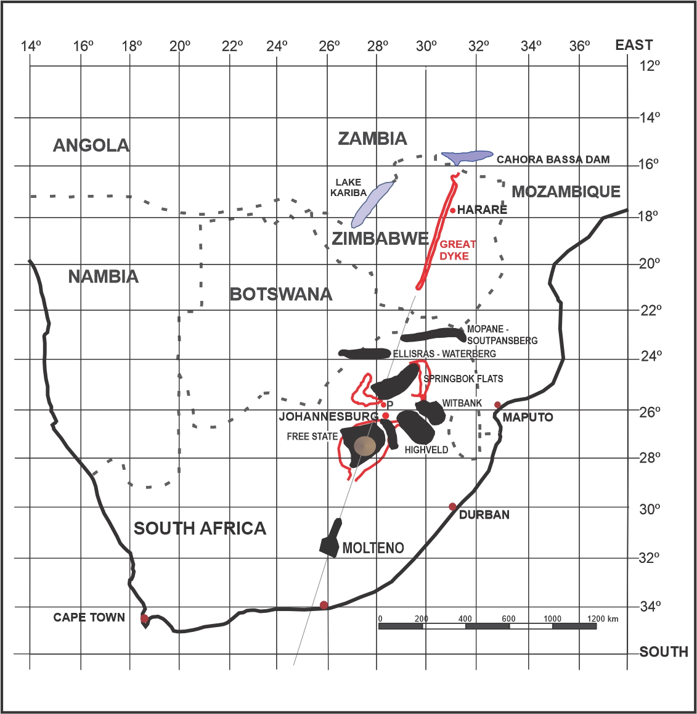
Fig. 22. Coalfields of southern Africa related to the Vredefort Impact Structure.

After the Vredefort meteorites had left a huge, oval crater, ~three hundred and thirty by one hundred and sixty-five kilometres in size and many kilometres deep with the rebound cone in the middle, it became a lake with an island. This would look similar, but larger, and oval compared to the round Manicouagan Crater of today.
In the now isolated Valleys, between the crater impact scarps, lakes also formed. As all these lakes silted with fluvial sediments from inflowing streams, as well aeolian, air borne dust, their surface area became larger until they too reached a point where they became swamps with forests of thick moisture-loving Dicroidium fork-leaved ‘seed-fern’ trees. These had evolved in ~247 Ma and died out suddenly at the end of the Triassic, ~201 Ma (Hancox & Goetz 2014, McLoughlin & Mays, 2019). Not Glossopteris and Gangamopteris, as they had died out in the Permian-Triassic mass extinction in ~252 Ma after creating the Natal Vryheid coalfields. The age of these younger coalfields is about 215- 208Ma (Schmidt 2006).
The large coalfields of the Eastern Cape, between Molteno and Aliwal North fit on to my proposed meteorite entry line close to Colesberg. In the Free State they cover most of the area where the crater had been as well as the Highveld and Witbank Coalfields where glacial Dwyka with Ecca Karoo sediments above had filled the craters allowing coal to form on top. In the Limpopo Province there were more large coalfields, the Springbok Flats in the center of the sunken, now dish-shaped, Bushveld Complex as well as Ellisras (Waterberg) and Mopane (Soutpansberg) that occurred in west-east synform valleys between the scarps north of the Vredefort Structure. These coalfields were laid down after the glaciation and Dwyka 298 Ma which would mean that the scarps are younger than that date (Fig. 22).
Richard Grieve and Ann Therriault state that Vredefort, Sudbury, and Chicxulub impact events are also the reason for the existence of world-class mineral and hydrocarbon deposits (Grieve & Therriault 2000).

Conclusions
For the first three quarters of the Twentieth Century Geoscientists had been arguing about whether Vredefort was crypto volcanic or crypto impact with impact accepted in 1987. I suggest, it was a penetrative impact that created the largest underground explosion known on Earth pushing down the transient floor to fifty kilometers below ground level. The rebound rose to lift, penetrate, and upturn the layers of Transvaal Supergroup forming the roof, leaving us with the exposed 20-25 km thick collar around the Vredefort Dome. The upper surface of this Transvaal Supergroup that slumped into the crater, and surrounds the Dome, is covered with a layer of ballistically shaped pebbles (conglomerates) containing rich gold deposits and uranium.
For the next 35 years, with the help of the most modern scientific instrumentation, the scientists have precisely dated what was considered to be impact melt to 2023 Ma. It is only recently that they have come to accept that the pseudotachylite at the Dome is solidified host rock dust created from violent shaking (or rebound shock) and not impact melt. This means that the impactor could be any age less than 2023 Ma. Current tests and computer simulations on oblique impacts of < 15º leave oval craters and a minimum or no impact melt, which is what occurs at the Vredefort Structure. The SW to NE direction is confirmed by major faults and the Colesberg Magnetic Anomaly Trend south of Welkom and by various authors listed in the text.
The Bushveld Complex (BC) is centered on the alignment of Vredeforts’ SW-NE direction and the edges of the two structures are less than 50km apart. The BC was intruded from the side in the same SW-NE direction based on the continuation into the northern Platreef. I suggest that the BC is an extension of the Vredefort Structure. The 370,000-1,000,000 cubic kilometers of mineral rich magma is a 7%/93% mix of metals and target rock. Pure minerals cannot be dated on their own therefore the dating is obtained from the mixture of target rock layer which is about 2060 Ma from Vredefort to the BC. This means that the minerals, all 100,000 billion tonnes, which I propose came from the meteorite, could have penetrated through to there any time less than 2060 Ma. The penetration distance from the start of Vredefort penetration at Colesberg, to the end of BC Platreef is about 1040 km. I propose that no impact shock metamorphic effects are found as the hypervelocity penetrator had slowed sufficiently by the time it reached BC and Platreef.
I suggest that the Great Dyke is a separate fragment of the same cluster which ploughed in a straight line across Zimbabwe for 550 km. It is in exact alignment with the Vredefort/Bushveld Complex both from above and parallel from the side, allowing for latitude. Mineral types and ratios are similar, and both GD and BC are the only known deposits of PGEs that have more platinum than palladium. This astrobleme, GD, is like the BC in that it does not have any signs of shock metamorphic effects. The most likely reason would be due to its shallow horizontal penetration which exploded off the roof along its path preventing the extreme pressures needed and leaving the Y-shaped lopolithic scar. The age given by the Geoscientists is 2575 Ma which falls into the age group for the target strata. Due to the extreme oblique impact, almost parallel with the surface, this impact is also extremely oval, 4-11 km wide x 550 km long! As such it would also not have the pressure and temperature to form impact melt or shock metamorphic effects.
It is unlikely that these structures, Vredefort, Bushveld Complex and Great Dyke would have been three separate events formed so far apart in time, 2020, 2056 and 2575 Ma, whilst being adjacent, exactly in line, and containing many of the richest mineral deposits in the world. Prior to the radiometric 2020/2060/2575 Ma dates that were arrived at, geophysicists and astrophysicists of the time believed that the Vredefort Structure’s age… ‘was in the order of at least 250 Ma’ (Dietz 1961
At that period, >2 Ga, there are no known major geological or biological indications of catastrophic events; neither would there be any signs of them left due to erosion. ‘Unless a crater is unusually large all traces of its presence will be eroded away in less than 600 million years’ (Wetherill 1979) and ‘Old craters are less abundant simply because they have been destroyed by erosion, sedimentation and other geologic processes’ (Grieve 1990) and ‘If crater preservation in terms of the depth to which the effects of impacts are visible, the geological signatures of structures with D>20 km that have not been protected from erosion by postimpact sedimentation and that occur in glaciated areas can be removed in as little as ~100 My’ (Grieve 1984) Note that these three structures were all under 4 km thick ice followed by glaciation at 288 Ma; or that… ‘the BC was comparatively young looking for the… ages given to it’ (Kinnaird 2005
Based on my argument against three separate events and the dating more than 2 Ga, we should look at an alternative: three connected events of cataclysmic energy, violent, large scale, and long-term effects. As there is no impact melt to date and only un-dateable minerals, we need to consider alternate clues from events that have been dated.
Glaciers from about 298 Ma left us with a glacial debris layer known in southern Africa as the Dwyka Layer. The Bushveld Complex surface strata sank in the middle shortly after forming and took the existing, above-ground, round Dwyka rocks down with it. (This could not have occurred for a depression formed 2+ Ga as it would have been filled with sediment by about 1900 Ma and the Dwyka rocks would today be at ground level.) A lake formed, silted with Karoo sediments then coal from ~215-208 Ma. In the same period coal formed in the entry gouge at Molteno, above the silted Witwatersrand crater, between the upturned south-facing scarps in Limpopo Province. All these coal deposits were covered with more Karoo sediment and Drakensberg Lavas. The Cape Fold Mountains were catastrophically turned on edge 215 Ma from the stretching then relaxing of strata during meteorite entry.
The Lower Elliot Formation, 220-201 Ma, fossil-rich, in the Karoo Supergroup is stained red with iron oxide and high levels of uranium, indications of the four-meter dust layer predicted from the impact and uranium found with gold in the Witwatersrand-Vredefort Structure. The drawn out Late Triassic mass extinction, about 220-201 Ma, is predicted to have been caused by a bolide impact of significant size and a large igneous province. The Vredefort and Great Dyke meteorite cluster and Bushveld Large Igneous Complex would meet both these expectations.
I have suggested that the giant Karoo Mantle Plume which first erupted on the northern border of South Africa (205-204 Ma) would require the dissipation of energy from an impact the likes of Vredefort. This would get it started on its 204-million-year journey encompassing all Gondwana with the eruption of the Karoo Flood Basalts in 200 Ma, the Drakensberg Lavas in 185-180 Ma and the beginning of Continental Drift in approximately 185 Ma.
I raise the observations and comment on the Swathe of Minerals and the Diamond Ring as points of interest as there is still information on dating the mineral deposits and the time delay in the eruption of diamonds to be investigated. I do, however, suggest that the location and timing of these are strongly in favour of a connection with the Vredefort Cluster.
Some authoritative members of the Geoscientific world have redefined the recognition of a meteorite impact; ‘It is widely accepted that the unambiguous evidence for an impact origin of a particular geological feature or sample in the terrestrial environment is the recognition of diagnostic sub-solidus shock metamorphic features (e.g., shatter cones, planer deformation features (PDFs), diaplectic glass, high pressure mineral polymorphs) or extraterrestrial chemical and/or isotropic signatures of the projectile’ (French & Koeberl, 2010, Osinski, Pilles and Grieve, 2018) I believe that the Bushveld Complex and The Great Dyke also meet the extraterrestrial chemical requirements to qualify as meteoritic impact structures and should be given their due.

‘The sciences progress not so much by the discovery of new truth as they do by the correction of old error’ (Robert Dietz August 1961b).

Reference list
Adamsky, V. & Smirnov, Y. 1994. ‘Moscow's biggest bomb: the 50-Megaton test of October 1961. Cold War International History Project Bulletin’, Issue 4, fall 1994; p. 3, 19-21.
Allsopp, H.L., Fitch, F.J., Miller, J.A. & Reimold, W.U. 1991. ‘⁴⁰Ar-³⁹Ar step heating age determinations relevant to the formation of the Vredefort Dome.’ South African Journal of Science 87, pp. 431-442
Allsopp, H.L. & Roddick, J.C. 1984. ‘Rb-Sr and 40Ar–39Ar age determination on phlogopite micas from the pre Lebombo Group, Dokolwayo kimberlite pipe’. Special Publication of Geological Society of South Africa, 13, pp. 267-271
ALVAREZ, L.W. 1983. Experimental evidence that an asteroid impact led to the extinction of many species 65 million years ago. Proceedings of the National Academy of Sciences Vol80, pp 627-642, January 1983 (Luis Alvarez)
Alvarez, L.W. & Asaro, F. 1990. ‘An extraterrestrial Impact’. Scientific American, October.
Anders, E. 1965. ‘Diamonds in meteorites.’ Scientific American, October
Armstrong, R. & Osborne, L. 2007. ‘The world's oldest caves: How did they survive and what can they tell us?’ Time in Karst Postojna 2007, pp. 133-142
Bangert, B., Stollhofen, H., Lorenz, V. & Armstrong, R. 1999. ‘The geochronology and significance of ash-fall tuffs in the glaciogenic Carboniferous-Permian Dwyka Group of Namibia and South Africa’. Journal of African Earth Sciences vol. 29(1), pp. 33-49
Barnes, V.E. 1961. ‘Tektites’ Scientific American, November
Barringer, B. 1964. ‘Daniel Moreau Barringer (1860-1929) and his crater’ Meteoritics, vol. 2, pp.183-199
Beals, C.S. 1958. ‘Fossil Meteorite Craters’. Scientific American July 1958.
BOARDMAN, L. 1977. ‘Kalahari Wealth, the story of manganese’ Samancor sponsored. Purnell & Sons, Cape Town. SBN 360 002730
BONIN, B. 2012. ‘Extra-terrestrial igneous granite and related rocks: a review of their occurrence and petrogenesis’ Lithos 153(2012)3-24
Boon, J.D. & Albritton, C.C. 1936. ‘Meteorite craters and their possible relationship to Cryptovolcanic Structures.’ Field and Laboratory, vol. 5, No. 1, pp. 1-9
Boon, J.D. & Albritton, C.C. 1938. ‘Established and supposed examples of meteoritic craters and structures.’ Field and Laboratory, vol. 6, pp 44-56
BORDY, E.M. ABRAHAMS, M. SHARMAN, G.R. VIGLETTI, P.A. BENSON, R.B.J. McPHEE, B.W. BARRETT, P.M. SCISCIO, L. CONDON, D. MUNDIL, R. RADEMAN, Z. JINNAH, Z. CLARK, J.M. SUAREZ, C.A. CHAPELLE, K.E.J. CHOINIERE, J.N. 2020. ‘A chronostratigraphic framework for the upper Stormberg Group: Implications for the Triassic-Jurassic boundary in Southern Africa’. Earth-Science Reviews 203 (2020)103120 dio.org/10.1016/j.earscirev.2020.103120
BOURDEAU J. E., HAYES B., ZHANG S. E., LOGUE A. & BYBEE G. M. 2022 ‘Origin and significance of noritic blocks in layered anorthosites in the Bushveld Complex, South Africa’. Contributions to Mineralogy and Petrology (2022) 177:11 doi.org/10.1007/s00410021-177:11
Bucher, W.H., 1963. ‘Are Cryptovolcanic Structures Due to Meteoritic Impact?’ Nature, March 30. pp. 1241-1245
BURCHELL, M. J. & WHITEHORN, L. 2003. ‘Oblique incidence hypervelocity impacts on rock’ Monthly Notes. Royal Astronomical Society 341, 192-198(2003)
CAIRNCROSS BRUCE, 2021. ‘The Witwatersrand Goldfield, South Africa’. Rocks & Minerals, 96:4, 296-351, doi:10.1080/00357529.2021.1901207
CARPORZEN, L., GILDER, S. A. & HART, R. J., 2006. Origin and implications of two Verwey transitions in the basement rocks of the Vredefort meteorite crater, South Africa’ Earth and Planetary Science Letters 251 (2006) 305-317 doi: 101016/j.epsl.2006.09.013
Carter, N.L. 1965. ‘Basal quartz deformation lamellae - a criterion for recognition of impactites’. American Journal of Science vol. 263 pp 786-806
CAWTHORN R, G. 2010. ‘The Platinum Group Element deposits of the Bushveld Complex in South Africa’ Platinum Metals Review, 2010, 54, (4), 205 doi:10.1595/147106710x520222
Cawthorn, R.G. & Walraven, F. 1998. ‘Emplacement and crystallisation time for Bushveld Complex’. Journal of Petrology, vol. 39, issue 9, September 1998, pp 1669-1687 https://doi.org/10.1093/petroj/39.9.1669
CAWTHORN R. G. & WEBB S. J. 2001 ‘Connectivity between the western and eastern limbs of the Bushveld Complex’ Tectonophysics 330 (2001) 195-209
Chamber of MINES, 2017. ‘Gold-key facts and figures’ www.chamberofmines.org.za/sa. mining/gold. Retrieved 20180614
Charters, A. C. 1960. ‘High-Speed Impacts’ Scientific American, October
CHIMA, P., BAIYEGUNHI, C., KUIWA, L. & GWAVAVA, O. 2018 ‘Diagenesis and rock properties of sandstones from the Stormberg Group, Karoo Supergroup in the Eastern Cape Province of South Africa’ Open Geoscience 2018; 10:740-771 doi.org/10.1515/geo-2018-0059
Coffin, M.F & Eldholm, O 1994. ‘Large Igneous Provinces: crustal structure, dimensions and external consequences’ Reviews of Geophysics, vol. 32, pp.1-36
Courtillot, V.E. 1990. ‘Volcanic Plumes’ Scientific American, October
Cox, K.G 1992 ‘Karoo igneous activity, and the early stages of the break-up of Gondwanaland’, in: Story, B.C., Alabaster, T. and Pankhurst, R.J. (Eds), ‘Magmatism and the causes of continental breakup’. Geological Society Special Publication, vol.68, pp.137-148
CROUGH S. T., MORGAN W. J. & HARGRAVES R. B. 1980 ‘Kimberlites: Their Relation to Mantle Plumes’. Earth & Planetary Science Letters, 50 (1980)260-274
Daly, R.A. 1947. ‘The Vredefort Ring Structure of South Africa’ Journal of Geology, vol. 55, pp. 125-145
Dence, M.R. 1968. ‘Shock zoning at Canadian craters: Petrography and structural implications’. In: Shock metamorphism of natural materials. Edited by French B.M. & Short N.M. Baltimore: Mono Book Corporation. pp. 169-184
Dietz, R.S. 1961a. ‘Vredefort Ring Structure: Meteorite Scar?’ Journal of Geology, vol.69, p499
Dietz, R.S. 1961b. ‘Astroblemes’ Scientific American, August
Dineen, A.A, Fraiser, M.L. & Isbell, J.L 2013. ‘Palaeoecology and sedimentology of Carboniferous glacial and post-glacial successions in the Paganzo and Río Blanco basins of northwestern Argentina, Sedimentological Impact’ Geological Society, London, Special Publications. vol. 376, pp.109-140, 147
Dirks, P.H.G.M. & Jesma, H.A. 2002. ‘Crust-mantle decoupling and the growth of the Archaean Zimbabwe craton’. Journal of African Earth Sciences, vol. 34, pp. 157-166 [3] https://dx.doi.org/10.1016/S0899-5362 (02) Retrieved 20180320
DORLAND, H.C. BEUKES, N.J. GUTZMER, J. EVANS, D.A.D & ARMSTRONG R.A. 2006. ‘Precise SHRIMP U-Pb zircon age constraints on the lower Waterberg and Soutpansberg Groups, South Africa’ South African Journal of Geology, 109, 139-156
DRENNAN, G.R. ROBB, L.J. MEYER, F.M. ARMSTRONG R.A. DE BRUIYN H. 1990 ‘The nature of the Archaean basement in the hinterland of the Witwatersrand Basin: II. A crustal profile west of the Welkom Goldfield and comparisons with the Vredefort profile’ South African Journal of Geology.1990, 93(1)41-53
EALES H., V. & CAWTHORN R., G. 1996 ‘The Bushveld Complex, Layered Intrusions’ Amsterdam Elsevier (p. 181-229)
ELKINS-TANTON L. & HAGER B. H. 2005 ‘Giant meteoroid impacts can cause volcanism’ Earth and Planetary Science Letters. 239 (2005) 219 - 232

Elkins-Tanton, L.T. 2016. ‘Solar System Smashup’. Scientific American, December
Elston, W.E. & Twist, D. 1986. ‘Bushveld Complex, South Africa: is Rooiberg felsite an impactite?’. Lunar and Planetary Institute. NASA 1986 LPI…17.204E
ELSTON W. E. 2008. ‘Proposed Bushveld Scenario: Impact, Mantle Upwelling, Meltdown, Collapse’ Large Meteorite Impacts and Planetary evolution IV (2008).
ENGELBRECHT, J. P. 1990. ‘Contact metamorphic processes related to the aureole of the Bushveld Complex in the Marico District, western Transvaal, South Africa’ S.Afr. J. Geol 1990,93(2),339-349
FALK SEB, 2020. The Light Ages, WW Norton; Allen Lane, Amazon Books
French, B.M. 1990. Absence of shock-metamorphic effects in the Bushveld Complex, South Africa, results of an intensive search. Tectonophysics vol.171, pp.1-4 (287) http://sciencedirect.com/journal/techtonphysics/vol/171 Retrieved 20180411
FRENCH, B. M. and KOEBERL, C. 2010. ‘The convincing identification of terrestrial meteorite impact structures: What works, what doesn’t, and why’. Earth-Science Reviews 98(1). 123-170. DOI 10.1016/earscir ev 2009.10.009
Friese, A.E.W., Charlesworth, E.G. & McCarthy, T.S. 1995. Tectonic processes within the Kaapvaal Craton, Economic Geological Research Unit, University of Witwatersrand, Johannesburg
FRIMMEL H E, GROVES D I, KIRK J, RUIZ J, CHESLEY J, MINTER W E L. 2005 ‘The Formation and Preservation of the Witwatersrand Goldfields, the World’s Largest Gold Province’ Society of Economic Geologists, Inc. Economic Geology 100th Anniversary Volume pp 769-797
GARDE A. A. & KLAUSEN M. B. 2016 ‘A centennial reappraisal of the Vredefort pseudotachylytes: shaken, not stirred by meteorite impact’ Journal of the Geological Society. doi:10.1144/jgs2015-147
GARDE A. A. & KLAUSEN M. B. 2018 ‘Comments on “The impact pseudotachylitic breccia controversy: Insights from first isotope analysis of Vredefort impact-generated melt rocks” by Reimold et al. 2017 (GCA 214, 266-282) Geochimica et Cosmochimica Acta 233(2018) 187-190 doi.org/10.1016/j.gca.2018.05.010
Gayre of Gayre R, 1972. ‘The origin of Zimbabwean Civilisation’. Galaxie Press
GIBSON, R.L. & STEVENS, G. 1998. Regional metamorphism due to anorogenic intracratonic magmatism. What drives metamorphism and metamorphic reactions? P.J.O.B. Treloar, P.J. London, Geological Society of London: pp.121-135.
GIBSON, R. L., 2019. Science opinion and serendipity – what a century of research in the Vredefort Dome can teach us about identifying an impact structure. Large Meteorite Impacts VI 2019 (LPI Contrib. No. 2136
GODERIS, S., SIMONSON, B. M., McDONALD, I., HASSLER, S. W., IZMER, A., BELZA, J., TERRYN, H., VANHAECKE, F., CLAEYS, P. 2013 ‘Ni-rich spinels and platinum group element nuggets condensed from a Late Archaean impact vapour cloud’ Earth and Planetary Science Letters 376 (2013) 87-98

Grieve, R.A.F., Robertson, P.B. & Dence, M.R. 1981. ‘Constraints on the formation of ring impact structures, based on terrestrial data’. In Multi-ring basins, edited by Schultz P.H. and Merrill R. B. New York: Pergamon Press. pp. 37-50
GRIEVE, R.A.F 1987 ‘Terrestrial Impact Structures’ Annual Review. Earth Planet. Science 1987. 15:245-70
Grieve, Richard 1990 ‘Impact Cratering on Earth’. Scientific American, April. GRIEVE, R.A.F & Therriault, A. 2000 ‘Vredefort, Sudbury, Chicxulub: Three of a Kind?’ Annual Revue Earth Planet Sciences 2000, 28:305-38
GRIEVE, R. A. F. & MASAITIS, V. L. 1994 ‘The Economic Potential of terrestrial Impact Craters. International Geology Review, Vol.36, 1994, pp. 105-151
GRIEVE, R.A.F. & THERRIAULT, A., 2000 ‘Vredefort, Sudbury, Chicxulub: Three of a kind?’ Annual Revue Earth Planet Science 2000.28:305-38
GRIEVE, R.A.F., 2005 ‘Economic natural resource deposits at terrestrial impact structures’ Geological Society, London’. Special Publications 248, 1-29 1 Jan 2005
GRIEVE R. A. F., REIMOLD W. U., MORGAN J., RILLER U., & PILKINGTON M, 2008.’Observations and interpretations at Vredefort, Sudbury, and Chicxulub: Towards an empirical model of terrestrial impact basin formation’ Meteoritics & Planetary Science 43, Nr 5, 855-882 (2008)
Hancox, P.J. & Goetz, A.E. 2014. ‘South Africa’s coalfields-a 2014 perspective’. School of Geosciences. University of Witwatersrand, & Department of Geology, University of Pretoria. https://repository.up.ac.za/handle/2263/58453 Retrieved 20170501
HAPGOOD, M.A. & ROTHWELL, P. 1981. ‘Fragmentation of a meteor in near-Earth space’ Nature 290, 384-386 (1981)
Hargraves, R.B. 1961. ‘Shatter cones in the rocks of the Vredefort Ring, Transvaal’ Geological Society of South Africa, vol. 64, pp147-154
Harmer, R.E. & Armstrong, R.A. 2000. ‘New precise dates on the acid phase of the Bushveld and their implications’. Abstract. Workshop on the Bushveld Complex, 18th-21st November 2000, Burgersfort. University of the Witwatersrand, Johannesburg
HARRIS, C. & FAGERENG, A., 2013 ‘Stable isotope evidence for impact-related pseudotachylite formation at Vredefort by local melting of dry rocks’ South African Journal of Geology October 2013
Hart, R.J. 1992. Earth and Planetary Science Letters vol. 147, pp. 25-30
HART, R. J. & HARGRAVES R. B. 1995. ‘Magnetic Anomaly near the centre of the Vredefort structure: Implications for impact-related magnetic signatures’ Geology March 1995; v.23; no. 3; p277-280.
Henkel, H & Reimold, W.U. 1996. ‘Integrated Gravity and Magnetic Modelling of the Vredefort Impact Structure: Reinterpretation of the Witwatersrand Basin as the Erosional Remnant of an Impact Basin’. Economic Geology Research Unit, University of the Witwatersrand, 1996-Cratering-89 pages
Horton, D.E., Poulsen, C.J. & Pollard, D. 2010. ‘Influence of high-latitude vegetation feedbacks on late Paleozoic glacial cycles. Natural Geoscience vol.3 pp. 572-77
HUBER M. S. & KOVALEVA E. 2020. ‘Identifying Gaps in the Investigation of the Vredefort Granophyre Dikes: A Systematic Literature Review’ Geosciences 2020, 10, 306; doi:10.3390/ geosciences10080306

Hurley, P.M. 1968. ‘The Confirmation of Continental Drift’. Scientific American, April
IVANOV, B. A., ‘Numerical modeling of the largest terrestrial meteorite craters’ Solar System Research Vol. 39, No.5, 2005, pp 381-409
JANSSENS, M-J, HERTOGEN, J., TAKAHASHI, H., ANDERS, E., LAMBERT, P. 1977 ‘Rochechouart, France, 20 km diameter, 214 Ma, analyzed for the siderophile elements Ir, Os, Re, Au, Au, Pd, Ni, and Ge by Radiochemical Neutron Activation’ https://doi.org/10.1029/JB082i005p00750
JEWITT, D, AGARWAL, J, JING, L, WEAVER, H, MUCHER, M, & LARSON, S. 2017. ‘Anatomy of an asteroid breakup: The case of P/2013 R3’ The Astronomical Journal, 153:223 (17pp) 2017 May. https:/doi.org/10.3847/1538-3881/aa6a57
Johnson, M.R., van Vuuren, C.J., Hegenberger, W.F., Key, R. & Shoko, U. 1996. ‘Stratigraphy of the Karoo Supergroup in southern Africa: an overview’. Journal of African Earth Sciences, vol. 23, pp. 3-15
Kamo, S.L., Reimold, W.U., Krogh, T.E. & Colliston, W.P. 1996. ‘A 2023 Ma age for the Vredefort impact event and a first report of shock metamorphosed zircons in pseudotachylictic breccias and granophyre’. Earth and Planetary Science Letters, Vol. 144, pp369-388
KENDALL, J. D. 2016. ‘Hydrocode modeling of oblique impacts into terrestrial planets’ Open Access Dissertations. 953 https://docs.lib.purdue.edu/open_access_dissertations/953
Kent, R.W., Storey, M. & Saunders, A.D. 1992. ‘Large igneous provinces: Sites of plume impact or plume incubation?’ Geology. vol. 20, pp. 891-894
Kinnaird, J.A. 2005. ‘The Bushveld Large Igneous Province’. School of Geosciences, University of Witwatersrand www.largeigneousprovinces.org/sites/default/files/ BushveldLIP.pdf Viewed 20170501
KINNAIRD J. A., NALDRETT, A. J., WILSON, A., YUDOVSKAYA, M., CHUNNETT, G. 2012 ‘The origin of chromitites and related PGE mineralization in the Bushveld Complex: new mineralogical and petrological constraints’ Miner Deposita (2012) 47:209-232 doi 10.1007/s00126-011-0366-3
KOEBERL, C. (2002) Mineralogical and geochemical aspects of impact craters. Mineralogical Magazine, 66, 745-768
LATYPOV R. CHRISTYAKOVA S. PAGE A. & HORNSEY R., 2015 Field Evidence for the In Situ Crystallization of the Merensky Reef. Journal of Petrology, 2015, 1-32 doi:10.1093/petrology/egv023
LAW, J. & PHILLIPS, N., 2006, Witwatersrand gold-pyrite-uraninite deposits do not support a reducing Archean atmosphere, Geological Society of America Memoir 198, p.121-141, doi:10.1130/2006.1198(07)
Lehmann, O. 1959. ‘Look beyond the wind’. Published by Howard Timmins (Hans Merensky biography)
LENHARDT, N. & ERIKSSON P.G. 2012. Volcanism of the Palaeoproterozoic Bushveld Large Igneous Province: The Rooiberg Group, Kaapvaal Craton, South Africa. Precambrian Research 214-215 (2012) 82-94
LeTOURNEAU, R. G. 1888-1967 ‘Mover of Men and Mountains’ Moody Press edition 1972
LU, Y., ZHANG Q., XUE, Y., GUO, X., SHANG, C., LIU, W., REN, S. & LONG, R. 2021 Hypervelocity penetration of concrete targets with long-steel projectiles: experimental and theoretical analysis. International Journal of Impact Engineering 148 (2021) 103742
M829A3. 2016. ‘M829A3 Penetration Power’. Google: M829A3 Penetration. Select Below the Turret, 10 Feb 2016 Viewed 20180512
Malik, J. 1985. ‘Hiroshima and Nagasaki yields’ Los Alamos National Laboratories. LA-8819 UC-34 September 1985.
‘MAP STUDIO. 2015. Southern Africa, RoadMap’. 7th Edition, 1:3 500 000 & Zimbabwe Adventure RoadMap, 1st Edition, 1:200 000. www.mapstudio.co.za pdf version available
Marcus, R., Melosh, J. & Collins, G. 2018. ‘Earth impact effects’ www.purdue.edu/ impactearth Viewed 20180412
Martini, J.E.J. 1979. ‘Coesite and stishovite in the Vredefort Dome, South Africa’. Nature vol. 277, pp.495-496 doi.org/10.1038/277495b0
MARTINI J. E. J. 1998 ‘The Loskop Formation and its relationship to the Bushveld Complex, South Africa. Journal of African Earth Sciences Vol 27, Issue 2 Aug 1998 Pages 193-222
McCLOUGHLIN, S. & MAYS, C., 2019 ‘Caught between mass extinctions – the rise and fall of Dicroidium.’ www.researchgate.net/publication/335946563 Downloaded 20211109 Deposits Magazine – Issue59(2019) pp 42-47
McLAREN C. H. and DE VILLIERS J. P.R., 1982 ‘The Platinum-Group Chemistry and Mineralogy of the UG-2 Chromitite Layer of the Bushveld Complex’ Economic Geology Vol. 77, 1982. pp 1348-1366
Melosh, H. J. 1989. ‘Impact Cratering: A geological process’. Oxford University Press, New York, New York
Milankovitch, M. 2018. ‘Feature Articles’. - NASA Earth Observatory https://earthobservatory.nasa.gov/ Features/Milankovitch/milankovitch_2.php Viewed 20180205
Montanez, I.P. & Poulsen, C.J. 2013. ‘The Late Paleozoic Ice Age: An Evolving Paradigm’. Annual review Earth and Planetary Science 2013 vol. 41 pp.629-656, www.annualreview.org
Moorbath, S. 1977. ‘The Oldest Rocks and the Growth of Continents’. Scientific American, March
MOSER D. E. 1997. ‘Dating the shock wave and thermal imprint of the giant Vredefort impact, South Africa’ http://pubs.geoscienceworld.org/gsa/geology/article-pdf/25/1 /7/3516779/ i0091-7613-25-1-7.pdf Viewed 20210503
MTIMKULU, N. 2009 ‘A provisional basal study of the Waterberg-Karoo, South Africa’ MSc Thesis supervised by Prof. P G Eriksson. Uni of Pretoria, July 2009
MUNGALL J, E, KAMO S, L & McQUADE S 2016. ‘U-Pb geochronology documents out-of-sequence emplacement of the ultramafic layers in the Bushveld Igneous Complex of South Africa’ Nature Communications Volume 7, Article Number 13385 (2016)
Nininger, H.H. 1949. ‘Oxidation studies at Barringer Crater’. American Philosophical Society Yearbook pp. 126-133
OBERTHUER, T., DAVIS, D.W., BLENKINSOP, T.G. & HOEHNDORF, A. 2002. ‘Precise U–Pb mineral ages, Rb–Sr and Sm–Nd systematics for the Great Dyke, Zimbabwe—constraints on crustal evolution and metallogenesis of the Zimbabwe Craton’. Precambrian Research, vol.113, pp.293-306 http://ingentaconnect.com/content/els/ 03019268/2002/ 00000113/00000003/ art00215. Viewed 20171020
OSINSKI G.R, GRIEVE R.A.F, COLLINS G.S, MARION C, & SYLVESTER P. 2008 ‘The effect of target lithologies on the products of impact melting’ Meteoritics & Planetary Science 43, Nr 12, 1939-1945 (2008)
Parkes, CSIRO. ‘Everyday hundreds of thousands of meteors crash into the Earth’ www.parkes.atnf.csiro.au/people/sar049/eternal_life/asteroid/asteroid.html Viewed 20180210
PIERAZZO, E. & MELOSH H. J. 2000a ‘Understanding Oblique Impacts from Experiments, Observation and Modelling’ Annul. Rev. Earth Planet Sci. 2000 28:141-67
Pretorius, D.A. 1991. ‘The sources of the Witwatersrand gold and uranium: a continued difference of opinion’. Society of Economic Geology, Monograph vol.8 pp.139-163
Prevec, R. 2011. ‘A structural re-interpretation and revision of the type material of the glossopterid ovuliferous fructification Scutum from South Africa’. Palaeontologia Africana vol. 46, pp. 1-19
Reimold, W.U., Hoffman, M., Hauser, N., Schmitt, R.T., Zaag, P.T. & Mohr-Westerheide, T. 2016. ‘A geological contribution to the discussion about the genesis of impact related Pseudotachylitic breccias: Studies of PTB in the Otavi and Kudu Quarries of the Vredefort Dome support the “In Situ Formation” hypothesis’. South African Journal of Geology vol.119.3 pp.453-472 doi:10.2113/gssajg.119.3.453
REIMOLD, W.U. & GIBSON, R.L. 1996. Geology and evolution of the Vredefort impact structure, South Africa. Journal African Earth Sciences vol. 23, pp. 125-162
REIMOLD, W.U. 2007. ‘Revolutions in the Earth Sciences: Continental Drift, Impact and other Catastrophes’ South African journal of Geology Monograph’ (in press).
Reimold, W.U. & Koeberl, C. 2014. ‘Impact structures in Africa: a review’ Journal of African Earth Sciences 93 (2014) 57-175
RHODES, R.C. 1975. New evidence for impact origin of the Bushveld Complex, South Africa Geology (October) pp.459-554
RIGO, M. ONOUE, T. TANNER, L.H. LUCAS, S.G. GODFREY, L. KATZ, M.E. ZAFFANI, M. GRICE, K. CESAR, J. YAMASHITA, D. MARON, M. TACKETT, L.S. CAMPBELL, H. TATEO, F. CONCHERI, G. AGNINI, C. CHIARI, M. BERTINELLI, A. 2020 ‘The Late Triassic Extinction at the Norian/Rhaetian boundary: Biotic evidence and geochemical signature’. Earth Science Reviews 204(2020)103180 https://doi.org/10.1016/j.earscirev.2020.103180
Schroeder, C. 2018. University of Stirling. Reported in Cosmos magazine. www.theconversation.com/metal-asteroid-psyche-is-all-set-for-an-early-visit-from-nasa-88044 Viewed 20171212
SCHMIDT, S 2006 ‘Coal deposits of South Africa – the future of coal mining in South Africa’ Institute for Geology, Gustav-Zeuner-Str. 12, 09599, Freiberg, Germany
SCHMIEDER, M. & BUCHNER, E. 2008 Dating impact craters: palaeogeographic versus isotopic and stratigraphic methods – a brief case study. Geol. Mag. 145 (4) 2008, pp. 586-590 2008 Cambridge University Press doi:10.1017/S0016756808005049
SCHMITZ1, B., FARLEY, K. A., STEVEN GODERIS S., PHILIPP R. HECK P. R., BERGSTRÖM, S. M., BOSCHI, S., CLAEYS, P., DEBAILLE, V., DRONOV, A., VAN GINNEKEN, M., HARPER, D. A. T., IQBAL1, F., FRIBERG, J., LIAO, S., MARTIN, E., MEIER, M. M. M., PEUCKER-EHRENBRINK, B., SOENS, B., WIELER, R., AND TERFELT, F. 2019. An extra-terrestrial trigger for the Mid-Ordovician ice age: Dust from the breakup of the L-Chondrite parent body. Science Advances Vol 5, No. 9 EAAX4184 DOI:10.1126/SCIADV.AAX4184
SCOATES, S.J and FRIEDMAN, R.M 2006 ‘Precise Crystallization Age of the Bushveld Complex, South Africa: Direct Dating of the Platiniferous Merensky Reef using the Zircon U-Pb Chemical Abrasion ID-TIMS Technique’ Researchgate.net/publication/259667607
Scoates, S.J. & Friedman, R.M. 2008. ‘Precise age of the platiniferous Merensky Reef, Bushveld Complex, South Africa, by the U-Pb Zircon Chemical Abrasion ID-TIMS Technique’. Economic Geology May 2008; 103 (3) DOI:10.2113/gsecongeo.103.3.465
SCOON, R. N and MITCHELL, A.A 2012 ‘The upper zone of the Bushveld Complex at Roossenekal, South Africa: Geochemical stratigraphy and evidence of multiple episodes of magma replenishment’ Geographical Society of South Africa. 2012 December
SEGEV, A. 2002. ‘Flood basalts, continental breakup and the dispersal of Gondwana: evidence for periodic migration of upwelling mantle flows (plumes)’ (PDF) European Geosciences Union. Stephan Mueller Special Publication Series, vol. 2, pp. 171-191. Bibcode: 2002SMSPS.2.171S
SENCKENBERG MUSEUM Frankfurt, Graphic ‘Continental Drift maps 540 Ma to 1.6 Ma’
SHAND, S. 1916. ‘The Pseudotachylite of Parijs (OFS) and its relation to ‘Trapschotten Gneiss’ and ‘Flinty crush-rock’. Quarterly Journal Geological Society of London, Vol. 72pp198-221 DOI: 10.1126/SCIADV.AAX4184
SHUMILOV T. G., ZUBOV A. A., ISAENKO S.I., KARATEEV I. A. & VASILIEV A. L. 2020 ‘Mysterious long-living ultrahighpressure or secondary impact crisis’ Nature Scientific Reports (2020) 10.2591 https:/doi.org/10.1038/s41598-020-595520-3
Spray, J.G., Kelley, S.P. & Reimold, W.U. 1995. ‘Laser probe 40Ar-39Ar dating of coesite and Stishovite-bearing pseudotachylites and the age of the Vredefort impact
Spray, J.G., Kelley, S.P. & Rowley, D.B. 1998. ‘Evidence for a late Triassic multiple impact event’ Nature vol. 392 pp.171-173 (12 March 1998) doi:10.1038/32397
SPRAY, J. G. & BIREN, M. B., 2021. ‘Distinguishing friction-from shock-generated melt products in hypervelocity impact structures’ The Geological Society of America Special Paper 550, p 147-170, https://doi.org/10.1130/2021.2550(06)
STOFFLER, D., GRIEVE, R.A.F., 2007. Impactites. In: Fettes, D., Desmonds, J. (Eds.), Metamorphic Rocks, Cambridge University Press, Cambridge, pp82-92
Steele, D. 1998. ‘Crater chain points to impact of fragmented comet’. The University of Chicago Chronicle, March 19, 1998, vol. 17, no. 12.
STOEFFLER, D., RYDER, G., IVANOV, B. A., ARTEMIEVA, N. A., CINTALA, M.J. & GRIEVE, R. A. F. 2006. Cratering History and Lunar Chronology. Reviews of Mineralogy & Geochemistry Vol. 60, pp 519-596, 2006
Storey, B.C., Leat P.T. & Ferris, J.K. 2001. ‘The location of mantle plume centres during the initial stages of Gondwana breakup’. Geo. Soc. Of America Special Paper 352, pp.71-80
Storey, B.C. 2004. ‘Links between large igneous provinces and breakup of Gondwana’. Large Igneous province Commission. International Association of Volcanology and Chemistry of the Earth’s Interior. www.largeigneousprovinces.org/node/27 Viewed 20180202
Struve, O. 1950. ‘The Great Meteor of 1947’. Scientific American, June
SUN, Y., SHI, C., LIU, Z. & WEN, D. 2015 ‘Theoretical Research Progress in High-Velocity/Hypervelocity Impact on Semi-Infinite Targets’. Hindawi, Shock & Vibration Volume 2015, Article ID 265321, 15 pages, dx.doi.org/10.1155/2015/265321
Tackley, P. 2017. ‘Mafic to Felsic’. Geophysicist at the Swiss Federal Institute of Technology, Zurich. As reported by Shannon Hall in Scientific American, December 2017
TAGLE, R, ERZINGER J, HECHT L, SCHMITT R T, STOFFLER D, and CLAEYS P. 2004. ‘Platinum group elements in impactites of the ICDP Chicxulub drill core Yaxcopoil-1: Are there traces of the projectile? Meteoritics & Planetary Science 39, Nr 6, 1009-1016 (2004)
Taylor, G. J. 1994. ‘The Scientific Legacy of Apollo’. Scientific American, July
Taylor, P. 2018. ‘The big five mass extinctions.’ Credit Natural History Museum, http://cosmosmagazine.com/palaeontology/big-five-extinctions Viewed 20161011

Therriault, A.M., Grieve, R.A.F. & Reimold, W.U. 1997. ‘Original Size of the Vredefort Structure: Implications for geological evolution of the Witwatersrand Basin’. Meteorites & Planetary Science vol. 32, pp. 71-77
TRUMBULL R.B, ASHWAL L.D., WEBB S and VEKSLER I.V. 2015 ‘Drilling through the largest magma chamber on Earth: Bushveld Igneous Complex Drilling Project (BICDP)’ Scientific Drilling 19, 33-37, 2015
Tucker, S.J. 2015. ‘Armageddon Cave’. South African Spelaeological Association vol. 41, pp. 28-47, http://wwwscintilena.com/wp-content/uploads/2015/11/SASABulletinVol-41-2015-final.pdf Viewed 20180320
TURTLE, E. P., 1996 ‘Finite–element modeling of the Vredefort Impact Structure with implications for the collapse and modification stage of large crater formation’. Lunar and Planetary Institute LPS XXVII 1347
TURTLE, E. P., PIERAZZO, E. & O’BRIEN, D. P., 2003 ‘Numeric modeling of impact heating and cooling of the Vredefort Impact Structure. Meteoritics & Amp. Doi.org/10.1111/j.1945-5100. 2003.tb00265.x
Turtle, E.P. 2005. In ‘Large Meteorite Impacts III’. Issue 384 Edited by Thomas Kenkmann, Friedrich Horz & Alexander Deutsch
Turton, A. 2012. ‘Going Underground for Water’. Media Club http://www.anthonyturton.com. Retrieved 20120604
VAN TONGAREN, J. A. & MATHEZ, E. A. (2015). On the relationship between the Bushveld Complex and its felsic roof rocks, part 2: the immediate roof. Contributions to Mineralogy and Petrology 170
Veevers, J.J. 2004. ‘Gondwanaland from 650–500 Ma assembly through 320 Ma merger in Pangaea to 185 Ma breakup: supercontinental tectonics via stratigraphy and radiometric dating’. Earth Science Reviews vol. 68, 1-2, pp.1-132. Elsevier
Veevers, J.J., Cole, D.I. & Cowan, E.J. 1994. ‘Southern Africa: Karoo Basin and Cape Fold Belt’ Memoirs of the Geographic Society of America vol. 184(1), pp. 223-279
Vorster, C.J. 2001a. www.geoscience.org.za/images/Maps/rsadeposits.gif Viewed 20180610
VORSTER, C.J. 2001b www.geoscience.org.za/index.php/publication/downloadable-material Viewed 20180610
Walraven, F. 1987. ‘Textural, geochemical and genetic aspects of the granophyric rocks of the Bushveld Complex’. Memoir 72, Geological Survey South Africa, pp 145
WALRAVEN F. ARMSTRONG R.A. & KRUGER F. J. 1990 ‘A chronostratigraphic framework for the north-central Kaapvaal craton, the Bushveld Complex and Vredefort structure’ Tectonophysics Volume 171, Issues 1-4, January 1990 Pages 23-48
Walraven, F. & Martini, J. 1994, ‘Zircon Pb-evaporation age determinations of the Oak Tree Formation, Chuniespoort Group, Transvaal Sequence: implications for Transvaal-Griqualand West basin correlations. S. African Journal of Geology, 1995, vol. 98(1), pp.58-67
WEBB S., ASHWAL L. D.& CAWTHORN R. G. 2011 ‘Continuity between eastern and western Bushveld Complex, South Africa, confirmed by xenoliths from kimberlite’ Contributions to Mineralogy and Petrology’ May 2011 doi:10.1007/s00410-010-0586-2
Wegner, A. 2018 Senckenberg Museum Frankfurt. GFZ German Research Centre for Geoscience. Re: Continental drift. https://phys.org/news/2012-01-flipped-toe-years-continental-drift.html Viewed 20171102
Wetherill, G.W. 1979. ‘Apollo Objects’. Scientific American, March 1979 University of California, Department of Planetary & Space Science
Whiteside, H.M., Hiemstra, S.A., Glasspool, K.R., Pretorius, D.A. & Antrobus, E.A. 1976. ‘Gold in the Witwatersrand Triad’. Mineral Resources of the Republic of South Africa’. Government Printer. pp. 39-68
WIELICKI M. M., HARRISON T.M. & STOCKLI D. 2014 ‘Dating terrestrial impact structures: U-Pb depth profiles and (U-Th)/He ages of zircon’ Geophys. Res. Lett., 41, 4168-4175, doi:10.1002/2014GL060757
WILSON A. H. & PRENDERGAST M. D. 2001 ‘Platinum-Group Element Mineralisation in the Great Dyke, Zimbabwe, and its Relationship to Magma Evolution and Magma Chamber Structure’. S A Journal of Geology, 2001, Volume 104, pages 319-342
Wilson, J., Ferré, E.C. & Lespinasse, P. 2000. ‘Repeated tabular injection of high-level alkaline granites in the eastern Bushveld, South Africa’. Journal of the Geological
WORLD BANK 2018 http://www.worldbank.org/en/region/afr/brief/the-kariba-dam-rehabilitation-project-fact-sheet Viewed 20180610
WYLLIE, P.J. 1975. ‘The Earth’s Mantle’. Scientific American March.
XU, T., QUI, Y., LI, J., CHENG, Y. and CHEN, W. 2021 ‘Mass Loss and Penetration Depth of Hypervelocity Projectiles’. Hindawi Shock and Vibration Volume2021, Article ID 7320711, 12 pages doi.org/10.1155/2021/7320711
YANG, H-W., JIN, X-C., ZHANG, J., WANG, Z-H. & WANG Z-Y. 2017 ‘Analysis of mass loss of different sized projectiles penetrating into concrete’. International Journal of Mechanical Sciences 131-132 (2017) 683-692
ZEH, A., WILSON, A. H., GUDELIUS, D. & GERDES, A. 2020. ‘Hafnium Isotropic Composition of the Bushveld Complex Requires Mantle Melt-Upper Crust Mixing: New Evidence from Zirconology of Mafic, Felsic and Metasedimentary Rocks’. Journal of Petrology 2020, 1-32 doi:10.1093/petrology/egaa004

Acknowledgements
Thanks to Dr. Ron Day of Gondor Writers Centre for his help with technical writing and many constructive comments. Thanks to Hester Susanne Howcroft, Suzy, for giving me the time to research & write and for the introductions at Pretoria (Tshwane) University.

Recommended reading
Meteorite Craters by Kathleen Mark. Uni of Arizona Press, Tucson.
Meteorite Impact! The Danger from Space and South Africa’s Mega Impact by Wolf Uwe Reimold and Roger L. Gibson. Amazon Books.
The Diamond Makers by Robert M. Hazen. Cambridge University Press, 1999
‘Look beyond the Wind’ (Hans Merensky) by Olga Lehmann 1959. Howard Timmins
‘The Light Ages’ by Seb Falk 2020 WW Norton; Allen Lane, Amazon Books
‘The origin of the Zimbabwe Civilisation’ R. Gayre of Gayre. Galaxie Press, 1972
‘Mover of Men and Mountains.’ Le Tourneau, 1888-1969) Moody Press 1967, 1972

For additional photographs and general information: -
http://en.wikipedia.org/16_psyche (Metallic asteroid)
http://en.wikipedia.org/Great Dyke (For good photo)
https://en.wikipedia.org/wiki/Pigeonite
https://en.wikipedia.org/wiki/_M829

About the author, David Parkinson Howcroft
David Howcroft is a Fellow and Past President of the Society for Automation, Instrumentation, Measurement and Control in South Africa. (SAIMC) and Past Chairman of the Industrial Instrumentation Group (IIG)
Born in Cape Town during 1942, he grew up in Johannesburg, serendipitously in the lee of Northcliff, the highest outcrop of the uplifted Witwatersrand.
After matriculating at Roosevelt High School, he went to Cambridge and studied electronics at the Pye Radio and Television training college. 1960 was the age of the first commercial transistors and his final project was to build a 9-transistor portable radio. Each separate transistor was the size of a fingernail. Today, in a memory stick, billions of transistors fit in the same space!
After two years of practical experience in Northern (Copperbelt) and Southern Rhodesia (now Zambia and Zimbabwe), he returned to Johannesburg to study further at Witwatersrand Technical College and use his knowledge of electronics in industry for instrumentation and automation.

Career Notes:
- Designed, installed, and commissioned automation systems for just about every industry in South Africa over 47 years.
- Installed the measuring instruments for the first synthetic diamond press in South Africa at De Beers Diamond Research Labs as well as steelmaking at Iscor, continuous casting at Highveld Steel, arc furnaces at Middleburg, Impala Platinum Refinery at Springs, vanadium at Steelpoort and gold at Rand Refineries in Germiston
- Oversaw the supply and installation of electrical data logging transducers for Escom countrywide and SA Railways Witwatersrand Electrical System.
- In 1980, started his own business importing, designing, and installing equipment for automation of factories at Unilever, SA Breweries, Nestle and many more
- During the 1980s, presentations on automation using loadcells to final year students at Witwatersrand University at the invitation of Prof Roy Marcus
- Designed a 32-channel computer based FFT sound analyser for large power station boilers to identify and locate high-pressure leaks before they could cause serious consequential damage. When he sold his businesses and retired in 2010, over 260 of these systems had been fitted to boilers on power stations in South Africa and around the world
- During 2008 he was invited to consult on measuring instrumentation for the Nuclear Pebble Bed Reactor which should have made South Africa the world leader in this technology. Unfortunately, as the prototype was being built, the funding was suddenly diverted to the more ‘immediate needs’ of the FIFA 2010 soccer World Cup with its’ required stadiums, roads, trains, and airport infrastructures.
Dynamic systems
To control anything, whether compressing carbon into diamonds, continuous casting steel or ensuring the quality of beer, one needs to understand the process and then imagine the dynamics of how the system will operate and what you want it to do. Temperature, pressure, distance, position, composition, and anything else that may be required. For this, one needs a thorough understanding of science as modern instrumentation uses almost every technology known. Level alone can be measured using mechanical, electrical (resistive, capacitive inductive), pressure, force, acoustic, ultrasonic, optical, radar, laser, and nuclear technology.
He has always maintained that ‘Instrumentation is the practical application of science.’ Luckily, he was always seriously interested in science and an avid reader of Scientific American for more than 60 years. During his long career in process automation, he knew instinctively which processes would work and how to automate them.
He approached his sixty-year interest in the Vredefort Meteorite Impact in the same way. Even though the forces, pressures and temperatures are almost beyond imagination, the philosophy remains the same. He is not looking at geology conventionally but starts from what feels right and makes sense in a Science, Technology, Engineering and Mathematics (STEM) way. More than seven years of researching hundreds of scientific papers were spent finding the proof of the theories.
From 1964 onwards his work took him underground in many mines, going down cramped, wet, crowded, high-speed cages into the bowels of the Earth. It became obvious to him that the gold in the Witwatersrand Complex was related to the Vredefort Impact Structure. He was always told that this was not the accepted geological explanation although everyone always thought it was a good story.
In the early 1990s, he produced his first PowerPoint on this subject which he called ‘Meteorites, Minerals and Merensky’. This, and updated versions have interested and intrigued many groups of people ever since.
To understand what he sees, you must really open your mind to the immensity of the variables involved. Most of them are millions, if not billions of times greater than what we are used to in the world around us. He believes he is offering a valid and considered solution to the mystery of the Vredefort Impact Structure, Bushveld Complex and Great Dyke.
These hypotheses regarding the meteorite structures and the minerals deposited in about 288-200 Ma could change the way that we look at the geology of southern Africa and the worldwide effects that resulted.
David has written an autobiography during 2022-2023 which will be available on the web from mid-2023 onwards. This leads up to the story of ‘The Unclothed Emperors – Observe, Theorize, Prove.’ How he came to be in the right place and time to make the observations, think about them to come up with his theories, and then spend years searching for the proof.

Copyright 2017, 2020, 2022, & 2023 Australia. David Parkinson Howcroft
(dave[at]howcroft.co.za)
www.vredefortmeteoritesminerals.com

